Bottle Drawing and Dimension:

0.8 L and 1L Bottle:

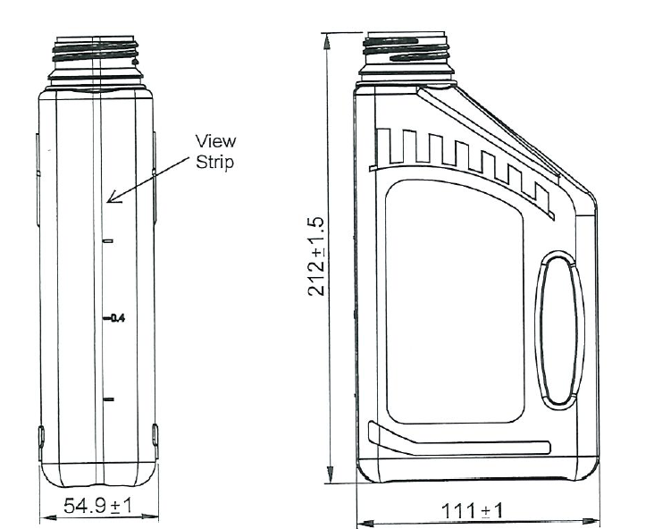

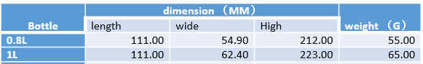

4L 、5L and 6L bottle Drawing with Dimension

