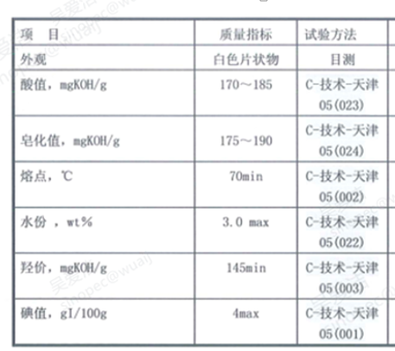

Project | Quality Indicators | Test Method
Apprence | White flake-like solid | Visually
Acid value, mgKOH/g | 170-185 | C- tcechnology-TianJin 05 (023)
Saponification Value, mgKOH/g | 175-190 | C- tcechnology-TianJin 05 (024)
Melting Point, °C | 70 min | C- tcechnology-TianJin 05 (002)
Moisture, wt% | 3.0 Max | C- tcechnology-TianJin 05 (002)
Hydroxyl Value, mgKOH/g | 145 min | C- tcechnology-TianJin 05 (003)
Iodine Value, gI/100 g | 4 max | C- tcechnology-TianJin 05 (001)

