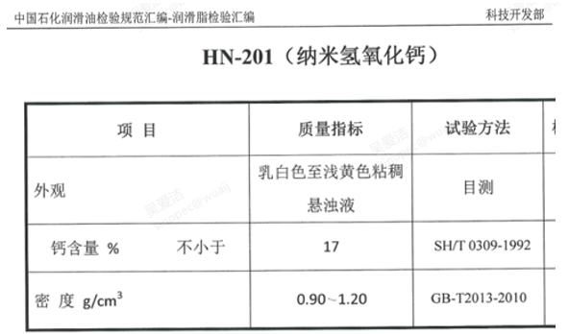

Project | Quality Indicators | Test Method
Apprence | A viscous suspension, milky white to light yellow in color. | Visually
Calcium concent % NO less. | 17 | SH/T0309-1992
Density：g/cm³ | 0.90-1.20 | GB-2013-2010

