AGREEMENT

Between

SINOPEC LUBRICANT (SINGAPORE) PTE LTD
(Hereinafter referred as “SINOPEC”)

And

XXXX
(hereinafter referred as “XXXX” or “CONTRACTOR”)
Contract No: XXXX

THIS AGREEMENT IS MADE ON DD MMM YYYY.

BETWEEN:

- SINOPEC Lubricant (Singapore) Pte Ltd, a company incoporated in Singapore and with its registered address at 150 Tuas South Avenue 5 Singapore 637363 (“SINOPEC”); and

- XXXX, a company incorporated in XXXX and with its registered address XXXX. (“XXXX” and/or “CONTRACTOR”)

WHEREAS:

(A) CONTRACTOR is in the marine transportation and delivery business with its own
vessels, equipment and personnel, and has considerable skill, knowledge and
experience in that field.

(B) SINOPEC wishes to engage CONTRACTOR to provide the Services (as defined in this
Agreement) within the Operating Area (as defined in this Agreement) from time to time in
connection with SINOPEC’s operations, and CONTRACTOR accepts this engagement, subject
to and in accordance with this Agreement.

IT IS AGREED as follows:

1. DEFINITIONS AND INTERPRETATION

1.1 The following definitions apply unless the context otherwise requires:
“Affiliate” means in relation to a Party, any person which controls, is controlled by, or is under
common control with, that Party and without limiting the foregoing, a person is deemed to
control another if it owns directly or indirectly at least 50% of: (i) the shares entitled to vote at
a general election of directors of the other person; or (ii) the voting interest in the other
person.

“Agreement” means this Agreement and all the Schedules and Attachments to this
Agreement and where the context permits, includes the e-Wave Orders issued pursuant to this
Agreement.

“Barge Delivery Order” means the document issued by SINOPEC to CONTRACTOR at the
point of products collection and is used at terminal jetties to confirm the type and quantity
of Products loaded from shore tanks into Barges.

“Barges” or “Delivery Vehicles” means delivery vehicles, delivery vessels,
barges, lighters and/or other modes of marine
transportation approved in writing by SINOPEC for use under this Agreement and where the
context permits, includes the equipment (including, without limitation, cranes) used in
Connection with a Delivery by a Delivery Vehicle.
"Bonded Goods" refers to goods that are imported into the EU but are not yet cleared for domestic consumption, and are stored, managed, and transported under customs control within a licensed Bonded Warehouse, with import duties and import-related taxes (e.g., Value-Added Tax - VAT) suspended. These goods remain under the purview of Netherlands Customs until their customs status is changed.

"Bonded Warehouse" refers to a warehouse licensed by Netherlands Customs for the storage of goods under customs supervision, including bonded logistics centers, bonded zones, or specific bonded warehouses.

" Netherlands Customs" refers to the Customs Administration of the Netherlands and its local customs offices.

“Commencement Date” means DD MMM YYYY .

“Confidential Information” means: (i) any and all information of whatsoever nature
(whether oral, written or in any other form) relating to SINOPEC and/or its Affiliates, their
businesses or operations provided by or on behalf of SINOPEC to CONTRACTOR
whether before or after the date of this Agreement and (ii) this Agreement and its terms.

“Customer” means a customer of SINOPEC or affilate of SINOPEC or a customer of the SINOPEC Lubricant (Singapore) Pte Ltd business of SINOPEC or afflilate of SINOPEC, which places an order for Products by other means (including telephone, facsimile and email).

“Delivery” means a delivery of Products within the Operating Area by or on behalf of CONTRACTOR for SINOPEC pursuant to this Agreement.

“Delivery Order” means the document (in a format approved by SINOPEC) issued by
SINOPEC to CONTRACTOR that contains the Product description and quantity as
indicated on the DELIVERY ORDER which is carried by the Delivery Vehicle for the purpose
of security clearance of the Delivery Vehicle upon its departure from the Supply Terminal.

“Delivery Location” means any location within the Operating Area, which may include:
(i) a customer vessel or marine vessel located at ports in the Netherlands, Germany, Belgium, and France, at anchorage, offshore islands, or off-port limits, and/or any duly appointed agent thereof; and/or
(ii) any other delivery location, premises, or site within the Operating Area as may be designated in writing by SINOPEC to the CONTRACTOR from time to time.

“Fee” has the meaning ascribed to it in Clause 10.1;

“Indemnitees” means SINOPEC, each of SINOPEC’s Affiliates and the employees,
officers, agents, CONTRACTOR and representatives of each of them.

“Letter of Protection” or “LOP” means a written declaration that records complaints
concerning any operational matter that is performed by a recipient or other party and/or
is a report of operations that have gone wrong and/or serves to protect the Master of a
Delivery Vehicle or CONTRACTOR from any blame in the case of mishandling of cargo,
delivery of wrong fuel, violation of regulations, berths unclear or equipment that has
become inoperative.

“Marine Services” means services provided by CONTRACTOR in connection with a
Delivery involving the use of Delivery Vehicle, as described in Schedule 1.

“Operating Area” means Netherlands, Germany, Belgium, and France .

“Packages” means drums, pails, cartons, intermediate bulk containers and/or other
forms of packaging for the Products.

“Parties” means SINOPEC and CONTRACTOR, and “Party” means one of the Parties,
and shall include their successors and permitted assigns.

“Personnel” means all personnel employed, contracted or engaged by CONTRACTOR
for the performance of the Services and/or for the purposes of this Agreement,
including, without limitation, drivers, shipping masters, crew and personnel to operate and handle Deliveries.

“Product” means any of the lubricating products advised by SINOPEC to be transported
pursuant to this Agreement from time to time and where the context permits, shall
include the Packages within which the Products are contained.

“Services” means the Services as referenced in Schedule 1 annexed hereto.

“Supply Terminal” means SINOPEC’s appointed blending plant or such other terminal or depot
nominated in the DELIVERY ORDER.

“Working Day” means a day on which banks are open for business in Netherlands,
excluding a Saturday, Sunday or gazetted public holiday.

1.2 All references in this Agreement to the masculine gender shall include the neuter and
feminine genders and vice versa and words importing the singular CONTRACTOR and shall include the plural and vice versa. Any reference in this Agreement to a statute or
provision of a statute shall be construed as a reference to that statute or provision as
amended, re-enacted or extended at the relevant time. The words “include”, “includes”
and “including” are not limiting and shall be deemed to be followed by the words
“without limitation”, whether or not so followed.

1.3 References in this Agreement to Clauses and Schedules shall, except where the context
otherwise admits or requires, be construed as references to clauses of and schedules to
this Agreement.

1.4 The headings in this Agreement are for convenience only and shall not affect their
interpretation.

2. NON-EXCLUSIVE APPOINTMENT

2.1 SINOPEC hereby engages CONTRACTOR to provide the Services within the Operating
Area, and CONTRACTOR hereby accepts this engagement, in accordance with the
terms set out in this Agreement.

2.2 CONTRACTOR’s engagement under this Agreement is non-exclusive. Nothing in this
Agreement shall confer on CONTRACTOR any exclusive right to transport or deliver
Products for SINOPEC nor prevent SINOPEC from engaging any other persons to perform
the Services or any other services relating to the transportation or delivery of the
Products.

2.3 In the event of any conflict, the terms in this Agreement shall prevail according to the
following order of preference:-

2.3.1 the terms in the body of this Agreement;

2.3.2 Schedules and Annexes.

- TERM

This Agreement shall come into effect on the Commencement Date and, subject to earlier termination in accordance with this Agreement, shall continue for a period from DD MMM YYYY to DD MMM YYYY and thereafter shall be automatically extended for another one year if there is no disagreement between both parties.

4. PERFORMANCE OF SERVICES BY CONTRACTOR

4.1 CONTRACTOR shall perform the Services pursuant in accordance with this Agreement.

4.2 Save only to the extent expressly set out, or provided for, in this Agreement, none of
CONTRACTOR’s terms and conditions of business or any other terms or conditions
(including, any terms and conditions set out in any acknowledgement or confirmation of
order of CONTRACTOR) shall apply to the supply of Services by CONTRACTOR.

4.3 SINOPEC may provide CONTRACTOR with additional instructions, including SINOPEC
requirements, necessary to ensure that each Delivery is
completed in a safe and efficient manner and in accordance with this Agreement and all
applicable laws. CONTRACTOR shall advise SINOPEC in writing if it does not have
sufficient instructions for it to carry out a Delivery and failing which, CONTRACTOR
shall be deemed to possess all the necessary instructions for it to carry out the Delivery
in accordance with this Agreement and to have fully understood the Services to be
carried out for the Delivery.

4.4 CONTRACTOR shall provide the Services seven days a week and on a 24-hour basis
including on Saturdays, Sundays and gazetted public holidays. No extra charges are
payable by SINOPEC for Services rendered after office hours, on Saturdays, Sundays
and gazetted public holidays.

4.5 CONTRACTOR shall liaise on a daily basis with SINOPEC to enable it to perform the
Services in a prompt, safe and efficient manner and co-operate with SINOPEC in all
matters in connection with the performance of this Agreement.

4.6 CONTRACTOR acknowledges that the Products are or may be of a highly flammable
nature and that it shall take all necessary steps and precautions and exercise due
diligence and vigilance to ensure the safe transportation and delivery of the Products.

4.7 SINOPEC shall be entitled to cancel any Order at any time without liability to SINOPEC. SINOPEC may also reject any Services which are not in accordance with this Agreement at any time before the Product is delivered to the Customer by giving verbal notification to CONTRACTOR specifying the reason for the rejection. Without prejudice to any other rights or remedies available to SINOPEC, CONTRACTOR shall forthwith return to SINOPEC all amounts which have been paid by SINOPEC in respect of any cancelled Order and/or non-conforming Services, which shall be a debt due and payable by CONTRACTOR to SINOPEC. SINOPEC may, at Its sole option, set off all amounts which have been paid by SINOPEC in respect of any cancelled Order and/or non-conforming Services against any amounts payable by SINOPEC to CONTRACTOR.

5. MARINE SERVICES

5.1 In addition to the terms set out in the body of this Agreement, the following terms shall
apply to all Marine Services performed by CONTRACTOR under this Agreement. In order to ensure the supply of SINOPEC’s Marine Lubricants to SINOPEC’s customers at ports, SINOPEC hereby entrusts CONTRACTOR to store, distribute and supply SINOPEC’s products, and CONTRACTOR hereby accepts SINOPEC’s entrustment. Through friendly consultations, the two parties hereto reach the following agreement:

5.1.1 Entrusted Services

5.1.1.1 SINOPEC entrusts CONTRACTOR to store SINOPEC’s Bulk and packaged Products, CONTRACTOR agrees to provide Barge (barge name IMO#XXXXXXX) for specific products / storage, which is legally owned by CONTRACTOR, as a storage place of SINOPEC’s Products. CONTRACTOR shall guarantee that the storage and ancillary facilities in the above storage place shall comply with the requirements for safety, fire prevention, and environmental protection.

5.1.1.2 CONTRACTOR shall, upon SINOPEC’s written notice, provide safe and efficient distribution and supply services of Oil Products as entrusted by SINOPEC.

5.1.2 Reception of SINOPEC’s Products

5.1.2.1 SINOPEC shall notify CONTRACTOR by email to inform Contractor for the product code, product name, packaging and quantity of SINOPEC’s Products.

5.1.2.2 At the time of receiving the Products, CONTRACTOR shall check whether the package are intact, and shall verify the varieties and quantity of the Products. In case of any discrepancy between the varieties and quantity of the received Products and those listed in the email, CONTRACTOR shall promptly notify SINOPEC and only accept the Products after obtaining SINOPEC’s permission. In case of any damage or severe deformation of the Products caused during transit, CONTRACTOR shall notify SINOPEC promptly and shall assist SINOPEC in dealing with the case. In such a case, CONTRACTOR shall not deal with Products without SINOPEC’s authorization unless in case of mandatory treatment by any applicable government department or authority, including but not limited to the customs office, etc.

5.1.2.3 Any and all risks of loss and damage of the Products after receipt shall be borne by CONTRACTOR.

5.2 Storage of the Products

5.2.1 Storage of SINOPEC’s Products

5.2.1.1 CONTRACTOR shall stack the Products entrusted by SINOPEC after classification by varieties, and store in clean, dry and secure warehouses.

5.2.1.2 CONTRACTOR shall keep detailed records of the accepted, delivered and stored Products, and shall verify the inventory quantity and check the storage conditions of the Products at the end of the day. CONTRACTOR shall also send SINOPEC a fax or an email containing the inventory records of the Products (containing the names of the Products, the quantity of the inventory at the beginning of the current month, the quantity of the Products having entered and exited the warehouses, the balance of the quantity of the current month, etc.).

5.2.1.3 The control of the existing inventory shall follow the principle of FIFO, unless otherwise specified in the Products Purchase Order by SINOPEC.

5.3 Distribution and Supply of the Products

5.3.1 SINOPEC’s Responsibilities and Obligations

5.3.1.1 SINOPEC shall notify CONTRACTOR in fax or hand writing or email of the Marine Lubricants Delivery Notice (containing the name of the ship, date of arrival if available, the varieties, quantity and the supply method of the Products demanded, and the ship agent, etc) at least two (2) working days in advance. In case of emergency, SINOPEC’s representative may first contact over phone and then subsequently notify CONTRACTOR’s person in charge in writing.

5.3.2 CONTRACTOR’s Responsibilities and Obligations

5.3.2.1 CONTRACTOR shall immediately contact the ship agent to confirm the ETA & ETD, the delivery date, whether the inventory is adequate, whether the parking place is suitable for the supply and the pumping of the Products (e.g., taking into consideration factors such as the voltages of different countries, the lubricating devices, etc), and shall email SINOPEC within 4 working hours after receiving SINOPEC’s order. In case the ship owner has not specified a ship agent, CONTRACTOR may confirm the reception of the fax and then officially confirm to SINOPEC after the ship agent has been specified and the supply has been arranged.

5.3.2.2 CONTRACTOR shall maintain the following documents available at the time of supplying the Products: Statement (Annex I), Pre-supply Checklist (Annex II and Annex III), Lubricants Delivery Dispute Report (Annex IV) and the Marine Lubricant Delivery Receipt (Annex V).

5.3.2.3 CONTRACTOR shall distribute and supply the Products to the ship specified by SINOPEC according to the Oil Product Service Specifications (Annex VI) prepared by SINOPEC.

5.3.2.4 In case CONTRACTOR to supply Products in bulk to the ship, CONTRACTOR shall distribute and supply such Products to the ship specified by SINOPEC according to the written requirements by SINOPEC, and the quantity of supply shall be based on the quantity on the Marine Lubricant Delivery Receipt. Any and all costs of any dispute incurred by and related to any discrepancy of the quantity shall be borne by CONTRACTOR.

5.3.2.5 CONTRACTOR’s representative and the person in charge of the ship to receive the Products (hereafter referred to as the “oil receiving ship”) specified by SINOPEC shall be on site during the whole process of oil supply, and shall inspect and confirm the readings of the flowmeter, the quantity and the varieties of the Products, the packaging and sealing conditions of the oil drums, etc. prior to further operations. After the oil has been supplied, the person in charge of the oil receiving ship specified by SINOPEC shall sign on and affix the ship seal thereof to the Marine Lubricant Delivery Receipt. In case the person in charge of the oil receiving ship refuses to inspect the readings of the flowmeter and/or the quantity and/or packaging of the Products, CONTRACTOR shall be entitled to refuse to supply the Products.

5.3.2.6 In case any sample of the Products is required, the staff of the oil receiving ship shall deliver the sample(s) to CONTRACTOR, and CONTRACTOR shall send the samples to the location designated by SINOPEC within two (2) working days after receipt.

5.3.2.7 CONTRACTOR shall send the Marine Lubricant Delivery Receipt to SINOPEC by fax or email within three (3) working days after supplying the Products, and shall mail the Pre-supply Checklist and the original copy of the Marine Lubricant Delivery Receipt to SINOPEC within five (5) working days after supplying the Products.

5.3.2.8 CONTRACTOR shall be entitled to a total of 168 hours for maintenance per year as and when requested and such request shall not be unreasonably withheld by SINOPEC. After the consumption of the allowed 168 hours and in case additional maintenance time is required, the barge shall be deemed off-hire and all payment obligations of SINOPEC under this agreement shall be waived (and permanently forfeited) for the period of such maintenance. For the avoidance of doubt, the Parties acknowledge and agree that SINOPEC shall have no responsibility or liability to the CONTRACTOR (or any other person) in connection with any loss (including consequential loss) claimed by any person in connection with any failure to discharge its obligations under this agreement as a result of such maintenance, and vice versa.

6. Quantity and Quality control

6.1 CONTRACTOR shall take sample for bulk product when products delivered to CONTRACTOR in accordance to agreed sampling procedure. The sample shall retain for a period of six (6) months from the date of sampling. CONTRACTOR shall ensure the product quality and quantity is in accordance with that as described in this agreement.

6.2 The CONTRACTOR is required to submit a Stock Balance Report to SINOPEC at the end of each month. In case a discrepancy on the quantity of the product stored at the CONTRACTOR’s barge is found at the end of the month, such difference should not exceed +/-0.3% tolerance.

7. VOLUMES AND OPERATING AREA

7.1 There are no minimum or maximum volume commitments under this Agreement.

7.2 CONTRACTOR shall perform the Services, and ensure that all Products are loaded and
discharged, within the Operating Area.

8. PACKAGING AND LOADING OF PRODUCTS

8.1 CONTRACTOR shall comply with all applicable laws and regulations relating to the
loading, unloading, segregation, handling, packaging and storage of the Products.

8.2 CONTRACTOR shall safeguard and ensure that the Products loaded on Delivery Vehicle shall remain on the relevant Delivery Vehicle until they are delivered in accordance with this Agreement, except in an emergency or as instructed in writing by SINOPEC.

9. DELIVERY, TITLE AND RISK

9.1 CONTRACTOR shall execute each order expeditiously and shall comply with the timelines
set out in this Agreement and/or as may be notified by SINOPEC to CONTRACTOR
from time to time. Time of Delivery is of the essence of this Agreement and Order.

9.2 Title to all Products shall be vested in, and remain with, SINOPEC at all times until the
Products are delivered to the Customer in accordance with the terms as agreed
between SINOPEC and the Customer.

9.3 CONTRACTOR shall ensure that the Products in its possession, custody or control are
at all times physically segregated from all other products which may be used, received
or stored by CONTRACTOR from time to time. CONTRACTOR shall not mix any other
products with the Products without SINOPEC’s prior written permission. CONTRACTOR
shall ensure that at no time shall the Products be combined, adulterated, mixed or
contaminated with any products.

9.4 Risk of damage to or loss or contamination of the Products while in CONTRACTOR’s possession, custody or control (including, without limitation, on the Delivery ) shall at all times remain with CONTRACTOR. CONTRACTOR shall indemnify SINOPEC in full for all losses, liabilities, damages, actions, proceedings and third party claims against SINOPEC arising out of or in connection with any damage to or loss or contamination of any Product while in CONTRACTOR’s possessions or custody or control.
9.5 Risk of damage to or loss or contamination of the Products shall pass to SINOPEC or the
relevant Customer at the point when the Products are delivered to, and the relevant
DELIVERY ORDER is signed by, the Customer.

9.6 The CONTRACTOR agrees, to the fullest extent permitted by applicable laws, to indemnify, defend and hold harmless SINOPEC from and against any and all losses, damages, demands, claims, causes of actions, costs and expenses based upon or arising directly or indirectly out of or in any way connected with any act, default or omission by the CONTRACTOR, its employees, agents or independent contractors.

9.7 In the event CONTRACTOR receives any claims, requests or disputes in relation to any of
the Services or the Products, CONTRACTOR shall notify SINOPEC immediately and shall
co-operate with SINOPEC to resolve all such claims, requests and disputes (including,
without limitation, taking such corrective actions as may be reasonably required by
SINOPEC and within such period as may be specified by SINOPEC). This Clause 9.7 shall
be without prejudice to the rights and remedies SINOPEC may have under this Agreement
or otherwise.

10. FEE, INVOICES AND PAYMENT

10.1 In consideration for the due and proper performance of this Agreement and subject to
this Agreement, SINOPEC shall pay CONTRACTOR a fee (“Fee”) calculated in
accordance with the respective rates for Marine Services set out in
Schedule 2 and on the basis of the quantity of Products delivered as specified in the
Delivery Order.

10.2 The amounts payable by SINOPEC to CONTRACTOR pursuant to this Clause 10 shall
constitute the entire compensation of CONTRACTOR in respect of the performance of
the Services and CONTRACTOR shall not be entitled to any other compensation or
remuneration in respect thereof.

10.4 CONTRACTOR’s invoices:-

10.4.1 CONTRACTOR shall deliver invoices once a month for Marine Services
and shall ensure that all invoices are addressed to SINOPEC Lubricant (Singapore) Pte Ltd (Supply Chain Department) and delivered to SINOPEC at its registered address or otherwise as notified by SINOPEC to CONTRACTOR from time to time.

10.4.2 CONTRACTOR shall include all the following information in every invoice:-

10.4.2.1 the amount due in the currency in US dollars that SINOPEC
has instructed that the invoice be issued in;

10.4.2.2 if applicable, all the following:-

(i) CONTRACTOR’s value added tax, goods and services tax,
sales tax or other taxes which CONTRACTOR proposes to
collect or for which it will seek reimbursement from SINOPEC
(including a tax assessed against SINOPEC but collected by
CONTRACTOR); and

(ii) CONTRACTOR’s tax registration number; and

10.4.2.3 such other information as may be notified by SINOPEC to
CONTRACTOR from time to time.

10.5 SINOPEC shall pay each invoice within 30days after receipt of the invoice together with
all relevant DELIVERY ORDERS signed by Customer, provided that if SINOPEC disputes any invoices, SINOPEC shall only pay the undisputed portion (if any) and payment of the
disputed portion shall be withheld until resolution of the dispute. If SINOPEC is unable
to make payment of any invoice (other than in connection with the withholding of
payment pursuant to a dispute on the invoice), both parties shall enter into negotiations
in good faith to resolve the issue. Parties agree that under no circumstances shall any
right of retention or lien upon the Product be exercised or enforced and Products shall
continue to be delivered to the Customer according to the nomination and schedule
prepared by CONTRACTOR.

10.6 If payment falls due on a Sunday or Monday bank holiday, payment shall be made on
the first banking day following the due date. If payment falls due on a Saturday or other
(non-Monday) bank holiday(s), payment shall be made on the last banking day prior to
the due date.

10.7 SINOPEC may set off against, deduct or withhold any amounts payable to
CONTRACTOR under this Agreement:-

10.7.1 any amounts payable by CONTRACTOR to SINOPEC under this Agreement or
other arrangements; and

10.7.2 any amount which is the subject of, arises out of or is connected with any
dispute, claim or action between the Parties.

10.8 Payment by SINOPEC shall be without prejudice to any claims or rights it may have
against CONTRACTOR and shall not constitute or be deemed to constitue any
admission by SINOPEC as to the adequacy or sufficiency of CONTRACTOR’s
performance of its obligations under this Agreement.

10.9 Any adjustments to Fee may only be made by Parties in writing on bilateral consent.

11. WARRANTIES AND UNDERTAKINGS

11.1 Without prejudice to Clause 21, CONTRACTOR warrants and undertakes to SINOPEC that it shall at all times ( and where applicable, shall also procure that its Personnel): -

11.1.1 obtain and maintain (at CONTRACTOR’s sole cost and expense) all necessary
licences, permits, certificates, approvals, concessions and authorizations as
may be required by applicable laws and regulations and/or as may be
necessary or desirable in connection with this Agreement;

11.1.2 comply with all applicable laws and regulations and all applicable directions,
guidelines, order and policies of any governmental body;

11.1.3 perform the Services in a manner reasonably believed to be in the best
interests of SINOPEC and with such care and skill as a reasonably prudent
provider of similar services would use under similar circumstances;

11.1.4 perform the Services in a safe, diligent and workmanlike manner, in accordance
with generally accepted industry practices and sound engineering principles and
utilize for the Services the technical competence, financial capacity,
management skills, competent and qualified personnel and equipment
necessary to carry out its duties and responsibilities;

11.1.5 ensure that its and Delivery Vehicle is fully equipped and
capable of safely carrying, transporting and delivering the Products;

11.1.6 ensure that its Personnel are trained, properly qualified and experienced for
the performance of the Services;

11.1.7 make and keep available for the purpose of this Agreement, the Delivery Vehicle, equipment and facilities as required and approved by SINOPEC from time to time and shall ensure that all its Delivery Vehicle, equipments and facilities meet the minimum safety standards specified by applicable laws and/or by SINOPEC from time to time;

11.1.8 keep and maintain at its own expense the Delivery Vehicle in a thoroughly efficient state in hull and machinery and the equipment and facilities used for the purpose of this Agreement in good working condition, all in accordance with applicable laws and/or any other standards and/or policies as may be prescribed by SINOPEC from time to time, and to insure the same;

11.1.9 ensure that its Delivery Vehicle and other equipment or
facility are not loaded in excess of any statutory, legal or manufacturer’s limits,
whichever is the lower;

11.1.10 ensure that its Delivery Vehicle and other equipment or
facility used for the purpose of this Agreement are properly calibrated by the
relevant government authority where it is so required;

11.1.11 ensure that all flowmeters onboard the Delivery Vehicles are calibrated
annually at a base temperature of 30 degrees centigrade or equivalent or at
such other temperatures as specified by SINOPEC and possess and promptly
provide to SINOPEC all relevant and authenticated copies thereof for
verification; and

11.1.12 inspect and test all hoses and other conduits used in the provision of Services
pursuant hereto on an annual basis for leaks, deterioration and other adverse
conditions and keep a record of this for inspection by SINOPEC. SINOPEC shall
have the right to require CONTRACTOR to replace any equipment (including
pumps and hoses) used in the provision of the Services if any of them are
found by SINOPEC to be unsatisfactory and all costs and expenses associated
with any replacement shall be borne solely by CONTRACTOR.

12. PERSONNEL

12.1 CONTRACTOR shall provide all Personnel as may be necessary or desirable for the
performance of the Services.

12.2 CONTRACTOR warrants that it has strictly screened and has hired only competent and
qualified Personnel. CONTRACTOR shall ensure that all its Personnel are properly
accredited and meet the minimum standards and requirements required by the relevant authorities.

12.3 CONTRACTOR shall ensure that it and its Personnel comply with all applicable laws
and regulations, including the rules and regulations prescribed by the applicable laws and regulations. This includes but
is not limited to adhering to legal work permits and licences, immigration passes and
procedures, valid and authorized certification for specified workers, Workmen
Compensation Insurance Policies, and safety rules and regulations in respect of
workers employed, contracted or engaged by CONTRACTOR.

12.4 CONTRACTOR shall ensure that all workers employed by CONTRACTOR have valid employment passes or
work permits.
12.5 No illegal worker may be used in the provision of Services
or the performance of this Agreement. CONTRACTOR shall be liable for any offence
under the applicable laws if any illegal worker is found to be so employed.

12.6 CONTRACTOR shall comply with, and shall ensure that its Personnel comply with, all
their respective duties and obligations under all legislations and other requirements
having the force of law relating to health and safety and the performance of the
Services, including all relevant codes of practice and standards.
12.7 CONTRACTOR shall be deemed to have inspected and examined this Agreement and
to have satisfied itself before executing this Agreement that the working methods
required for executing the Services are suitable for complying with the applicable laws and all other applicable laws and regulations.

12.8 CONTRACTOR shall be solely responsible for ensuring that its Personnel have valid
and current driver or marine chartering or equivalent licenses at all times throughout the
term of this Agreement.
12.9 CONTRACTOR shall provide regular training for its Personnel for land transportation in
safe and defensive driving procedures, dangerous goods handling, and other safety-
related topics at frequencies as may be prescribed by SINOPEC from time to time.

12.10 CONTRACTOR shall ensure that all Personnel who require access to a Supply
Terminal shall have completed the appropriate training in the Supply Terminal's safety,
operational and procedural requirements to the reasonable satisfaction of SINOPEC
before he enters that Supply Terminal.

12.11 CONTRACTOR undertakes to provide a drug and alcohol-free work place for its
Personnel and in particular, shall ensure that its Personnel and other personnel
including its employees, subcontractors and agents shall not perform any Services for SINOPEC while under the influence of alcohol or any drug or controlled substance.

13. RELATIONSHIP WITH CUSTOMER

CONTRACTOR shall at all times, maintain good business relations with SINOPEC’s
business associates, customers and consignees and shall ensure that the Personnel
and CONTRACTOR’s employees, subcontractors and agents foster and maintain
such good relationships. If, in the opinion of SINOPEC, the continued employment
and/or engagement of any of the Personnel and/or CONTRACTOR’s employees,
subcontractors or agents in carrying out any Services shall give cause for serious
complaint by SINOPEC or by SINOPEC’s business associates, customers and consignees
or if the performance of any of the Personnel and/or CONTRACTOR’s employees,
subcontractors or agents are, in SINOPEC’s reasonable opinion, unsatisfactory, CONTRACTOR shall immediately withdraw such Personnel, employee,
subcontractor or agent from the provision of Services and provide a suitable
replacement which is acceptable to SINOPEC and bear all costs and expenses incurred
thereby.

14. DELIVERY VEHICLES

CONTRACTOR shall ensure that all relevant business and operating licences,
certifications and permits issued by competent authorities (including the use and
operation of its Delivery Vehicles, equipment and facilities) are valid
and kept current at all times throughout the term of this Agreement, and that
authenticated copies thereof are provided to SINOPEC for verification on every
anniversary of the Commencement Date.

15. SINOPEC’S OPTIONS

15.1 Wihout prejudice to any rights or remedies available to SINOPEC, SINOPEC may, at any
time, refuse entry by any of the Delivery Vehicles or Personnel to its Supply Terminal in the event of any breach of this Agreement by CONTRACTOR or its
Personnel and may, in addition, exercise any one or more of the following:-

15.1.1request CONTRACTOR to provide an alternative or replacement, Delivery Vehicle or Personnel to carry out a Delivery;

15.1.2 make alternative arrangements for the delivery of the Products affected by
CONTRACTOR’s or its Personnel’s breach; and/or

15.1.3 terminate this Agreement pursuant to Clause 21.
16. INSURANCE

16.1 Evidence of Insurance. Before commencing performance, and at the request of
SINOPEC anytime thereafter, CONTRACTOR shall provide SINOPEC with
certificates or other documentary evidence satisfactory to SINOPEC of the
insurance coverages and endorsements required by Sinopec. Acceptance by SINOPEC of an improper certificate shall not constitute a waiver, release or modification of any of the insurance coverage and endorsements required hereunder.

16.2 Insurance Required from Subcontractors. Without in any way limiting
CONTRACTOR's liability pursuant to Clause 18 hereof or recovery under
CONTRACTOR’s insurance with respect to performance by subcontractors,
CONTRACTOR shall require its subcontractors, if any, to name CONTRACTOR
and Indemnitees as additional insureds to the insurance carried by
subcontractors with respect to operations performed under this Agreement.

16.3 In relation to Delivery Vehicles:-

16.3.1 CONTRACTOR warrants that from the time the obligation to proceed to the
loading port(s) and throughout Delivery Vehicles’ service under this Agreement,
Delivery Vehicle shall be insured at CONTRACTOR’s expense for:

• Hull and Machinery Insurance including collision liability with a limit equal
to or greater than CONTRACTOR’s yearly declared value of Delivery
Vehicle. Such insurance to waive all rights of subrogation against SINOPEC
to the extent of the liabilities and/or indemnity obligations assumed by
CONTRACTOR under this Agreement;

• Protection and Indemnity Insurance on a full entry basis with an
International Group P&I Club. Such insurance shall include, but not be
limited to: coverage for injuries to or death of masters, mates and crew;
collision liabilities not insured under the H&M policy, excess collision
liabilities, cargo legal liabilities and pollution liabilities. The limit of such
insurance shall be as established by the rules of the International Group of
P&I Clubs except for pollution liabilities which shall be limited to the
maximum pollution limit offered through the P&I Clubs of the International
Group (currently US $1 billion); and

16.3.2 If so requested by SINOPEC, CONTRACTOR shall promptly furnish to SINOPEC
proper evidence of such insurance.

17. TAX

17.1 CONTRACTOR is solely responsible for all liabilities or claims for taxes that any taxing
authority (including any of its political subdivisions) claiming jurisdiction over this
Agreement or the area of operations may assess or levy against CONTRACTOR
relating to the Services, including but not limited to:

17.1.1 Income, excess profit or other taxes, charges and imposts assessed or levied on
account of CONTRACTOR’s earnings or receipts;

17.1.2 Taxes assessed or levied against or on account of compensation or other
benefits paid to CONTRACTOR’s employees;

17.1.3 Taxes assessed or levied against or on account of any property or equipment
(including materials and consumable supplies) of CONTRACTOR except
customs duties and imports and re-export taxes reimbursed by SINOPEC under
this Agreement; and

17.1.4 Taxes assessed or levied against or on account of the value of the Services
performed by CONTRACTOR.

17.2 CONTRACTOR must fully comply with all applicable tax rules and requirements, submit
all tax reports, file all registrations and take all actions necessary to make its tax
payments. If CONTRACTOR claims an exemption from any taxes (including without
limitation taxes described in Clause 17.1), CONTRACTOR must disclose such
exemption to SINOPEC on a timely basis and provide SINOPEC with all exemption documentation requested by SINOPEC. If required by the Laws, SINOPEC will, as
appropriate, report, withhold and pay to the tax authorities any tax levied or assessed on
account of CONTRACTOR’s Services, based on the certifications or written
representations provided by CONTRACTOR. SINOPEC will provide CONTRACTOR with
tax receipts for any withheld taxes but will not reimburse CONTRACTOR for any
withheld taxes.

17.3 CONTRACTOR must promptly and timely notify SINOPEC of any pending or actual
assessment of VAT, GST, sales tax or similar taxes, or any customs duties or import
and export taxes described in this Agreement, for which CONTRACTOR may seek
reimbursement from SINOPEC. “promptly and timely” as used in this Clause 17.3 means
that CONTRACTOR must notify SINOPEC so that SINOPEC has enough time and a reasonable opportunity to appeal, protest or litigate the pending or actual assessment in
an appropriate venue. To the extent that CONTRACTOR fails to give prompt and timely
notice, SINOPEC has no obligation to, and will not, reimburse CONTRACTOR for these
taxes, duties or costs. At SINOPEC’s request and at SINOPEC’s cost, CONTRACTOR
must initiate an appeal, protest or litigation in CONTRACTOR’s own name if
CONTRACTOR is the only party that can legally initiate this appeal, protest or
litigation. If SINOPEC or another indemnitee is required to pay any amount indemnified
by CONTRACTOR under Clause 17.4 or this Agreement in order to pursue an appeal,
protest or litigation, CONTRACTOR must reimburse SINOPEC or other indemnitee for
that amount promptly upon receipt of a written request from SINOPEC.

17.4 CONTRACTOR must defend, indemnify and hold indemnitees harmless from and
against any and all liabilities or claims for taxes, including interest and penalty, that any
taxing authority may assess or levy against indemnitees in connection with or arising
from CONTRACTOR’s tax obligations under this contract, including any taxes, interest,
damages, losses, costs, duties, charges, fines or penalties arising out of CONTRACTOR’s action or failure to act diligently under Clause 17 as well as any income taxes imposed on indemnitees as a consequence of receiving payment under this Clause.

17.5 CONTRACTOR must maintain records sufficient to substantiate all taxes, duties, fees,
indemnities or other payments that are the responsibility of or reimbursed to
CONTRACTOR under Clause 17 for so long as the longest applicable statute of
limitations (including any waivers of a statute of limitations by CONTRACTOR) remains
open, under which a taxing authority may institute audit, assessment or collection
procedures for taxes paid or allegedly due in connection with this
Contract. CONTRACTOR must provide at SINOPEC’s request schedules, summaries or
other data that SINOPEC requires to prepare tax returns, refunds, claims and credits or
for use in external tax audits.

18. INDEMNITY

18.1 CONTRACTOR shall be responsible for and shall on demand indemnify in full the
Indemnitees from and against any and all actions, claims, demands and proceedings
(including those brought against SINOPEC by SINOPEC’s business associates, customers
or consignees), injury to or death of any person (including a Personnel or an employee
of CONTRACTOR or an Indemnitee), all damages, liabilities, costs (including legal costs
on a full indemnity basis), damages, fines and penalties (including those paid by
SINOPEC on the advice of its legal advisers to compromise or settle any claim), costs of
any environment audit and clean-up, loss or damage to Products, failure, delay or error
in delivery of Products and any other losses, costs, expenses and liabilities of
whatsoever nature and howsoever, in each case, whether directly or indirectly arising
out of or in connection with:-

18.1.1 any bribery or corruption on the part of any Personnel (whether at the Supply
Terminal or a Delivery Location or otherwise);

18.1.2 any tampering with the seals of product compartment hatch covers and outlet
valves of a or Delivery Vehicle;

18.1.3 any tampering with the delivery meters, product compartment gauge markers
and/or product/government calibration seals of a Delivery Vehicle or Delivery
Vessel;

18.1.4 any improper handling of the Products by or on behalf of CONTRACTOR;

18.1.5 any pilferage or theft of Products or fraud or malpractice against SINOPEC or
SINOPEC’s customers;

18.1.6 any oil spillage or pollution from the Delivery Vehicles, or any
destruction or deterioration of the Products, whether accidental, negligent or
otherwise;

18.1.7 any contamination or adulteration or admixture of the Products, whether
accidental, negligent or otherwise;
18.1.8 any Delivery to a location other than a Delivery Location;

18.1.9 any breach or non-compliance with any of the provisions of this Agreement by
CONTRACTOR or the Personnel or any of CONTRACTOR’s employees,
subcontractors or agents;

18.1.10 any misconduct or negligence on the part of CONTRACTOR or the Personnel or
any of CONTRACTOR’s employees, subcontractors or agents; and/or

18.1.11 any alleged or actual infringement (whether or not the alleged infringement is
joint or indirect) of patent rights, trademarks, copyrights, design rights or alleged miuse of trade secret information, by CONTRACTOR or the Personenel or any of CONTRACTOR’s employee, subcontractors or agents.

19. EXCLUSION OF LIABILITY

19.1 This Clause 19 sets out the entire financial liability of SINOPEC to CONTRACTOR under
or in connection with this Agreement (including any breach thereof).

19.2 If, in respect of a claim against the Indemnitees, CONTRACTOR is able to make a claim
under any policy of insurance, then CONTRACTOR shall be obliged to make a claim
against its insurers under the aforesaid policy of insurance and the amount recovered
by CONTRACTOR pursuant to such insurance claim (or any claim which could have
been made had such policies or their equivalent been maintained under Clause 16 shall
then be applied so as to reduce or extinguish the claim against the Indemnitees
accordingly.

19.3 No claim shall lie against any Indemnitee under this Agreement if such claim is wholly or
partly attributable to any act, omission, transaction or arrangement carried out at the
request of or with the consent of CONTRACTOR or any Personnel, or any of
CONTRACTOR’s employees, or agents.

19.4 The Indemnitees shall not be held responsible or liable for any loss or damage
sustained by any Delivery Vehicle resulting from or caused by CONTRACTOR, its
Personnel or any pilots, tugboats or stevedores. CONTRACTOR authorises SINOPEC, its
employees, representatives and persons authorised by it to bind any Delivery Vehicle
and CONTRACTOR to all the terms and conditions (whether written or implied) of
contracts or agreements for pilotage, towing or stevedoring services in accordance with
established local practice in the ports where such services are engaged, and
CONTRACTOR shall indemnify and keep the Indemnitees fully indemnified from and
against any and all losses, damages, costs, legal costs and expenses that may be
sustained or incurred by them.

19.5 Notwithstanding anything contained herein, SINOPEC shall not be liable to
CONTRACTOR (whether in contract, tort, negligence, breach of statutory duty or
otherwise) for any consequential, special or indirect loss or damage of any kind
whatsoever arising out of or in connection with the performance of or failure to perform
this Agreement, including but not limited to any economic loss or loss of profit or
business or opportunity or any other losses whatsoever even if such loss was reasonably foreseeable or SINOPEC had been advised of CONTRACTOR incurring or suffering the same.

20. LIEN

20.1 SINOPEC shall have a lien on the Delivery Vehicle (as the case may
be) for all moneys paid in advance and not earned, and for all claims for loss, damages,
costs and expenses (including legal costs) arising from any breach by CONTRACTOR
or the Personnel of this Agreement.

20.2 CONTRACTOR shall not have a lien upon the Product for all and any part of the Fee,
cost of recovery whatsoever thereof (including legal costs) and other expenses to
enforce the lien, incurred by CONTRACTOR.

21. TERMINATION

21.1 SINOPEC may terminate this Agreement by giving CONTRACTOR notice in writing of not
less than 2 months.

21.2 SINOPEC may terminate this Agreement at any time if CONTRACTOR commits a breach
of any of the terms of this Agreement and (if capable of remedy) fails to remedy the
breach within 14 days after being required by written notice to do so.

21.3 Notwithstanding any other provisions of this Agreement, this Agreement may be
terminated at any time forthwith by either of the Parties giving notice in writing of such
termination to the other in the event that:-

21.3.1 CONTRACTOR ceases for any reason to be able to carry on business or is
otherwise prevented from carrying on such business; or

21.3.2 if the other Party enters into liquidation whether voluntarily or compulsorily by
any final order of any competent court of jurisdiction (other than for the
purposes of amalgamation or reconstruction while solvent) or enters into any
arrangement or composition with its creditors or takes or suffers any similar
action in consequence of debt.

21.4 Upon termination of this Agreement for whatever reason:

21.4.1 CONTRACTOR shall within five days return, or otherwise dispose of, in
accordance with SINOPEC’s written instructions, all materials, documents and
other information and items relating to the business/operations of SINOPEC or
its Affiliates which SINOPEC has provided to CONTRACTOR. The costs and
expenses of carriage, insurance, and other charges incurred in connection with
the aforesaid return or disposal shall be borne by CONTRACTOR;

21.4.2 CONTRACTOR shall immediately return all undelivered Products in its care
and custody to SINOPEC, unless SINOPEC otherwise requests CONTRACTOR
in writing to complete the delivery of such Products, in which event
CONTRACTOR shall complete delivery of such Products subject to all the
terms and conditions of this Agreement;

21.4.3 CONTRACTOR shall immediately refrain, from using the name of SINOPEC and
any other trademarks, marks, trade names, brand names or logos in relation to
the Products that would indicate or tend to indicate that CONTRACTOR was or
is a carrier of the Products; and

21.4.4 CONTRACTOR shall not have any right whatsoever to any indemnity from or
any claim against SINOPEC of any nature for any reason whatsoever, including
but not limited to any severance payment, damages or compensation for loss
of rights to transport and deliver the Products.

21.5 Any termination of this Agreement in accordance with its terms shall be without
prejudice to accrued liabilities and obligations up to the date of termination and to any
rights or remedies a Party may be entitled to hereunder or at law and shall not affect
any accrued rights or liabilities which are expressly or by implication intended to come
into or continue in force on or after such termination.

22. ENVIRONMENT, HEALTH AND SAFETY

22.1 CONTRACTOR undertakes to SINOPEC that it shall have full and proper regard and
shall comply with all applicable laws and codes of conduct relating to environment,
health and safety in the performance of its duties and obligations under this Agreement
(including but not limited to safe transportation, handling and storage).

22.2 CONTRACTOR hereby undertakes and agrees that throughout the term of this
Agreement, it shall take all measures as are necessary or desirable including (but not
limited to) implementing and conducting its own safety inspections, procedures, controls
and other safety-related activities (including without limitation, installing proper
equipment, maintaining and repairing Delivery Vehicles, equipment
and facilities, correct usage of dispensing equipment and regularly training its
employees, Personnel, subcontractors and agents) competently and with due diligence
having regard to all applicable laws and other requirements, so as to ensure minimum
pollution and hazard to the environment and optimum health and safety in the course of
performing its duties and obligations under this Agreement and in all SINOPEC’s
premises (including the Supply Terminal) and the Delivery Location.

22.3 CONTRACTOR shall provide SINOPEC with their standard operating procedures with
regard to journey plan, and barge loading, cranage and lighterage operations prior
to commencement of the Services

22.4 CONTRACTOR shall provide SINOPEC with the maintenance records of the hoses,
pumps, meters, and barges on a regular basis as shall be determined by
SINOPEC.

22.5 CONTRACTOR shall at all times remain solely and exclusively responsible for the
protection of the environment and the health and safety of those people affected by its
operations including but not limited to the Personnel, its employees, subcontractors and agents and SINOPEC’s customers.

22.6 CONTRACTOR grants to SINOPEC, its agents and representatives the right to enter
CONTRACTOR’s premises at all reasonable times to inspect the
Delivery Vehicle, equipment, facilities, procedures, and materials being used in
connection with this Agreement and to obtain samples of and conduct tests on the
Products to test for adulteration and/or admixture and/or contamination or otherwise
verify compliance with this Agreement.

22.7 In the event that SINOPEC conducts any inspection of CONTRACTOR’s premises
pursuant to Clause 22.6 above, the Parties agree that:-

22.7.1 the scope of the inspection shall be limited to enabling SINOPEC to determine
for its own internal assessment whether CONTRACTOR is fully able to comply
with its obligations set out under this Agreement;

22.7.2 CONTRACTOR remains solely and exclusively responsible for the safety of
the Personnel, its employees, subcontractors and agents and
SINOPEC assumes no duty to CONTRACTOR or the Personnel, its
employees, subcontractors and agents whatsoever;

22.7.3 the inspection shall not supersede or replace CONTRACTOR’s own
environment, health and safety inspections and other related activities which
should continue in full force and effect at all times;

22.7.4 CONTRACTOR acknowledges that the inspection is for the sole and exclusive
information of SINOPEC only and it shall not in any way rely on the findings
thereof and shall not in particular diminish or relax its own environment, health
and safety practices in place or otherwise in the course of carrying out the
Services; and

22.7.5 CONTRACTOR agrees to comply with such further safety, health and
environmental measures which may be implemented by SINOPEC from time to
time and which shall be in addition to any requirements imposed by any
applicable laws and the existing SINOPEC Operating Procedures and Health Environmental and Safety Guidelines.

23. EMERGENCY RESPONSE

23.1 CONTRACTOR warrants that it has the resources to respond to emergencies and shall
cooperate fully with SINOPEC and any government agency or authority in responding to
any emergencies. CONTRACTOR undertakes and agrees to take responsibility for
providing 24-hour telephone coverage, notifying emergency services, and providing
technical advice and equipment for recovery of Products.

23.2 Without prejudice to Clause 23.1 and subject to Clause 24, in the event of any leakage,
spillage, collision, explosion, fire or any other occurrence or accident involving the
Products while such Products are in the possession, custody and control of
CONTRACTOR or its Personnel or CONTRACTOR’s employees, subcontractors or
agents, CONTRACTOR shall:-

23.2.1 take all preventive and remedial measures for recovering and safeguarding at
its own cost and expense all its Delivery Vehicle, equipment
and facilities, and the Products in its possession, custody and control;

23.2.2 make such prior arrangements with SINOPEC and/or any government
agency/authority as are necessary to ensure that all equipment or supplies
needed for recovering and safeguarding the Products, as well as for preventing
environmental contamination are available at the scene without undue delay;
and

23.2.3 provide SINOPEC with CONTRACTOR’s standard operating procedures
pertaining to emergency response.

24. NOTIFICATION

24.1 Unless otherwise specified by SINOPEC from time to time, CONTRACTOR shall notify in
writing immediately if and when any of the following events occur:-

24.1.1 any loss of or damage to the Products;
24.1.2 any Delivery-related incident including, missed Delivery, cancellation and/or
quantity disputes;
24.1.3 any damage to the environment or of any other nature whatsoever;
24.1.4 any injury to person or death,which arises out of or in connection with the
Services provided by CONTRACTOR under this Agreement.

24.2 CONTRACTOR shall supply SINOPEC with full written details within 24 hours after the
occurrence of any incident referred to in Clause 24.1 and follow up with a complete
written report as soon as reasonably practicable, but in any case no later than five days
from the date of the incident.

25. FORCE MAJEURE

25.1 Neither Party shall be liable to the other Party for any failure to perform its obligations hereunder to the extent that such failure is caused by an event unforeseeable and beyond the affected Party’s reasonable control, without the affected Party’s fault or negligence, including but not limited to actions by any governmental authority (whether valid or invalid), fires, floods, windstorms, explosions, riots, natural disasters, wars and sabotage (“Force Majeure Event”).

25.2 In the event that there is a Force Majeure Event that prevents either Party from performing its obligations under this contract, the affected Party shall immediately inform the other Party of such Force Majeure Event (including the anticipated duration of the delay) and use its best endeavours to avoid or mitigate the effect of such Force Majeure Event.

25.3 A Party successfully invoking this clause is relieved from its duty to perform its obligations under this contract and from any liability in damages or from any other contractual remedy for breach of contract, from the time at which the impediment causes inability to perform, provided that the notice thereof (which should include sufficient proof of the Force Majeure Event) is given without delay, and in any event no more than ten (10) days after the Force Majeure Event occurs. If such notice is not given without delay, the relief is effective from the time at which notice thereof reaches the other Party. The other Party may suspend the performance of its obligations, if applicable, from the date of the notice.

25.4 Where the effect of the impediment or event invoked is temporary, the consequences set out under the paragraph above shall apply only as long as the impediment invoked prevents performance by the affected Party of its contractual obligations. The affected Party must notify the other Party as soon as the impediment ceases to impede performance of its contractual obligations and resume its performance of this contract thereafter.

25.5 The affected Party is under an obligation to take all reasonable measures to limit the effect of the event invoked on the performance of this contract. If requested by the other Party in writing, the affected Party shall, within five (5) days after the other Party’s request, provide adequate assurances that the delay in the affected Party’s performance resulting from such event will not exceed thirty (30) days.

25.6 In the event that: (i) the Force Majeure Event lasts for more than thirty (30) calendar days; (ii) the delay in the affected Party’s performance resulting from such event lasts more than thirty (30) days, or (iii) the affected Party does not provide such adequate assurances, either Party shall have the right to terminate this contract with thirty (30) calendar days advance notice.

26. CONFLICT OF INTEREST, GOVERNMENT CONTACT, RIGHT OF AUDIT

26.1 Conflicts of interest relating to this Agreement are strictly prohibited. Except as
otherwise expressly provided herein, neither CONTRACTOR nor any director, employee
or agent of CONTRACTOR or its subcontractors or vendors shall give to or receive from
any director, employee or agent of SINOPEC any gift, entertainment or other favor of
significant value, or any commission, fee or rebate. Likewise, neither CONTRACTOR
nor any director, employee or agent of CONTRACTOR or its subcontractors or vendors
shall, without prior written notification thereof to SINOPEC, enter into any business
relationship with any director, employee, or agent of SINOPEC or any Affiliate, unless
such person is acting for and on behalf of SINOPEC. CONTRACTOR shall promptly
notify SINOPEC of any violation of this Clause and any consideration received as a result
of such violation shall be paid over or credited to SINOPEC. Additionally, in the event of
any violation of this Clause, including any violation occurring prior to the date of this
Agreement, resulting directly or indirectly in SINOPEC's consent to enter into this
Agreement, SINOPEC may, at SINOPEC's sole option, terminate this Agreement at any
time and notwithstanding any other provision of this Agreement, pay CONTRACTOR
only for that part of the Services performed prior to the date of termination.

26.2 Neither CONTRACTOR nor its employees, agents or subcontractors, or their
Employees or agents, shall make any payment or give anything of value to any
official of any government or public international organization (including any officer or
employee of any government department, agency or instrumentality) to influence his or its
decision, or to gain any other advantage for SINOPEC or CONTRACTOR in
connection with the Services performed hereunder. CONTRACTOR shall immediately
notify SINOPEC of any violation of this Clause and shall immediately reimburse
SINOPEC out of any and all monies paid by SINOPEC to CONTRACTOR, an
amount equal to the amount of the payment or the value of the gift to such an official
which gives rise to such violation.CONTRACTOR shall hold SINOPEC harmless
for all losses and expenses arising out of such violation. In the event of any violation of this Clause SINOPEC may, at its sole option, terminate this Agreement at
any time and notwithstanding any other provision of this Agreement, pay no compensation
or reimbursement to CONTRACTOR whatsoever for any Service performed after the
date of such violation.

26.3 CONTRACTOR and its subcontractors and vendors of any tier shall maintain true
and correct records in connection with the Services and all transactions related thereto and shall retain all such records for at least twenty-four (24) months after termination
of this Agreement or such other periods as may be required under applicable
laws, whichever is longer Any representatives authorized by SINOPEC may audit any
and all records of CONTRACTOR and its subcontractors and vendors for the
sole purpose of determining whether there has been compliance with this Clause 26.

26.4 Without prejudice to Clause 26.3, CONTRACTOR shall, upon receiving not less than
three days’ notice in writing from SINOPEC, permit any representative of SINOPEC to gain
access to the CONTRACTOR’s offices and premises for any or all of the following
purposes:

26.4.1 inspect and audit CONTRACTOR’s books, accounts and records relating to
the Deliveries;

26.4.2 inspect CONTRACTOR’s offices and premises,
equipment and facilities;

26.4.3 attend training courses conducted by CONTRACTOR for its employees,
Personnel, subcontractors or agents;

26.4.4 meet with, interview and assess the suitability and competence of
CONTRACTOR’s employees, Personnel, subcontractors or agents
(as the case may be) who will perform the Deliveries;

26.4.5 meet with members of CONTRACTOR’s management personnel; and

26.4.6 make other inquiries and review any other relevant information and documents
in the possession, custody or control of CONTRACTOR for the purpose of
enabling SINOPEC to evaluate and review CONTRACTOR’s performance and
compliance with its obligations under this Agreement.

26.5 Any representative of SINOPEC may at all times board and shall have free access to any
Delivery Vehicle for the purpose of inspecting the Delivery Vehicle and investigating
whether the Master, officers and crew are properly complying with operational and
safety stipulations. CONTRACTOR shall comply with the requirements of SINOPEC
relating to fire fighting equipment, pollution control, competence of officers and crew,
IMO regulations and general health, environmental and safety aspects. CONTRACTOR
or the Master shall give all possible assistance and information to such representative of
SINOPEC during such inspections and investigations.

27. DATA PRIVACY

CONTRACTOR will comply with all reasonable requests of SINOPEC with respect to
protecting the personal data of SINOPEC employees, customers, and suppliers it receives in
connection with its performance of this Agreement, including but not limited to following
SINOPEC’s instructions in connection with processing such personal data; implementing
adequate security measures to protect such personal data; not disclosing such personal
data to any third party without SINOPEC’s written permission; and complying with all
applicable data privacy laws.

28. NO ASSIGNMENT

The obligations of CONTRACTOR contained in this Agreement shall be performed
solely by CONTRACTOR and shall not (in whole or in part) be subcontracted or
assigned to any other person without the prior written consent of SINOPEC (which may
be withheld in its sole discretion). If SINOPEC consents to any such assignment or
subcontracting by CONTRACTOR, CONTRACTOR shall remain solely responsible and
fully liable for the performance of the obligations under this Agreement and
CONTRACTOR shall also procure that any assignee or subcontractors shall also comply
with all the terms and conditions of this Agreement.

29. CONFIDENTIALITY

29.1 Except with the prior consent in writing of SINOPEC, CONTRACTOR shall at all times
during the term of this Agreement and at all times thereafter:

30.1.1 not use any Confidential Information for any purpose other than the
performance of its obligations under this Agreement; and

30.1.2 not disclose any Confidential Information to any person, other than a person
employed or engaged by CONTRACTOR in performing its obligations under
this Agreement.

29.2 CONTRACTOR shall ensure that its Personnel, employees, subcontractors and agents are
aware of and comply with the provisions of this Clause 30 and shall establish and maintain
security measures and procedures which are sufficient to ensure the safe custody of
the Confidential Information and to prevent unauthorized access thereto or use thereof.

29.3 Clause 30.1 shall not extend to information:

29.3.1 which was rightfully in the possession of CONTRACTOR prior to the date of
this Agreement; or

29.3.2 which is already public knowledge or becomes so at a future date (otherwise
than as a result of CONTRACTOR’s breach of its obligations of confidentiality
hereunder) provided that nothing contained in this Clause 30 shall prevent any
Party from disclosing any such information to the extent required in or in
connection with legal proceedings arising out of this Agreement; or

29.3.3 which is required to be disclosed by law or an order of a court, judicial or other
competent authority provided that CONTRACTOR has given to SINOPEC not
less than 14 days’ notice in writing that it intends to disclose the information,
particulars of the law or order and particulars of the Confidential Information
intended to be disclosed.

30. WAIVER

No failure or delay by SINOPEC to insist upon strict performance of any of the terms and
conditions of this Agreement, or to exercise any of its rights, powers, privileges or
remedies hereunder, shall constitute a waiver of such terms and conditions or a waiver
of any preceding or succeeding breach or default by CONTRACTOR or a waiver of
SINOPEC’s rights, powers, privileges or remedies nor shall any single or partial exercise
by SINOPEC of any right, power, privilege or remedy preclude any other or further
exercise of such or any other right, power, privilege or remedy provided in this
Agreement. The rights, powers, privileges and remedies provided in this Agreement are
cumulative and are not exclusive of any rights, powers, privileges or remedies provided
by law or otherwise.

31. ENTIRE AGREEMENT

This Agreement and all the documents referred to in this Agreement represent the entire
agreement between the Parties for provision of the Services and supersedes all prior
negotiations, representations, arrangements, understandings or agreements between
the Parties, whether written or oral. No amendment or variation to this Agreement shall
take effect unless it is in writing, signed by authorized representatives of each of the
Parties.

32. ILLEGALITY

If any provision or part of any provision of this Agreement is prohibited by law or held by
a court, judicial or other competent authority to be unlawful, void, voidable, illegal or
otherwise unenforceable, such provision shall to that extent be deemed not to form part
of this Agreement and the enforceability of the remainder of this Agreement shall not be
affected.

33. COSTS AND EXPENSES

Each Party shall bear its own legal costs and other costs and expenses arising out of
and in connection with the drafting, negotiation, preparation and execution of this
Agreement. CONTRACTOR shall pay any stamp duty (including any fines, interest or
penalties) payable on this Agreement.

34. COUNTERPARTS

This Agreement may be executed in any number of counterparts, each of which shall be
an original. All such counterparts shall together constitute one and the same agreement.

35. NOTICES

35.1 Any notice, demand or communication to be served on any Party by the other
concerning this Agreement or any matter arising herein shall be in writing and may be
served by posting it by prepaid registered mail or by sending it by facsimile transmission or email to the Party to be served at the address stated in this Agreement or facsimile number
stated below or to such other address or facsimile number as the Party to be served
may from time to time notify the other in writing in accordance with this clause. The
facsimile numbers and email addresses of the Parties are as follows:
SINOPEC : Sinopec Lubricant (Singapore) Pte Ltd
Attn : Becky Yong Sook Ching
Tel : +65 6499 7024
Fax : +65 6499 7049
Email: sookching.lube@sinopec.com

CONTRACTOR : XXXX.
Attn : XXXX
Tel :
Fax : XXXX
Email: XXXX

35.2 Notices, demands or communications as sent above shall be deemed to have been
received by the addressee:

35.2.1 in the case of a facsimile transmission:

35.2.1.1 if sent during normal business hours, then at the time of
transmission; and

35.2.1.2 if sent after normal business hours, then on the next working day;
provided (in each case) that an activity or transmission report is generated by
the sender’s facsimile machine confirming that the facsimile has been sent to
the facsimile number indicated above and that all pages have been
successfully transmitted.

35.2.2 In proving the giving or service of a notice, demand or communication it shall
be sufficient to show that the envelope containing the notice, demand or
communication was properly addressed and posted, or that the applicable
means of telecommunication was addressed and dispatched and dispatch of
the transmission was confirmed and/or acknowledged as the case may be.

36. GOVERNING LAW

This Agreement shall be governed by and construed in accordance with the laws of
Singapore.

37. DISPUTE RESOLUTION

37.1 Any dispute, controversy or claim arising out of or related to this Agreement, including but not limited to breach of contract, validity and termination of this Agreement, etc. shall be referred to and finally resolved by arbitration administered by the Singapore International Arbitration Centre (“SIAC”) in accordance with the arbitration rules of the SIAC for the time being in force, which rules are deemed to be incorporated by reference in this clause. The seat of the arbitration shall be Singapore. The Tribunal shall consist of one (1) arbitrator. The language of the arbitration shall be English.

37.2 The decision made by the SIAC shall be final and binding upon both parties, and the fees for arbitration shall be borne by the losing party unless otherwise awarded.

38. THIRD PARTY RIGHTS

38.1 An Affiliate of SINOPEC, or an Indemnitee, may enforce this Agreement in accordance
with its terms and the provisions of the Contracts (Rights of Third Parties) Act 2001 (the
“Act”).

38.2 Except as provided in Clause 38.1, a person who is not a Party to this Agreement has
no right under the Act to enforce any term of this Agreement but this does not affect any
right or remedy of a third party which exists or is available apart from the Act.

38.3 The terms of this Agreement (including those terms which may be or become
enforceable by an Affiliate of SINOPEC or an Indemnitee or any of them) may be varied,
amended or modified or this Agreement may be suspended, cancelled or terminated by
agreement in writing between the Parties or this Agreement may be rescinded (in each
case), without the consent of the Affiliates of SINOPEC or the Indemnitees.

38.4 In any legal action or proceedings brought by an Affiliate of SINOPEC or an Indemnitee
against CONTRACTOR to enforce any term of this Agreement pursuant to the Act,
CONTRACTOR shall not have available to it and shall not be entitled to raise, by way of
defense or set-off, any defense or set-off that CONTRACTOR may have against
SINOPEC in respect of any matter that arises from or in connection with this Agreement.

38.5 Before any Affiliate of SINOPEC or an Indemnitee commences any legal action or
proceedings against CONTRACTOR to enforce any term of this Agreement pursuant to
the Act, it shall first obtain the prior written consent of SINOPEC.

39 Health, Safety and Environment (HSE)
Each Party shall ensure that performance of its obligations under this Contract shall meet health, safety and environment standards as required by the applicable laws and regulations .

40 Sanctions and Anti-Corruption

40.1 None of the Parties, their legal/beneficial owners, their subsidiaries (if any), nor (to the knowledge of the respective Party) any of their respective officers, directors or employees, is the subject or target of any sanctions administered by the United Nations Security Council, the European Union, the Office of Foreign Assets Control of the U.S. Department of the Treasury, Singapore or China (collectively, “Sanctions”), nor are the Parties located, organized or resident in a country or territory that is the subject or target of broad and comprehensive countrywide or territory-wide sanctions administered by the United Nations, European Union, United States, Singapore or China. Either Party shall be entitled to terminate this Contract immediately upon written notice to the other Party if, at any time, the contents of this clause or any part thereof proves to have been or becomes untrue.

40.2 Each Party shall procure its officers, directors, employees, representatives, affiliates, consultants and/or advisors to comply with the applicable anti-corruption laws applicable to the relationship between them.

41 Schedules and Annexes
The Schedules and Annexes to this Agreement shall be an integral part of this Agreement and shall have the same effect as the terms of this Agreement.

IN WITNESS WHEREOF, the Parties hereto have executed this Agreement on the date first
written above.

For and on behalf of SINOPEC Lubricant (Singapore) Pte Ltd

Name:
Title:
For and on behalf of XXXX.

Name:
Title:

SCHEDULE 1
SERVICES
SCOPE OF SERVICES

- Land/Marine Services

  - All services from time to time as are necessary or desirable in connection with the loading,transportation, storage, unloading and/or delivery of the Products involving the use of Delivery Vessels/Vehicles, including, without limitation:‐

    - DeliveryVehicle/Barge scheduling, Delivery Vehicle/Barge loading and unloading and inventory monitoring in accordance with record keeping and documentation consistent with SINOPEC’s
requirements.

    - Order receiving.

    - Liaison with vehicles/vessels’ agent on deliveries details, scheduling cargo collection
and loading at Supply Terminal as well as coordinating on deliveries to ensure that order are delivered on time in full to customer

1.1.3 Administer and keeping records of completed deliveries. Dispatching the

endorsed records and documents to Sinopec within 2 days working days up on completion of supplies.
1.1.4 Any other tasks as assigned by SINOPEC.

2. Equipment

2.1 In order to perform the required tasks to expectations, CONTRACTOR must have sufficient
tools and equipment to support the operations. Current operations require the following
tools and equipment at minimum:

- Lube Oil barge

2.2 The barges shall be fully equipped to be capable of loading, carrying and discharging of products.

2.3 The flowmeters of the Barge shall be calibrated at a base temperature of 30 degree Centigrade or equivalent or at such other temperature as specified by SINOPEC and its accuracy certified annually by the relevant authority. All certification expenses are to be Paid by the CONTRACTOR and copies of the certificate are to be submitted to SINOPEC for verification.

2.4 The CONTRACTOR shall take sealed samples of the said Products discharged or
delivered, identify the samples by tagging, and retain these on board the Barge for a period of
Six(6) months from the date of discharge or delivery for quality control purposes.

2.5 Products may be delivered in the following forms:‐
- Packed (including drums, cartons, pails, crates and palletized cargo)
- Bulk Ex‐ Intermediate Bulk Container (“IBC”)
- Bulk Ex‐Barge
- Bonded warehouses
3.1 Contractor shall carry out its services in a safe, secure, accurate, efficient, professional and workmanlike manner that at least meets prevailing industry standards, including:
(a) Pre-Transport Checks: verifying goods against accompanying documentation (e.g., transfer manifests, customs transfer forms, waybills) before loading.
(b) Loading: professional and careful loading of Bonded Goods onto suitable, secure, and Netherlands Customs-compliant vehicles.
(c) Secure Transportation: timely and secure transport of Bonded Goods between designated Bonded Warehouses within the EU, using permitted routes and ensuring cargo integrity and security throughout transit.
(d) Security Measures: implementing robust measures to prevent unauthorised access, tampering, or diversion of Bonded Goods during transit. This may include customs sealing, GPS tracking, and, if necessary, trained security personnel.
(e) Unloading & Handover: unloading of Bonded Goods at the destination Bonded Warehouse with care and formal handover to the Client's authorised personnel, with proper acknowledgment of receipt and seal verification.
(f) Documentation: accurate and timely preparation, endorsement, and submission of all required documentation for Netherlands Customs control and audit trails. This includes, but isn't limited to, transfer manifests, Customs declaration forms for inter-warehouse transfer, delivery orders, electronic data interchange (EDI) transmissions to Customs, and any other documents mandated Netherlands Customs or agreed in the Standard Operating Procedure
SCHEDULE 2
FEE

Annex I 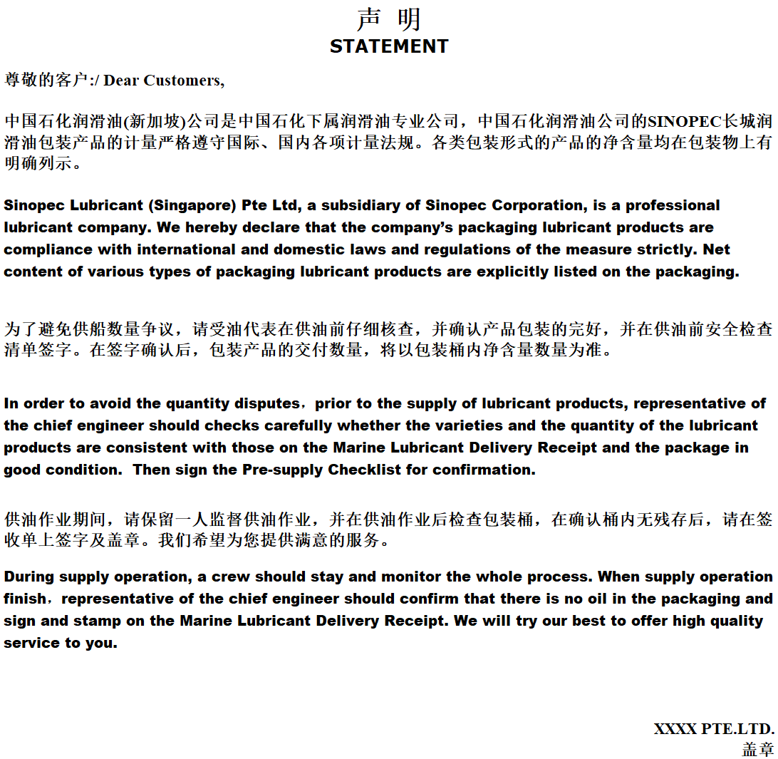

Annex II
Pre-supply Checklist
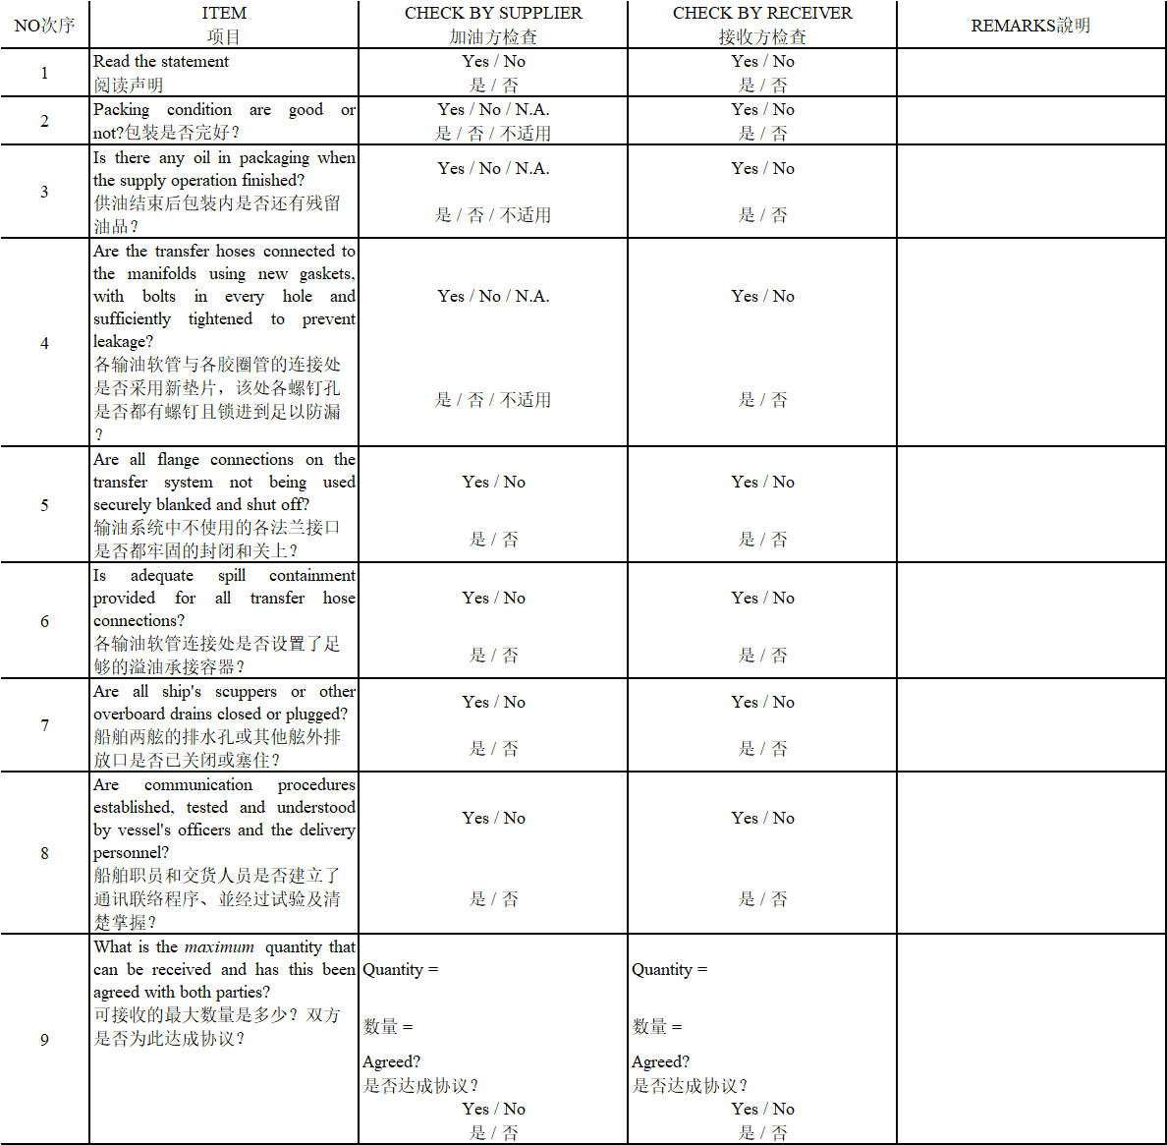

Annex III
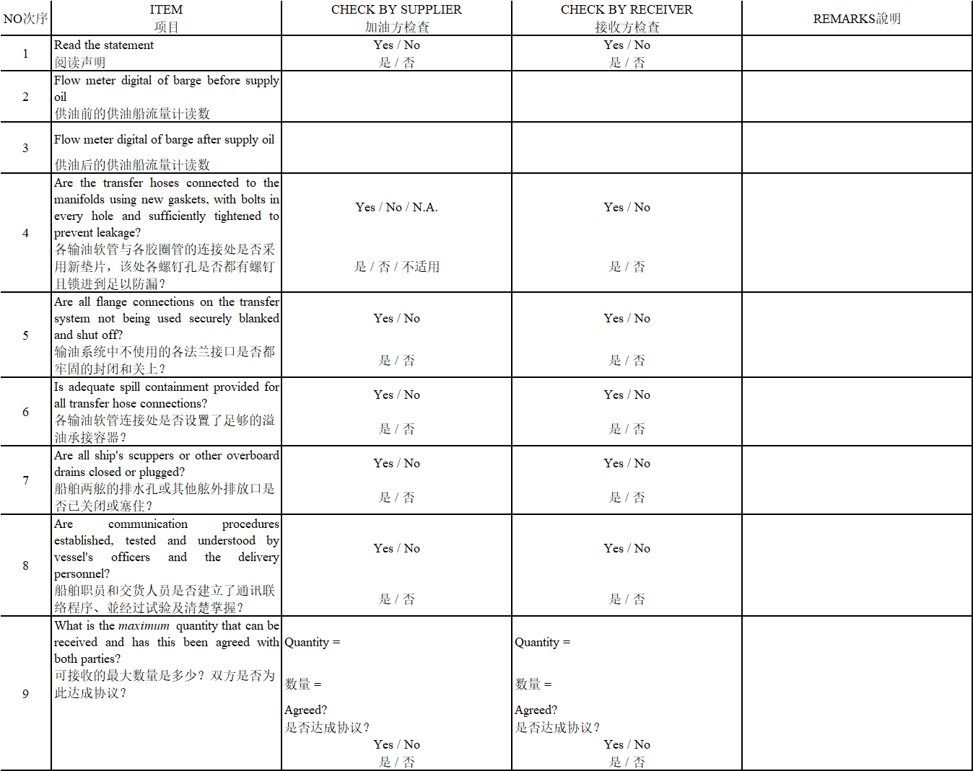

Annex IV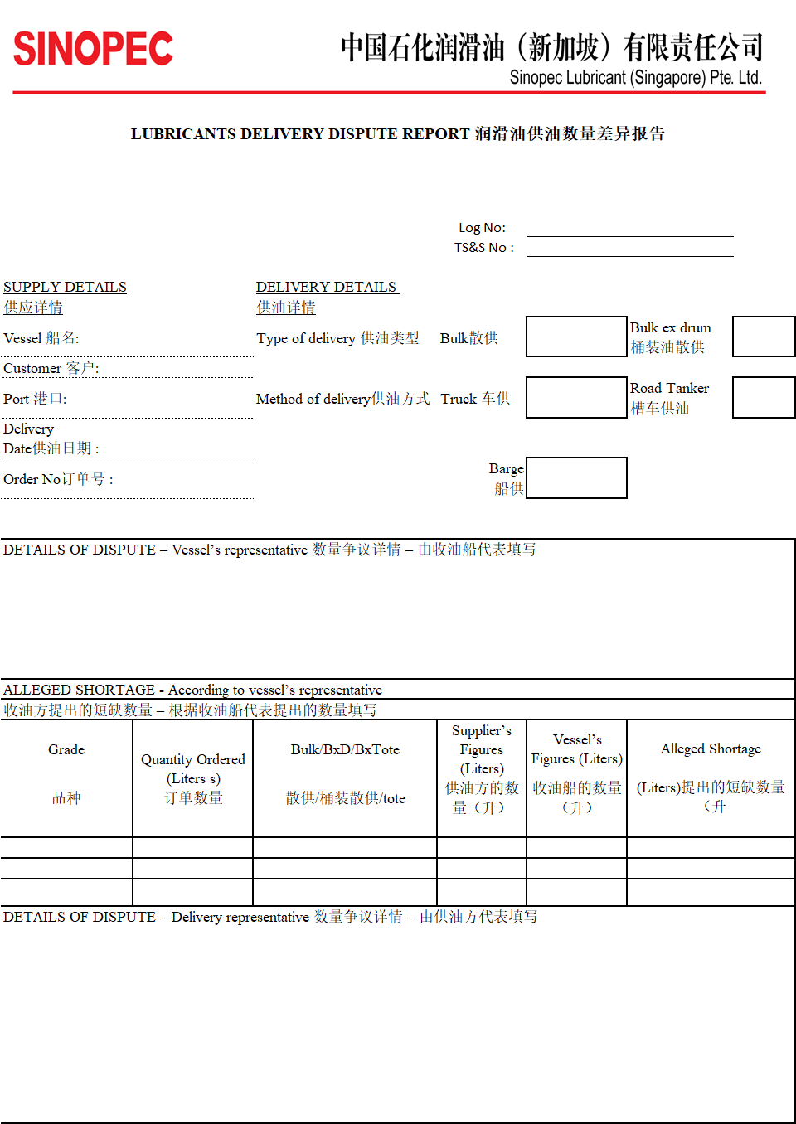
Annex V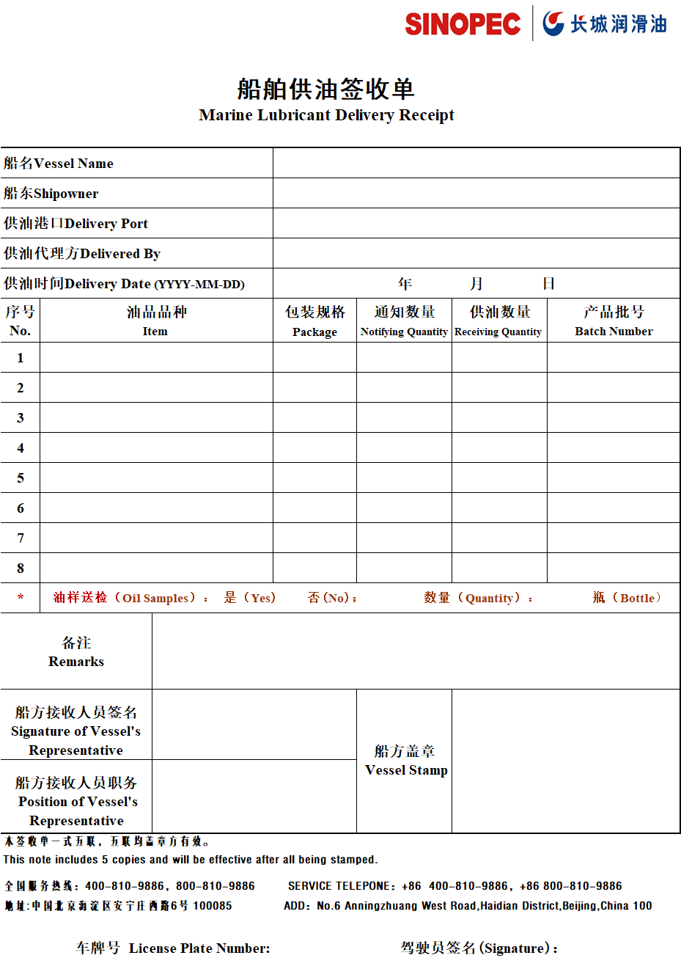

Annex VI
Oil Product Service Specifications
- Precautions for oil supply
  - The following documents shall be maintained available at the time of supplying the Products: Pre-supply Checklist
- Lubricants Delivery Dispute Report
- Marine Lubricant Supply Receipt
  - Pre-supply inspection process
    - Before supplying the Products, CONTRACTOR’s representative shall request the chief engineer of the oil receiving ship to collaborate in inspecting and accepting all the items listed in the Pre-supply Checklist.
    - Any Pre-supply Checklist already inspected shall be reserved for one (1) year.
    - Any Pre-supply Checklist already inspected shall be kept available and provided at any time on SINOPEC’s request.
- Safety precautions
  - Supply in Bulk
    - In case two or more varieties of Products are supplied, the order of supply shall be confirmed by the chief engineer or the representative of the chief engineer of the oil receiving ship; and any and all of the pipes shall be rechecked after connection to ensure correct connection before pumping the Products.
    - After correct connection of the pipeline, CONTRACTOR’s representative and the representative of the oil receiving ship shall recheck to ensure that the oil pipeline of the oil tanks of the oil receiving ship has been correctly connected, and to ensure that the correct variety of Products will be pumped into the oil tanks of the oil receiving ship.
    - Prior consent of the representative of the oil receiving ship shall be obtained before sweeping the pipeline to ensure that the ship has been fully prepared and to reduce the possibility of spilling of the Products.
  - Supply in Drums
    - CONTRACTOR’s representative shall ensure that net slings are used when lifting the Products onto the ship. The Drums of Products shall be correctly stacked in the net slings so as to prevent the drums from falling off the net slings or being dented by collision.
    - A sufficient number of guide ropes shall be used and tied to the net slings to control the movement of the net slings during the whole process of operation to avoid collision between the Products and ship.
- Supply Procedures
  - Bulk Oil
    - Metering of the Supplied Products
The quantity of the supplied Products must be equal to the readings of the flowmeter onboard. The flowmeter onboard shall be inspected and certificated regularly by a qualified institution, the original inspection certificate shall be in the possession of CONTRACTOR, and the copy thereof shall be deposited in the barge to serve as proof available for inspection by the oil receiving ship.

    - Oil Supply Procedures
      - After CONTRACTOR has received SINOPEC’s Marine Lubricant Delivery Notice, the quantity of the Products on the oil supply ship shall be checked to ensure that enough oil is available.
      - In case of failure to supply oil due to any of the following reasons, CONTRACTOR shall promptly notify the relevant personnel of SINOPEC.
- Faults of any engine, machine or pumping device
- Sudden change of the travel route of the oil receiving ship resulting in failure to supply oil
- Time delay of the oil receiving ship at the time of refueling
      - Prior to the supply of the Products, CONTRACTOR’s representative shall confirm with the chief engineer or the representative of the chief engineer of the oil receiving ship whether the varieties and the quantity of the Products are consistent with those on the Marine Lubricant Delivery Receipt. In case of any discrepancy, CONTRACTOR’s representative shall ask SINOPEC for instructions first, and proceed with the supply procedure after receiving instructions from SINOPEC. CONTRACTOR’s representative shall request the chief engineer of the oil receiving ship to check the initial readings of the flowmeter. In case the person in charge of the oil receiving ship refuses to inspect the initial readings of the flowmeter, CONTRACTOR shall be entitled to refuse to supply the Products.
      - Before supplying the Products, CONTRACTOR’s representative shall require the chief engineer or the representative of the chief engineer of the oil receiving ship to fill out the Pre-supply Checklist and sign thereon for confirmation.
      - In case of two or more varieties of the Products are supplied, CONTRACTOR’s representative shall ask the chief engineer or the representative of the chief engineer of the oil receiving ship for instructions of the sequence of supply. Under normal circumstances, varieties of low viscosity and lighter color shall be supplied first. Before supplying the Products, the chief engineer or the representative of the chief engineer of the oil receiving ship shall give clear instructions of the sequence and flowrate of supply, and shall clearly indicate such information on the Marine Lubricant Delivery Receipt and sign thereon for confirmation.
      - Consensus as to the following shall be reached by the relevant personnel of the oil supply ship and the oil receiving ship before pumping.
- starting and stopping steps
- emergency instructions and closing steps
- sequence and flowrate of supply
- communication channels
The party of the oil receiving ship shall designate a representative to board the oil supply ship to communicate with a crew member of the oil supply ship. CONTRACTOR’s oil supply ship shall designate a crew member of the oil supply ship to inspect the conditions of oil supply at the pipeline connection point of the oil receiving ship.
      - The chief engineer or the representative of the chief engineer of the oil receiving ship shall give instruction to CONTRACTOR’s representative as to the pipeline connection point of each variety of the Products. In case of any change of the choke and/or connection point of the oil receiving ship, CONTRACTOR’s representative shall clearly identify with the personnel of the oil receiving ship after connection before pumping. The above procedure is required for supplying each variety of Products to ensure that the oil receiving ship has been well prepared and is ready to receive oil supply. CONTRACTOR’s representative shall continuously supervise the whole process to ensure compliance with the sequence and quantity of oil supply agreed previously. After pumping each variety of oil, the remaining oil in the pipeline shall be cleaned and stored in a tank of the oil receiving ship before pumping another variety of oil.
      - The shortest possible pipeline shall be used on the oil supply ship to supply oil to minimize the amount of the remaining oil in the pipeline. After pumping each variety of oil, CONTRACTOR’s representative shall send out a notification for purging the remaining oil in the pipeline of the oil receiving ship.
      - After pumping each variety of oil, CONTRACTOR’s representative shall notify the representative of the oil receiving ship to check the readings of the flowmeter. On completion of the oil supply, the chief engineer or the representative of the chief engineer of the oil receiving ship shall sign on the Marine Lubricant Delivery Receipt and the Flowmeter Pre-/Post-supply Readings Sheet.
      - Two samples of the variety of the Products supplied in bulk each time shall be taken in accordance with the requirements of SINOPEC, the volume of each sample shall be 300ML, the sampling point shall be at the location of the flowmeter, and the each of the two lube oil samples taken shall be packaged, labeled and preserved by CONTRACTOR and the party of the oil receiving ship for one year. The labels on the sample bottles shall be in the following format:
Sampling records: ①sampling date ②product name(s) ③name of the oil receiving ship ④Number of the Marine Lubricant Delivery Receipt
      - On completion of the oil supply, the chief engineer of the oil receiving ship shall sign on and affix the ship seal thereof to the Marine Lubricant Delivery Receipt.
      - In case of any claim of shortage of the Products supplied, the person in charge of the oil receiving ship shall fill out the Lubricants Delivery Dispute Report provided by SINOPEC. CONTRACTOR shall promptly notify SINOPEC of such case and settle the measurement dispute with SINOPEC as arranged by SINOPEC.
  - Supply in Drums
    - Oil Supply Procedures
      - Before supplying the Products, CONTRACTOR’s representative shall deliver the Marine Lubricant Delivery Receipt to the chief engineer or the representative of the chief engineer of the oil receiving ship to verify whether the varieties and the quantity of the Products scheduled to be supplied are correct, and shall ask SINOPEC for instructions first in case of any discrepancy, and proceed with the supply procedure after receiving instructions from SINOPEC. And then CONTRACTOR’s representative shall request the chief engineer or the representative of the chief engineer of the oil receiving ship to check whether the sealing covers are intact to ensure that the Products are not damaged. The original sealing covers shall not be removed before inspection by the chief engineer or the representative of the chief engineer of the oil receiving ship.
      - Before supplying the Products, the representative of the supplying ship shall require the chief engineer or the representative of the chief engineer of the oil receiving ship to fill out the Pre-supply Checklist and sign thereon for confirmation.
      - A permitted and required crane shall be used by CONTRACTOR to lift the drummed Products to the deck of the oil receiving ship. In case of drop between the oil supply ship and the oil receiving ship, the crane of the oil receiving ship shall be used. Although the crane belongs to the receiving party, CONTRACTOR’s representative shall inspect whether the crane of the oil receiving ship can be used safely. In case CONTRACTOR’s representative reasonably believes that there are factors of insecurity in the crane of the oil receiving ship, CONTRACTOR’s representative may refuse further operation. At the same time, CONTRACTOR’s representative shall promptly report to the relevant personnel of SINOPEC for instructions.
      - On completion of the oil supply, the chief engineer of the oil receiving ship shall sign on and affix the ship seal thereof to the Marine Lubricant Delivery Receipt.
  - Procedures for Settling Disputes of Supply Quantity
In order to protect the interests and goodwill of SINOPEC, any and all the disputes arising out of and/or associated with the quantity of the supplied Products shall be settled in a positive attitude and a professional manner, and as many as possible documentary evidences shall be obtained for effective settlement.
The following procedures shall be applicable to any and all disputes associated with the supply quantity of the Sinopec (Great Wall) Lubricants in bulk and 200L drums and supplied by trucks and barges.
- Procedures
- On completion of the inspection of the items on the Pre-supply Checklist and prior to pumping, the chief engineer or the representative of the chief engineer of the oil receiving ship shall be requested to check the initial readings of the flowmeter and check the sealing covers of the 200L drums are intact. In case the chief engineer or the representative of the chief engineer of the oil receiving ship refuses to inspect the readings of the flowmeter and/or the sealing conditions, the personnel of the oil supply ship shall be entitled to refuse to supply the Products.
- In case of any dispute resulting from and/or associated with the quantity of supply in any circumstance, the reason(s) therefor shall be identified as soon as possible and as many as possible documentary evidences shall be obtained.
- In case of any dispute, CONTRACTOR’s representative shall promptly notify the relevant personnel of SINOPEC.
- The chief engineer of the oil receiving ship shall fill out, sign on and affix seal thereof to the Lubricants Delivery Dispute Report.
- In case the amount in the dispute is more than 200L, CONTRACTOR may entrust a third party approved by SINOPEC to board the ship for verification.
- Before completing all the procedures and instructions required by SNIOPEC, the connected pipes on the oil supply ship shall not be disconnected.
- Any and all disputes shall be reported to the following person of SINOPEC within twelve (12) hours:
Name: Becky Yong Sook Ching
Tel: 65-93854896
Email:lsookching.lube@sinopec.com

  - Filling and sending of the Marine Lubricant Delivery Receipt
    - Points to be noted when filling out the Marine Lubricant Delivery Receipt
- The supply method filled out the Marine Lubricant Delivery Receipt (by truck/by ship) and the means of transport used in the supply of the Products shall be the same.
- The scanned Marine Lubricant Delivery Receipt shall be clear and complete, in particular, the seal and signature by the receiving party shall be clearly visible.
- The Marine Lubricant Delivery Receipt filled out and signed by the receiving party shall not be altered without authorization, and additional necessary information shall be provided in the Remarks column.
- When supplying the SINOPEC (Great Wall) Marine Lubricants to a ship, the version of the Marine Lubricant Delivery Receipt provided by SINOPEC, the Sinopec Lubricant Company, shall be used, and the batch number of the Products supplied shall be recorded in the Product Batch Number column of the Marine Lubricant Delivery Receipt.
    - Sending of the Marine Lubricant Delivery Receipt
- Within three (3) working days after the Products are supplied, the ship-owner work sheet of the Marine Lubricant Delivery Receipt shall be scanned and sent by email to the following address: sookching.lube@sinopec.com.
- Within five (5) working days after the Products are supplied, at least two(2) sheets in the original copy of the Marine Lubricant Delivery Receipt and the Pre-supply Checklist shall be sent to of SINOPEC, wherein, the Financial Settlement sheet in the Marine Lubricant Delivery Receipt shall be sent to the following address as notified by SINOPEC.

Annex VII
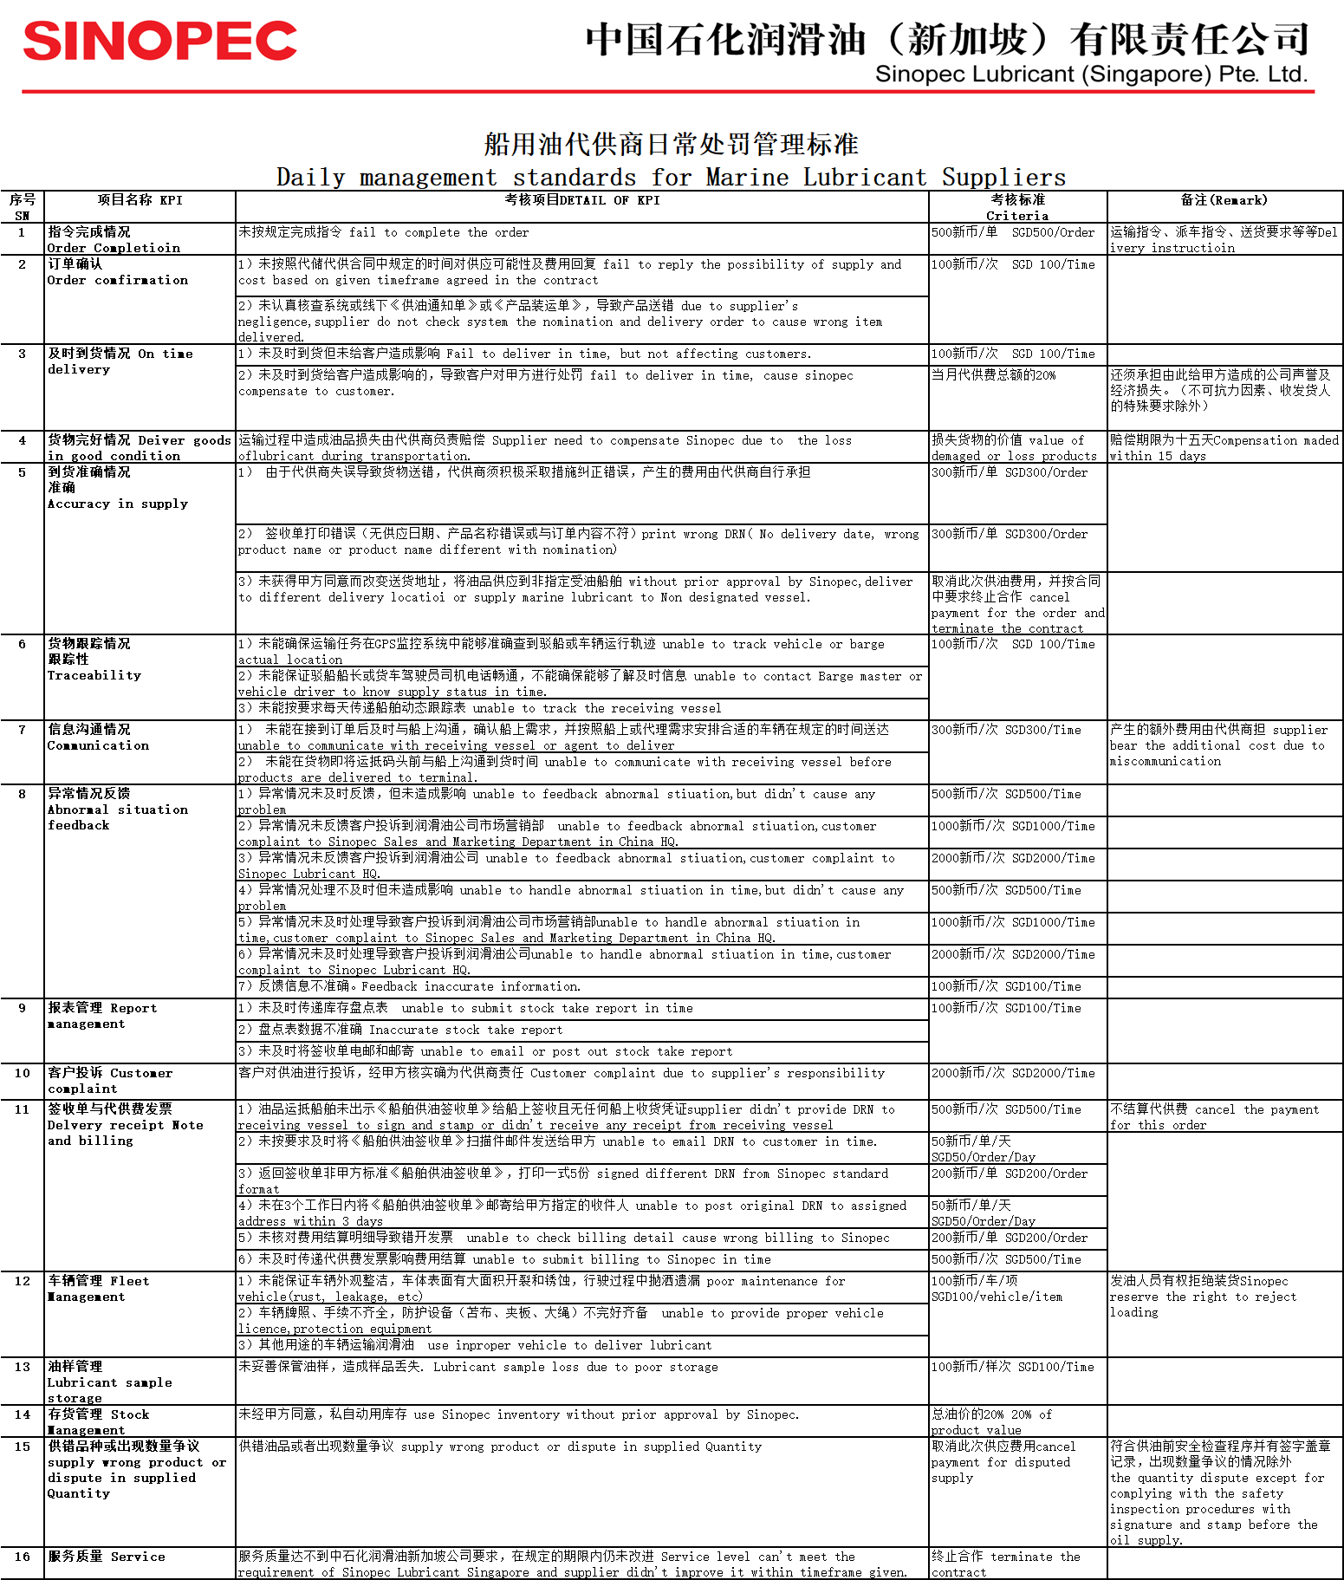

Annex VIII
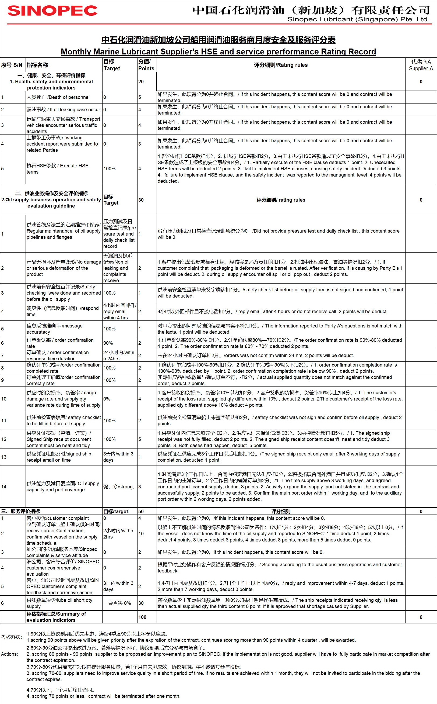
Annex IX