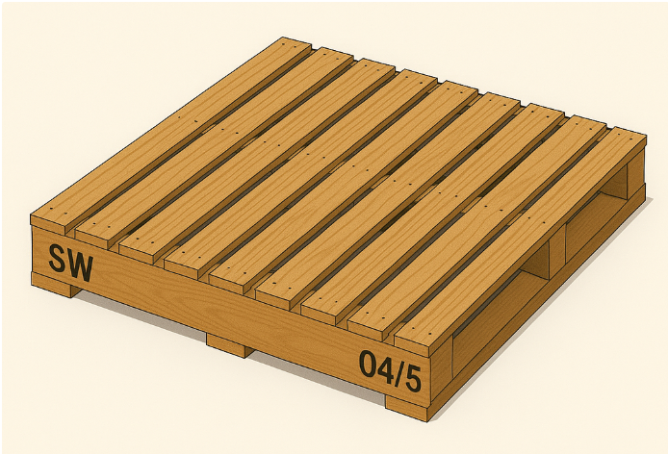
20
20
120
90
35
1143
20
90
1143
- Wooden Pallet 1143mm x 1143mm x 130mm
Wooden top planks: 1143L x 92W x 20H x 9 pcs
Wooden runners: 1143L x 38W x 90H x 4pcs
Wooden bottom planks: 1143L x 120W x 20H x 3 pcs
UOM: MM
Material: Mixed Hardwood (selected MHW for prolong outdoor storage)
Local SG Heat Treatment Required include 60 days warranty, IPPC stamp and certificate
Load weight: Min 3.8 MT / pallet
Surface: S4S Smooth sawn all sides
Weight: 25-30KG
Pallet marking : Company Abbreviation “XX” (Left of runner)
Pallet marking: Date “MM/YY” (Right of runner)

- Wooden Plywood 2311mm x 1143mm x 9mm
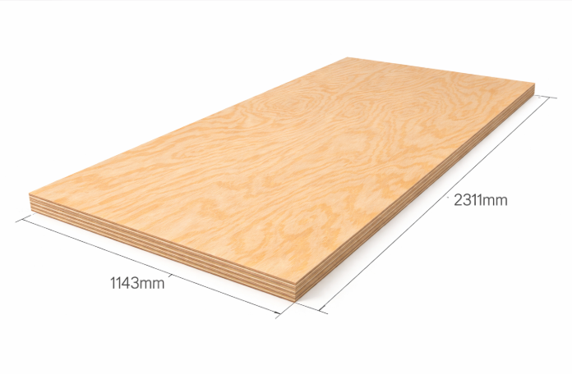
9mm

Weight: 10-12 KG
Material: BBCC plywood (BB-grade front face, CC-grade back face)
Local SG Heat Treatment Required include 60 days warranty, stamp and certificate
Stamp Requirements: SG IPPC Mark required on every single sheet of plywood
Surface: 1 sided Red face, water resistance, another white face
Moisture content: > 12%
Glue: MR/E2
With Sanding, closely filled inner fillings
Note * Plywood inner filling required to be filled tightly, loose inner filling is not accepted
Note * Plywood needs to be straight, delivered in wooden pallet base to ease unloading

3.Kubota plywood 900mm x 1040mm x 5.5mm (T)
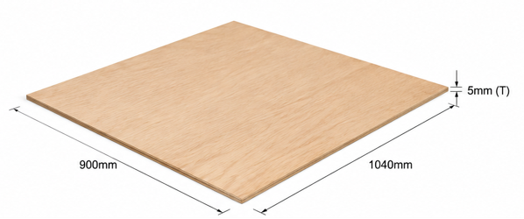
Weight: 5 KG
Material: BBCC plywood (BB-grade front face, CC-grade back face)
Local SG Heat Treatment Required include 60 days warranty, stamp and certificate
Stamp Requirements: IPPC Mark required on every single sheet of plywood
Surface: 1 sided Red face, water resistance, another white face
Moisture content : > 15%
Glue: MR/E2
No Sanding, hot pressing x 1 time
Note * Plywood inner filling requires to be filled tightly, loose inner filling is not accepted

4.Wooden stick 2438.4mm x 88mm x 38mm
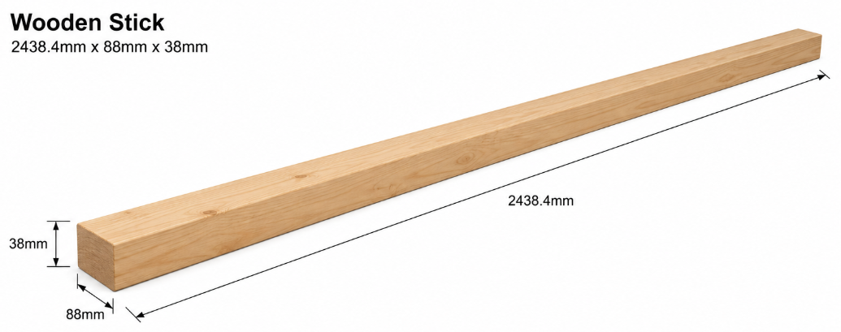
Weight: 10 KG
Material: Mixed Hardwood
Local SG Heat Treatment Required include 60 days warranty, stamp and certificate
Stamp Requirements: IPPC Mark required on every timber stick
Surface: Rip-Sawn S2S
Note * Timber needs to individually selected and wood need to be straight; bend wood will be rejected.

5.Wooden Stick 782.8mm x 88.9mm x 38.1mm
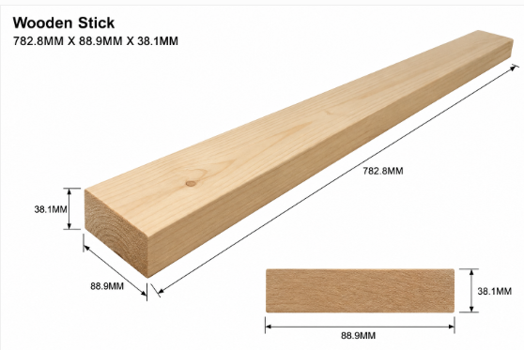
Weight: 5 KG
Material: Mixed Hardwood
Local SG Heat Treatment Required include 60 days warranty, stamp and certificate
Stamp Requirements: IPPC Mark required on every timber stick
Surface: Rip-Sawn S2S
Note * Timber needs to individually selected and wood need to be straight; bend wood will be rejected.

6.Wooden stick 2550mm x 88mm x 38mm
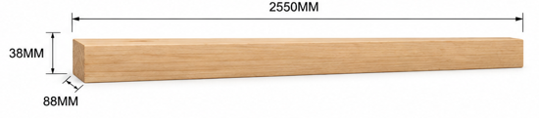
Weight: 10-12 KG
Material: Mixed Hardwood
Local SG Heat Treatment Required include 60 days warranty, stamp and certificate
Stamp Requirements: Every IPPC Mark required on every single timber stick
Surface: Rip-Sawn S2S
Note * Timber needs to individually selected and wood need to be straight; bend wood will be rejected.

