Supply Agreement

This Supply Agreement (this "Agreement") is made on this day of this month 2026.

BETWEEN:-

Toll-Blender : Toll-Blender
Registration No.:
Business Address:

AND
Sinopec : Sinopec Lubricant (Singapore) Pte. Ltd.
Registration No.: 201010257K
Business Address: 150 Tuas South Avenue 5 Singapore 637363

(Each a “Party”, and collectively the “Parties”).

- Supply of Product

  - TOLL-BLENDER agrees to produce, store, and deliver lubricant products (“Products”) to the place specified in Sinopec’s Order (as defined below) as mutually agreed by the Parties. The list of Products to be provided by TOLL-BLENDER is set out in Appendix 1.

  - TOLL-BLENDER will process the Products in accordance with Sinopec’s written order form, which will be submitted by Sinopec as and when Sinopec requires the Products (each an “Order”, collectively the “Orders”).

  - All purchases of Products shall be on a “made to order” basis. TOLL-BLENDER will ship or make available for collection all Orders for the Products, provided such Orders are placed by Sinopec.

  - TOLL-BLENDER shall be responsible for ensuring that Products are blended, produced, packaged, tested, stored and shipped in accordance with specifications and standards set out in Appendix 2.

  - TOLL-BLENDER shall purchase all packaging material from Sinopec’s approved vendors and ensure the handling process meets the specifications and standards set out in Appendix 2. TOLL-BLENDER shall verify the quality of such packaging material through inspections. TOLL-BLENDER shall reject packaging material that does not conform to the inspection standards. TOLL-BLENDER shall compensate Sinopec for all losses incurred as a result of any non-compliance with the specifications and standards stipulated in this contract.

  - TOLL-BLENDER is not allowed to sell any Sinopec Products or any part thereof for its own account. TOLL-BLENDER shall produce the Products under this Agreement only for Sinopec and strictly in accordance with Sinopec’s requirements and instructions.

  - Parties will work together on a trial basis first, without the provision of forecasts by Sinopec. Thereafter, Parties may, at their option, mutually agree in writing that Sinopec provide TOLL-BLENDER with forecasts of the likely demand of Products on a quarterly basis, with a tolerance limit of ±20% in terms of the forecasted quantity. These forecasts are indicative only and do not constitute a commitment to purchase the estimated demand.

  - The lead times for the Products shall be followed as per Appendix 5

  - TOLL-BLENDER shall use its best endeavors to fulfil any urgent Orders by Sinopec, subject to TOLL-BLENDER ’s confirmation of the Orders.

  - If new products need to be added to this agreement, Appendix 1 "List of Products" and Appendix 2 "Specifications and Standards" should be updated through an addendum.

- Delivery

  - TOLL-BLENDER shall deliver the Products in accordance with the applicable Incoterms® 2020 (“Applicable Incoterms”), delivery location and delivery date specified in Sinopec’s Order. Delivery shall occur at the point that risk in the Products passes in accordance with the Applicable Incoterms (“Delivery”). Time is of the essence for each delivery and TOLL-BLENDER shall use its best endeavors to meet Sinopec’s stated delivery dates.

  - Sinopec may choose whether to accept early, late, partial or excess delivery, within a tolerance of ± five (5) working days of the delivery date specified in Sinopec’s Order (“Tolerance Range”). Such acceptance by Sinopec will be given in writing. In the event that Sinopec chooses to accept late delivery, and TOLL-BLENDER is still unable to deliver the Products within the extended delivery period despite TOLL-BLENDER ’s best efforts, Sinopec may, at its sole discretion and upon documentary proof provided by TOLL-BLENDER to Sinopec’s satisfaction, agree in writing to grant a further extension of the delivery deadline (“Further Extension Period”). Sinopec may cancel all or part of any Order delivered outside the Tolerance Range or Further Extension Period (as the case may be), in which case Sinopec will not be liable for any costs and/or expenses arising out of and/or in connection with such non-acceptance of delivery and/or cancellation of Order. TOLL-BLENDER bears the risk of loss of all Products delivered in advance of or after the Tolerance Range or Further Extension Period (as the case may be) and Sinopec may dispose of, store or return such Products at TOLL-BLENDER ’s sole cost and expense.

  - Based on the receipt of the order, TOLL-BLENDER will confirm the order to Sinopec and share the expected readiness date based on the delivery date shared by Sinopec within one to four (1 to 4) working days from receipt of order date.

  - Invoicing model is to be followed as ‘bill to ship to model’ for all Ex-works, CFR,CIF, DAP and DDP shipments. Bill to ship to model is defined in Appendix 4.

- Risk and Title

  - The applicable Incoterms will govern the passing of risk in all Products.

  - Title to Products will pass to Sinopec on the earlier of: (a) payment for the Products; or (b) Delivery.

- Prices

  - The prices for the Products in respect of selected Incoterms® 2020 shall be as set out in Appendix 3. Unless the Applicable Incoterms provide to the contrary, the prices shall include all delivery, packaging and insurance costs.

  - For orders placed by Sinopec based on Quarterly pricing, following shall apply:

    - POs placed before 20th of the last month of the Quarter: For POs placed with TOLL-BLENDER before 20th of the last month of the Quarter, if the delivery is done in the same month as per the Expected Shipment Date mentioned on the PO, then same month rate will apply. If the delivery is done on the first month of the next Quarter (Spill over orders) as per the Expected Shipment Date mentioned on the PO, then, the rate of first month of the next Quarter will apply.

    - POs placed after the 20th of the last month of the Quarter: For PO’s placed with TOLL-BLENDER after the 20th of the last month of the Quarter, if TOLL-BLENDER is able to deliver in the same month, then same month rate will apply. If the delivery is done on the first month of the next Quarter (Spill over orders), the rate of first month of the next Quarter will apply. Additive and packaging rates are locked in a Quarter. Any change to be implemented will be based on the letter received from the suppliers on the same.

  - As the invoices will be issued in USD by TOLL-BLENDER, the payment from Sinopec to TOLL-BLENDER will be in USD. For the First Quarter (trial run), monthly spot rate will be provided once the forecast is received from Sinopec. For subsequent quarters after the First Quarter, TOLL-BLENDER shall quote the prices for the Products in respect of selected Incoterms® 2020 (as requested by Sinopec) for the destination ports provided by Sinopec on a quarterly basis, on the 25th of the last month of the previous quarter. The new prices will only take effect after Sinopec gives its written acceptance of the same. If Sinopec objects to the proposed price changes, the Parties shall negotiate in good faith to find an acceptable compromise. Before the Parties arrive at a compromise, TOLL-BLENDER shall continue supplying the Products to Sinopec in accordance with the prices of the previous quarter.

- Term of Agreement

This Agreement shall commence on day of month 2026 and shall continue in effect for a period of two (2) years until day of month 2028. On the expiry of the term of this Agreement, the Parties to this Agreement may, subject to mutual consent, renew this Agreement in writing on such terms as the Parties may mutually determine.

- Payment Terms

  - TOLL-BLENDER will issue an invoice for all Orders for which Delivery has been completed during the month at the end of each month by e-invoice delivered to an e-mail address provided by Sinopec (an “Invoice”).

  - Sinopec will verify the Invoice before accepting the Invoice for payment. Sinopec will confirm with TOLL-BLENDER by email that the Invoice has been verified and that payment will be arranged.

  - The payment terms are as follows:

Mode of payment | TELEGRAPH TRANSFER
Payment timeframe | Payment will be made thirty (30) days from the date of the Invoice.
Method of settlement | Direct payment from Sinopec to TOLL-BLENDER in USD.
TOLL-BLENDER ’s bank details | Account:  Bank Name:  Bank Branch:  Currency: USD  Account No.:  IBAN No.:  Swift Code:

6.4. If there is a dispute as to the quantity and/or quality of the Products, Sinopec will withhold payment arising out of and/or in connection with the Products in dispute until the said dispute is resolved. To avoid any doubt, Sinopec shall pay the undisputed part of the invoices.

- Taxes

7.1 Each Party shall be responsible for meeting all taxes applicable to it in its jurisdiction.

7.2 The Party responsible for the necessary taxes or duties for the shipping of the Products shall be as set out in the applicable Incoterm® for the shipment of the Products.

7.3 All prices for the Products shall be exclusive of applicable goods and services tax, value-added tax or any other applicable sales tax and payment of such taxes shall be made in accordance with the applicable laws.

- Quality Control & Formulations

  - TOLL-BLENDER agrees to supply Products meeting Sinopec’s specifications. Sinopec shall notify TOLL-BLENDER of any change in the specifications at least three (3) months prior to the change taking effect.

  - TOLL-BLENDER shall be responsible for product blending and filling in accordance with the specifications and standards approved by Sinopec.

  - TOLL-BLENDER shall inspect each batch of Products in accordance with the quality standards and inspection methods approved by Sinopec. TOLL-BLENDER shall provide Sinopec with product inspection reports and certificates of analysis on each batch of Products in a timely manner.

  - TOLL-BLENDER warrants that for a period of twelve (12) months after blending by TOLL-BLENDER, subject to Clause 1.4, the quality of the Products will:
- meet Sinopec’s requirements in terms of workmanship and materials; and
- Conform to Sinopec’s specifications.

  - Unless there are obvious errors, including but not limited to typographical errors in the product name and/or the batch number and/or errors in the testing method, the Parties shall be bound by the Product inspection report. In the event that a Party raises any objection to the inspection results, the objecting Party shall immediately appoint an independent inspection agency with ISO/IEC 17025 certification and shall be mutually agreed upon by both parties to conduct inspections in accordance with the inspection specifications, and the inspection results shall be regarded as the final results. If the difference between the product inspection report and the final inspection result is not within the reasonable margin of error (outside the repeatability and reproducibility limits specified in the applicable ASTM/IP/ISO test method), the inspection fees shall be borne by TOLL-BLENDER. Otherwise, the inspection fees shall be borne by Sinopec. If the product quality is confirmed by an independent inspection agency to be inconsistent with the inspection results stated in the Product Certificate of Analysis, TOLL-BLENDER shall indemnify Sinopec for all inspection costs, and all direct losses thereby as mentioned in Clause 13.

  - TOLL-BLENDER shall cooperate with quality control personnel and third-party auditors appointed by Sinopec to inspect the production process as and when requested by Sinopec with prior notice of 14 days. If there are issues with the production process, Sinopec will provide recommendations and suggestions to TOLL-BLENDER, and TOLL-BLENDER shall cooperate in good faith in the implementation of Sinopec’s recommendations and suggestions. TOLL-BLENDER shall also propose suggestions for improvement to ensure product quality.

  - For product quality complaints and customer complaints, TOLL-BLENDER shall actively cooperate with Sinopec to resolve the problem, including by going to the customer site. TOLL-BLENDER shall be fully responsible for all direct losses as mentioned in Clause 13 arising out of and/or in connection with quality problems caused by TOLL-BLENDER. In case customer complaint is not due to quality issues from TOLL-BLENDER, Sinopec will bear all travel related expenses of TOLL-BLENDER representative(s).

Sinopec will only carry out spot checks of the Products on delivery for identity, quantity (number of pack pieces) and for transport damage clearly recognizable on the packaging exterior. Recognized deficiencies will be raised as soon as practicable after delivery, while concealed deficiencies related to the packaging/leakage shall be raised within two (2) months of delivery. If there are problems such as leakage, packaging damage, or product quality, the products need to be returned to TOLL-BLENDER, and all relevant costs shall be borne by TOLL-BLENDER. TOLL-BLENDER will not be responsible for any complaints related to the product performance raised after (1) Calendar year from the date of manufacturing.

  - TOLL-BLENDER shall pass ISO 9001 quality management system certification and ensure that the certificate remains valid. TOLL-BLENDER shall ensure that it has sufficient funds and personnel to invest in product quality improvement and stability as well as technological progress.

- Health, Safety and Environment (HSE)

Each Party shall ensure that performance of its obligations under this Agreement shall meet quality, health, safety and environment standards as required by the applicable laws and regulations.

- Intellectual Property

  - Nothing herein shall grant TOLL-BLENDER any right, title or interest in Sinopec’s intellectual property (including but not limited to trademarks, patents, technical information or other trade secrets) owned or used by Sinopec or its associated organizations. TOLL-BLENDER acknowledges that the aforementioned rights are exclusive to Sinopec. TOLL-BLENDER shall not at any time acquire or claim any right in the aforementioned intellectual property, regardless of whether the intellectual property rights are registered.

  - TOLL-BLENDER shall not make use of any of the packaging materials carrying trademarks, trade names, logos, designs or color schemes of Sinopec, technological formulae, patents, technical information, or other trade secrets provided by Sinopec to TOLL-BLENDER for the purpose of this Agreement on any products and/or services without Sinopec’s authorization. Sinopec may withdraw its consent to TOLL-BLENDER’s usage of the aforesaid content at any time at Sinopec’s sole discretion. At no time during the term of this Agreement or at any time thereafter shall TOLL-BLENDER challenge or assist others in challenging Sinopec’s intellectual property including but not limited to trademarks and patents, or the registration thereof, or attempt to register any trademarks, patents, or other intellectual property confusingly similar to those of Sinopec.

  - TOLL-BLENDER shall bear all direct or indirect losses caused to Sinopec and/or defend, indemnify, and hold Sinopec harmless from any loss, damage, claim or liability arising from and/or in connection with TOLL-BLENDER ’s breach of this Clause 10 or any part thereof.

- Confidentiality
  - Prior to the execution of this contract and during the term of this Agreement, either Party may disclose non-public information (the “Confidential Information”) to the other Party from time to time. Once the Party receives the Confidential Information, the Parties shall, in perpetuity:

    - hold and keep secret and in confidence any and all such Confidential Information, and not release any Confidential Information to any third party without prior written approval from other Party;

    - not make use of the Confidential Information or any part thereof except for and solely for the purposes specified in this Agreement;

    - use the same degree of care but no less than a reasonable degree of care as it would use to prevent the unauthorized use, dissemination and republication of the Confidential Information as the Party uses to protect its own confidential information;

    - ensure that only such of its directors, officers, advisors, employees or agents (collectively referred to as “Representatives”) whose duties require them to possess the Confidential Information shall have access to the Confidential Information provided always that such access shall strictly be to the extent and on a “need-to-know” basis only. Each of such Representatives shall be informed of the contents of this contract by the Parties and it shall be the responsibility of the Parties to ensure compliance of the contents of this contract by each employee and to restrain such Representatives from any prohibited or unauthorized disclosure or use of the Confidential Information. In any event, any default or breach by a Party’s Representatives of any term in this clause shall be deemed a default or breach by that Party;

    - ensure that the Confidential Information will not be copied or reproduced in any form whatsoever by the Parties or their Representatives or any other third party without the express written permission of the owner of the Confidential Information, except for such copies and to such extent as may be necessary for the performance of this Agreement;

    - after the expiry or termination of this Agreement (or upon the request of the Party owning the Confidential Information at any time), whichever is earlier, the Parties shall return or procure the return to the other Party (or destroy upon the other Party’s request) all the materials (including their copies) that contain and/or are based on the Confidential Information, whether supplied to or reproduced by either Party or its Representatives. Within ten (10) days of such a request, the relevant Party shall provide a written assurance to the Party that owns the Confidential Information that the aforementioned materials have been returned or destroyed.

    - immediately inform the Party that owns the Confidential Information of any loss of confidentiality, unauthorized disclosure, misappropriation, or misuse by any person of any Confidential Information or part thereof, upon either Party having knowledge of the same; and

    - take, at the expense and under the control of the Party that owns the Confidential Information or any other party designated by that Party, any action, including but not limited to legal proceedings, reasonably required to prevent or stop the unauthorized disclosure or use of the Confidential Information or any part thereof by any of the other Parties’ Representatives, or by any third party who has gained access to the Confidential Information or any part thereof due to the fraudulent, willful or negligent act or omission of either the other Party or any of its Representatives or the failure by the other Party or any of its Representatives to perform any of its obligations hereunder.

11.2 For the avoidance of doubt, nothing in this Agreement or any disclosure of Confidential Information grants, explicitly or implicitly, any license, title, ownership, or right of any kind under any patent, trademark, copyright, trade secret, or other intellectual property right to the Receiving Party.

11.3 The Parties agree that any breach or threatened breach of this Clause 11 will cause irreparable harm to the Disclosing Party, for which monetary damages are inadequate. Accordingly, the Disclosing Party is entitled to seek immediate injunctive relief and specific performance to prevent or stop any breach, in addition to any monetary damages or other legal remedies available under the law or this Agreement.

- Indemnity and Compensation

  - TOLL-BLENDER shall complete the production and delivery of the Products according to Sinopec’s requirements as set out in this Agreement.

  - In the event that there are any delays in production and/or non-compliance of the Products or any part thereof with Sinopec’s requirements as set out in this Agreement caused by TOLL-BLENDER (save for situations in which the Force Majeure clause in this Agreement is properly invoked by TOLL-BLENDER), Sinopec has the right to refuse to accept the Products in question and decline to make payment of any sums in connection with the production, packaging and delivery of the said Products. TOLL-BLENDER shall bear the corresponding costs of disposal of such Products. Without limitation to the foregoing, in the event that TOLL-BLENDER breaches its obligations in this Agreement, TOLL-BLENDER shall, at Sinopec’s discretion, compensate and/or fully indemnify and hold Sinopec harmless from and against any and all direct losses, damages, liabilities, costs and expenses of whatsoever kind or nature which arise out of and/or in connection with such breach.

  - TOLL-BLENDER shall indemnify Sinopec and be liable for any bodily injuries and/or damage to property suffered by any third party as a result from the proper use of any Products that do not conform to the standards as set out in this Agreement due to any fault of TOLL-BLENDER .

  - TOLL-BLENDER shall, at Sinopec’s option and at TOLL-BLENDER ’s sole cost and expense, take back any and all Products and replace them with compliant Products within thirty (30) days from Sinopec notifying TOLL-BLENDER about the non-compliant Products and providing a third-party inspection report to verify that the non-compliance arises as a result of TOLL-BLENDER ’s fault.

  - Sinopec shall defend, indemnify and hold TOLL-BLENDER harmless from and against any liability, loss, damage, cost and expense (including without limitation reasonable attorneys’ fees) suffered as a result of any successful claim, action or suit raised against TOLL-BLENDER that TOLL-BLENDER ’s use of Sinopec’s trademark, artwork or design under this Agreement infringes any third-party intellectual property right. This commitment is conditioned upon TOLL-BLENDER: (i) providing Sinopec with prompt written notice of the claim; (ii) giving Sinopec sole control of the defense to the claim including settlement negotiations (if any); and (iii) providing reasonable assistance as requested by Sinopec in the defense or settlement of the claim. Under this commitment, Sinopec shall indemnify TOLL-BLENDER for the payment of: (i) any damages awarded by any competent court by way of a final decision, and (ii) reasonable attorneys’ fees (if any).

- Direct Losses
13.1 For the avoidance of doubt, the Parties agree that TOLL-BLENDER 's liability for direct losses, damages, liabilities, costs and/or expenses under this Agreement shall be strictly limited to the following exclusive remedies: (i) free of cost replacement of the specific defective products. (ii) Arranging for the return of the defective products to TOLL-BLENDER factory. In the event that the Products do not pass any quality checks by the relevant authorities due to defects in quality caused by TOLL-BLENDER, TOLL-BLENDER shall be responsible for providing the relevant authorities with the necessary clarifications.

13.2 For avoidance of doubt, “Defective or Non-Compliant product” refers to Product dispatched that is not aligned with the agreed specifications of Sinopec. If there are requirements specific to a certain country (“Country Specific Product Requirements”), Sinopec will share such requirements with TOLL-BLENDER. If TOLL-BLENDER fails to comply with the Country Specific Product Requirements, TOLL-BLENDER will be liable for the relevant losses as set out in this Agreement. However, if Sinopec does not share any Country Specific Product Requirements, TOLL-BLENDER will not be liable for any losses arising out of any non-compliance with these requirements.

13.3 Exclusion of Consequential Damages Notwithstanding any other provision in this Agreement, neither Party shall be liable to the other for any indirect, incidental, special, punitive, or consequential damages, including but not limited to loss of profit, loss of revenue, loss of business opportunity, third-party claims, or any damage to machinery or equipment, regardless of whether such damages were foreseeable.

- Assignment

No assignment, cession or transfer of any right or obligation arising under this Agreement shall be made by either Party to a third party without the prior written consent of the other Party. Otherwise, such assignment, cession or transfer shall not be valid and/or effective.

- Amendment

  - Any supplements, changes and/or amendments to the contents of this Agreement shall be negotiated and finalized by the Parties, and a supplementary agreement or deed shall be signed. Any such supplementary agreement or deed signed by both Parties shall be in written form, formally signed by both Parties’ representatives, and be effective after being stamped with the official seals or stamps of the Parties.

  - In the event of any conflict between the terms of this Agreement and the terms of the supplementary agreement or deed, the supplementary agreement or deed shall prevail.

- Termination

  - In addition to the right of termination provided for in other clauses of this Agreement, this Agreement may be terminated as follows:-

    - by mutual written agreement;

    - by either Party, if the other Party commits a material breach of its obligations and such other Party does not cure such breach within thirty (30) calendar days after receipt of written notice by the non-breaching Party specifying the breach and asking for it to be remedied;

    - should either Party be declared insolvent, or be the subject of proceedings for insolvency, liquidation or dissolution, or cease to carry on business or lack ability to pay its debts as they become due, this Agreement may be terminated by the other Party; and

    - by either Party, without cause, by three (3) months written notice.

  - Upon the occurrence of an event described in Clause 16.1.2, the Party relying on its right to terminate may, if the specified breach has not been cured in the given period, give written notice to the other Party stating the ground upon which it is seeking to terminate this Agreement, and this Agreement shall be terminated immediately upon the issuance of such termination notice.

  - Upon the occurrence of an event described in Clause 16.1.3, this Agreement shall terminate immediately upon written notice from the non-defaulting Party.

  - Any termination by either Party hereof shall not have any effect on each Party’s rights, liabilities and obligations, to the extent accrued prior to termination.

- Force Majeure

  - Neither Party shall be liable to the other Party for any failure to perform its obligations hereunder to the extent that such failure is caused by an event unforeseeable and beyond the affected Party’s reasonable control, without the affected Party’s fault or negligence, including but not limited to actions by any governmental authority (whether valid or invalid), fires, floods, windstorms, explosions, riots, natural disasters, wars and sabotage (“Force Majeure Event”).

  - In the event that there is a Force Majeure Event that prevents either Party from performing its obligations under this contract, the affected Party shall immediately inform the other Party of such Force Majeure Event (including the anticipated duration of the delay) and use its best endeavors to avoid or mitigate the effect of such Force Majeure Event.

  - A Party successfully invoking this clause is relieved from its duty to perform its obligations under this Agreement and from any liability in damages or from any other contractual remedy for breach of contract, from the time at which the impediment causes inability to perform, provided that the notice thereof (which should include sufficient proof of the Force Majeure Event) is given without delay, and in any event no more than ten (10) calendar days after the Force Majeure Event occurs. If such notice is not given without delay, relief is effective from the time at which notice thereof reaches the other Party. The other Party may suspend the performance of its obligations, if applicable, from the date of the notice.

  - Where the effect of the impediment or event invoked is temporary, the consequences set out under the paragraph above shall apply only as long as the impediment invoked prevents performance by the affected Party of its contractual obligations. The affected Party must notify the other Party as soon as the impediment ceases to impede performance of its contractual obligations and resume its performance of this Agreement thereafter.

  - The affected Party is under an obligation to take all reasonable measures to limit the effect of the event invoked on the performance of this contract. If requested by the other Party in writing, the affected Party shall, within five (5) calendar days after the other Party’s request, provide adequate assurances that the delay in the affected Party’s performance resulting from such event will not exceed thirty (30) calendar days.

  - In the event that: (i) the Force Majeure Event lasts for more than thirty (30) calendar days; (ii) the delay in the affected Party’s performance resulting from such event lasts more than thirty (30) calendar days, or (iii) the affected Party does not provide such adequate assurances, either Party shall have the right to terminate this Agreement with thirty (30) calendar days advance notice.

- Appendixes

All Appendixes annexed to this Agreement are integral parts of this Agreement and have the same effect as the terms of the main body of this Agreement.

- Dispute Resolution

  - Any dispute arising out of or in connection with this Agreement, including any question regarding its existence, validity or termination, shall be settled through friendly negotiation. In case no settlement can be reached within thirty (30) days of such negotiation, the dispute shall be referred to and finally resolved by arbitration administered by the Singapore International Arbitration Centre (“SIAC”) in accordance with the arbitration rules of the SIAC for the time being in force, which rules are deemed to be incorporated by reference in this Clause 19.1.

  - The seat of the arbitration shall be Singapore. The Tribunal shall consist of one (1) arbitrator. The language of the arbitration shall be English.

  - The decision made by the Tribunal shall be final and binding upon both Parties, and the fees for arbitration shall be borne by the losing Party unless otherwise awarded by the Tribunal.

- Governing Law

This Agreement shall be governed by and construed in accordance with the laws of Singapore.

- Notice

  - Any notice to be given under this Agreement (including but not limited to all orders, order confirmations and other written documents or notices under this contract) shall be delivered: (i) in person; (ii) by registered mail; (iii) by email; or (iv) by fax in accordance with the Parties’ respective addresses below:

  - Notices to Sinopec shall be sent to:
Attention: Yeu Chai Fen
Address: 150 Tuas South Ave 5, Singapore 637363
Tel.: +65 6499 7018
Email: chaifen.lube@sinopec.com

Notices to TOLL-BLENDER shall be sent to:
Attention:
Address:
Tel.:
Email:

  - The address of either Party for the purpose of notices or communications under this Agreement may be amended by giving advance written notice to the other Party.

- Sanctions and Anti-Corruption

22.1 None of the Parties, their legal/beneficial owners, their subsidiaries (if any), nor (to the knowledge of the respective Party) any of their respective officers, directors or employees, is the subject or target of any sanctions administered by the United Nations Security Council, the European Union, the Office of Foreign Assets Control of the U.S. Department of the Treasury, Singapore, United Arab Emirates or China (collectively, “Sanctions”), nor are the Parties located, organized or resident in a country or territory that is the subject or target of broad and comprehensive countrywide or territory-wide sanctions administered by the United Nations, European Union, United States, Singapore, United Arab Emirates or China. Either Party shall be entitled to terminate this Agreement immediately upon written notice to the other Party if, at any time, the contents of this clause or any part thereof proves to have been or becomes untrue.

22.2 Each Party shall procure its officers, directors, employees, representatives, affiliates, consultants and/or advisors to comply with the applicable anti-corruption laws applicable to the relationship between them.

22.3 For the avoidance of any doubt, nothing in this Agreement shall require TOLL-BLENDER to ship any Products to any country or territory that is the target of broad and comprehensive countrywide or territory-wide Sanctions. TOLL-BLENDER will inform Sinopec in writing within one to three (1 – 3) working days from the date of receipt of Sinopec’s order of TOLL-BLENDER’s inability to accept such an order.

22.4 TOLL-BLENDER represents, warrants, and undertakes that it shall not engage, subcontract with, or otherwise enter into any contractual relationship with any subcontractor, vendor, supplier, or other third party in connection with the performance of this Agreement, who is, or is owned or controlled by, a target of any Sanctions. TOLL-BLENDER shall conduct appropriate risk-based due diligence prior to engaging any such third party, and shall maintain ongoing monitoring throughout the term of this Agreement to ensure continuous compliance with this Clause. Any breach of this sub-clause shall entitle Sinopec to terminate this Agreement immediately upon written notice.

- Miscellaneous

23.1 Entire Agreement. This Agreement contains the entire agreement between the Parties relating to the subject matter of this Agreement and supersedes all previous agreements, contracts, letters of intent, memorandum of understanding, etc. between the Parties relating to the subject matter.

23.2 Severability. The invalidity of any provision of this Agreement shall not affect the validity of any other provision of this Agreement.

23.3 No Waiver. The failure of any one of the Parties to exercise, or the delay in the exercise of, the rights, powers or privileges under this Agreement shall not be construed as a waiver of such rights, powers or privileges unless there is an express written waiver of such rights, powers and privileges. Any individual or partial exercise of such rights, powers or privileges shall not hamper the future exercise thereof.

23.4 Third Party Rights. A person who is not a party to this Agreement has no right under the Contracts (Rights of Third Parties) Act (Cap 53B) of Singapore to enforce any term of this Agreement.
IN WITNESS whereof the Parties hereto or their duly authorized representatives have duly executed this contract the day and year first above written.

Signed by )
Designation )
for and on behalf of )
TOLL-BLENDER ) Company Stamp

Signed by )
)
)
for and on behalf of )
SINOPEC LUBRICANT (SINGAPORE) PTE. LTD )
Company Stamp

廉洁从业责任书
Agreement on Business Ethics and Principles

甲方：中国石化润滑油（新加坡）有限责任公司
Party A: SINOPEC LUBRICANT (SINGAPORE) PTE. LTD.

乙方： TOLL-BLENDER
Party B: TOLL-BLENDER

为规范甲乙双方的商业行为，维护公平竞争，经双方协商，签订本责任书。
For the purpose of regulating business activities and maintaining the fair competition, after kind negotiation, Party A and Party B herein agree to sign this Agreement on Business Ethics and Principles as follows:
第一条 任何一方应严格遵守双方注册地或主要住所地所在国有关反对商业贿赂和廉洁从业的各项法律规定，严格履行双方签订的合同或协议，恪守商业道德和正当竞争的市场行为准则，共同营造公平公正的商业交易环境。
Article 1. Either party shall strictly comply with relevant laws and regulations of anti-commercial bribery and business of ethics and principles of both parties’ register locations or their main domiciles of their own country. Party A and Party B shall strictly execute any contracts or agreements signed by and between them, adhere to commercial morality and code of market conduct, to jointly build a fair and impartial business environment.
第二条 甲方应禁止本公司员工、代理人利用职务之便，向乙方及其相关单位和人员索要或接受折扣费、中介费、佣金、礼金、有价证券、支付凭证、贵重物品等任何好处；不得参加乙方及其相关单位安排的可能影响公平交易的宴请及健身、娱乐等活动；不得向乙方及其相关单位和人员提出超出工作范围之外的，可能影响公平交易的事项或要求。乙方发现甲方及其员工、代理人有违反本责任书规定的，应当予以拒绝，并及时向甲方监察部门通报。
Article 2. Party A shall prohibit any of its employees and agencies from taking advantages of their positions to request or accept discount fees, agency fees, commissions, gift-money, marketable securities, disbursement voucher, costly presents or any other valuable goods and services from Party B or any other relevant companies and personnel; and shall prohibit them from attending any banquets, gymnastic activities, entertainment or any other activities arranged by Party B or relevant companies which may affect the fair execution of business between Party A and Party B. Party A shall not make any requirements or demands on Party B or any other relevant companies or personnel that are beyond the working scope and may affect the fair execution of business between both parties. If Party A, its personnel and agencies are found to break rules of this Agreement, Party B shall reject those requirements or demands and report timely to Party A’s inspection and supervision department.
第三条 乙方应禁止本公司员工、代理人及其相关单位和人员，给予或允诺、暗示给予甲方员工、代理以折扣费、中介费、佣金、礼金、有价证券、支付凭证、贵重物品等任何好处；不得安排有可能影响公平交易的宴请、健身、娱乐等活动；不得为甲方员工、代理及其特定关系人提出的超出工作范围之外的，可能影响公平交易的任何事项提供便利。
甲方发现乙方及其相关单位和人员有违反本责任书规定的，有权选择索赔或在本公司、本公司控股企业及其关联企业内给予通报、限制或禁止与其交易的处理。
Article 3. Party B shall take all necessary measures to prevent its employees, agencies, relevant companies and personnel from offering, promising, or implying presenting discount fees, agency fees, commissions, gift-money, marketable securities, disbursement voucher, costly presents or any other valuable goods and services to Party A’s employees and agencies; and shall not arrange any banquets, gymnastic activities, entertainment or any other activities which may influence the fair and impartial execution of business between Party A and Party B; and shall not offer any improper convenience which is beyond the working scope and may affect the fair execution of business between both parties to Party A’s employees, agencies and special related person.
If Party B, or its relevant companies and personnel are found to violate the rules of this Agreement, Party A will be entitled to request the compensation, or to give notification among Party A, its holding companies and relevant enterprises, and to restrict or prohibit Party B to do business with Party A.
第四条 本责任书经双方签署后生效。甲乙双方签订交易合同的，本责任书作为交易合同附件，与交易合同具有同等法律效力；未签订交易合同的，本责任书独立有效。
Article 4. This agreement will come into effect as soon as it is signed by Party A and Party B. If contracts are signed by both parties, this agreement shall be deemed as the appendix of the contracts and have the same legal effect as that of the contracts; if no contracts have been signed by and between both parties, this Agreement shall be valid independently.
第五条 甲乙双方及其人员在商业活动完成后，发生或发现违反本责任书规定的行为，按本责任书规定处理。
Article 5. Party A, Party B and their personnel should conform to this Agreement strictly, and should be governed by this Agreement after the business activities are fulfilled.
第六条 本责任书以中文和英文书就，中文内容与英文内容之间的任何不一致，以英文内容为准。
Article 6. This agreement has been made out in both
Chinese and English versions. In case of any divergence of interpretation, the English version shall prevail.
第七条本责任书一式两份，甲乙双方各执一份，具有同等法律效力。
Article 7. This Agreement is made in two copies, one copy to be held by each party, and each copy is legally of equal effect.

甲方单位：中国石化润滑油（新加坡）有限责任公司
Party A: SINOPEC LUBRICANT (SINGAPORE) PTE. LTD
姓名/Name:
职称/Designation:
电话/Telephone Number:
日期/Date:
签名和公章/Signature and company stamp:

乙方单位： TOLL-BLENDER
Party B: TOLL-BLENDER
姓名/Name:
职称/Designation:
电话/Telephone Number:
日期/Date:
签名和公章/Signature and company stamp:
Appendix Agreement

Appendix 1 List of Products

S/N | Product Code | Product Name | Pack Size
1 | 0609100063003543 | SINOPEC\TULUX T500 E7/CI-4 15W-40 Diesel Engine Oil | 200L DRUM
3 | 0609160060204871 | SINOPEC\L-HM 68 Anti-Wear Hydraulic Oil | 200L DRUM

Appendix 2 Specifications and Standards
Inspection Specification of Products, Packaging Material Standard, and Product Packing Standard.

- OBJECTIVE

The objective of this appendix is to detail Sinopec's technical requirements for TOLL-BLENDER’s production, storage, and delivery of lubricant products to the place specified in Sinopec’s Order. TOLL-BLENDER shall ensure that these products meet the requirements set out in this appendix.

- GENERAL REQUIREMENTS

  - Raw materials

The raw materials used include base oil, additives, and packaging materials.

  - Raw material management requirements

    - The specification of raw materials used are agreed by both parties and shall not be amended without the written consent of Sinopec.
    - TOLL-BLENDER is responsible for collecting the MSDS and PDS of the base oil and additives. MSDS and PDS can be provided when requested by customers or Sinopec.
    - TOLL-BLENDER shall inspect each batch of base oil. The base oil can only be used after passing the tests set out in Section 3 of this appendix below.
    - TOLL-BLENDER shall ensure that the raw materials are used within the expiry date according to the first-in first-out principle.
    - TOLL-BLENDER shall ensure that every batch of the finished products is traceable, and keep proper blending, filling and raw material usage records for a minimum period of three (3) years.

  - Drum specification

  - Reference Regulations

All drums used must be new drums. Recycled drums are unacceptable.
The drums used must meet the following standards:
    - ISO 15750-2; 2002(E)
    - BS 814-1:1987
    - EN 210:1986
    - ANSI MH2-1997 & ANSI MH2a-1998

  - Description

The cylindrical packaging must be made of cold rolled steel, the ends of which are permanently fixed to the body with opening for filling, emptying, and venting in the head. Drums must have 3 corrugations on the upper and lower parts of drum body.

  - Material of Construction

The body and ends of the drum must be of steel sheet CR1 commercial quality cold rolled steel, as per ISO 3574:1986; JIS G3141 SPCC-SD or equivalent. Sheet thickness: 0.9 mm + 7% for body and ends.

  - Construction Type

The longitudinal seam of the body is welded. The body and ends are to be seamed in a triple seam (round) construction with a non-hardening (natural or synthetic rubber) seaming compound.

  - Additional Features

Two Rolling Hoops (Beads) in “W” style expanded & rolled into the body; external diameter of the rolling hoop will not exceed 585 mm.

  - Closures

- Tri-sure or equivalent
- Flanges: One each of 2” & 3/4th inch zinc plated flanges with black nitrile gasket fitted to the top of the drum diametrically opposite to each other.
- Other gaskets may be used as per customer’s requirement.
- Plugs (bungs – plain white): 2” & 3/4th inch zinc plated plugs with black nitrile gaskets screwed onto the respective flanges to the torque specified by the closure manufacturer. Other gaskets may be used as per customer’s requirement.

  - Dimensions

Internal diameter is 571.5 mm + 1 mm ; External height is 883 mm + 3 mm ; Distance between beads 280 mm + 2 mm ; Distance between beads to end 300 mm + 2 mm ; Diameter over top/bottom seams 585 mm + 1 mm.

  - External Coating

Painted with a single coat of Stoving Paint of minimum 15 micron Dry Film Thickness, red and white colors confirmed by Sinopec are used in the designated positions of the drums to ensure that there will be no obvious fading and rust within 6 months (without scratches on drum body with exception of top and bottom drum rings due to handling of drum) when put in outdoor storage. The Sinopec Red color code is RED MSP8201 and the Sinopec White color code is WHITE MSP8202. The final color for drum body shall conform to the approved actual color sample provided by Sinopec.

  - Internal Lining/Finish

Unlined/Plain

  - Approved UN/Other marking

1A1/X1.5/290/**/SGP/BL 007 (** is the year of manufacture)

  - Weight

The weight specification must be 15.8 Kg + 7% (may vary subject to variation in steel thickness).

  - Drawing
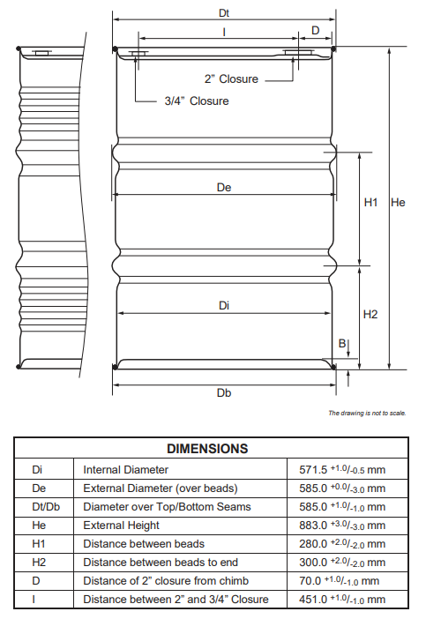

  - Artwork
The artwork of drum body must meet the following requirements: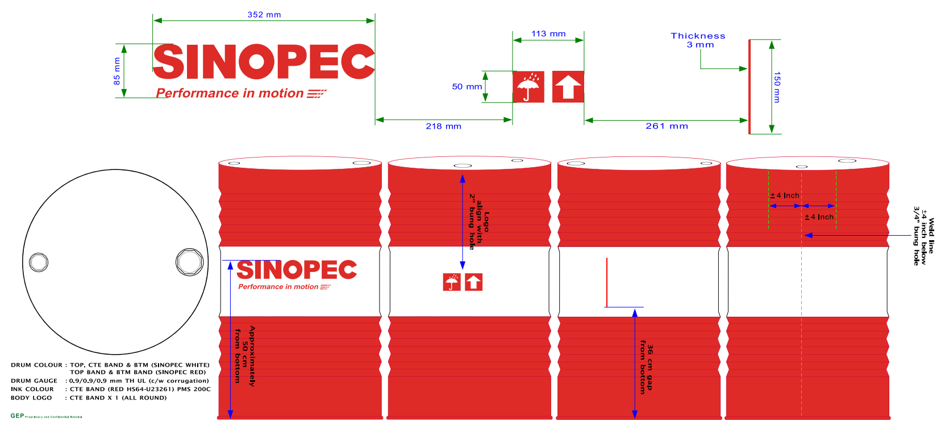

  - Product volume and weight requirements

Each product must fulfill the weight of specification with acceptance tolerance as stated below:
- 1000L: Net Volume: 1000L ± 0.5%
- 200L: Net Volume: 200L ± 0.5%
- 18L: Net Volume: 18L ± 0.5%

  - Marking and labeling requirements

- The label must not fade when stored outdoors for a period of six (6) months. The ink printed on the label must last for a period of at least six (6) months under outdoor conditions and not be easily wiped off. If any concerns arise within 6 months of product dispatch, TOLL-BLENDER will arrange for additional labels to be dispatched to the distributor with the consent of Sinopec.
- All products of Sinopec with different weight specification of 20L/200L/1000L must fulfill the universal label requirement（F version, label dimension is 190mm X 220mm, content to be confirmed by Sinopec）as stated below:

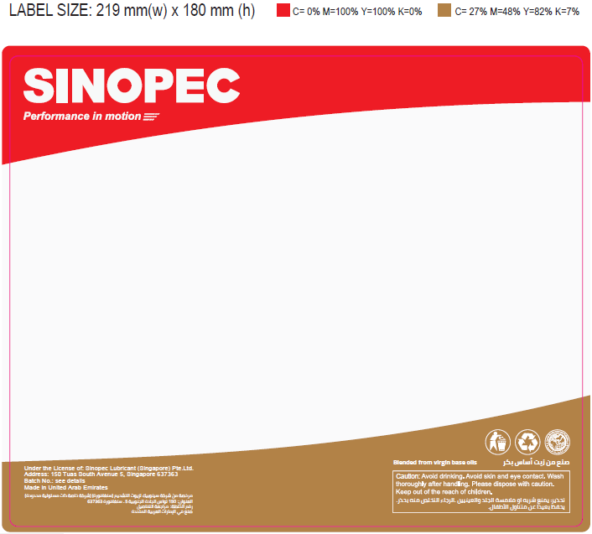
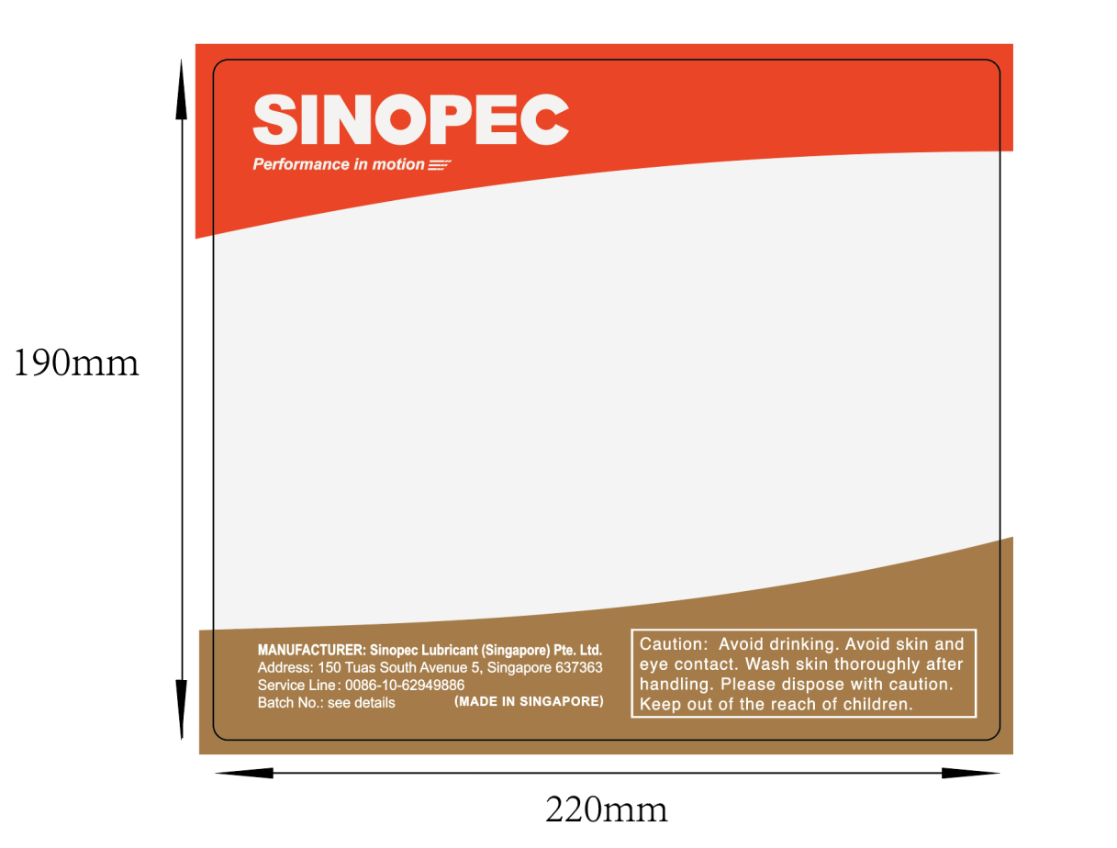
Size specification and company information of general label for Sinopec products

2.6.3 Label template for 200L and 1000L SINOPEC products
The batch number rules for conventional lubricating oil products on top and side of 200L drums are shown in the following Templates and Notes:


Label template for 200L Sinopec products (Side of drum body)
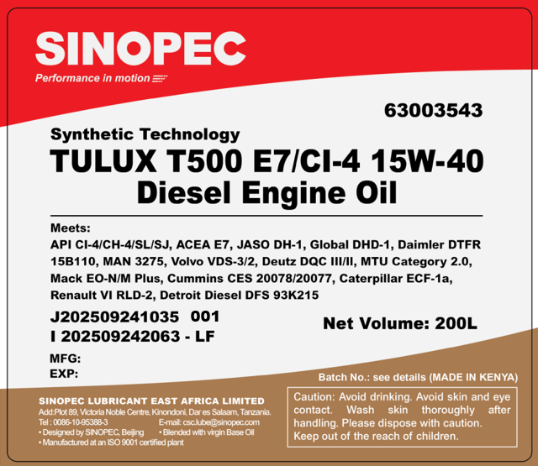
Label template for 200L Sinopec products (Top of drum)

Notes:
- Product code (last 8 digits): 63003543 for Diesel Engine Oil T500 E7/CI-4 15W-40
- First line of Blending Batch no. J202509241035 001
J: Custom code (change quarterly), 202509241035: Blending date (8 digits, YYYYMMDD), 1035: Blending tank (4 digits, as per agreement with TOLL-BLENDER on coding）, 001: Sequence number (required only on drum top label, side label sequence number not required),
- Second line of Filling Batch no. I202509242063 – LF :
I: Custom code (change quarterly), 202509242063: Filling date (8 digits, YYYYMMDD), 2063: Filling line (4 digits, as per agreement with TOLL-BLENDER on coding), LF: Place of origin number, Singapore factory (2 digits). TOLL-BLENDER needs to decide 2 digits of place of origin number and informs Sinopec.
- MFG: production date (6 digits, MM/YYYY). EXP: expiration date (6 digits, MM/YYYY), 5 years from production date.
- TOLL-BLENDER will follow the approved drum label sample provided by Sinopec.

2.6.4 Labeling Position Requirements

The position of labeling on the top and body of the drum are shown below:
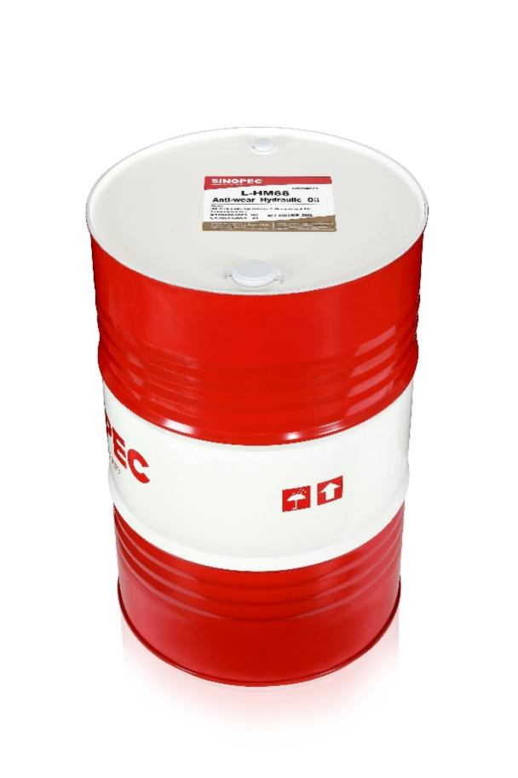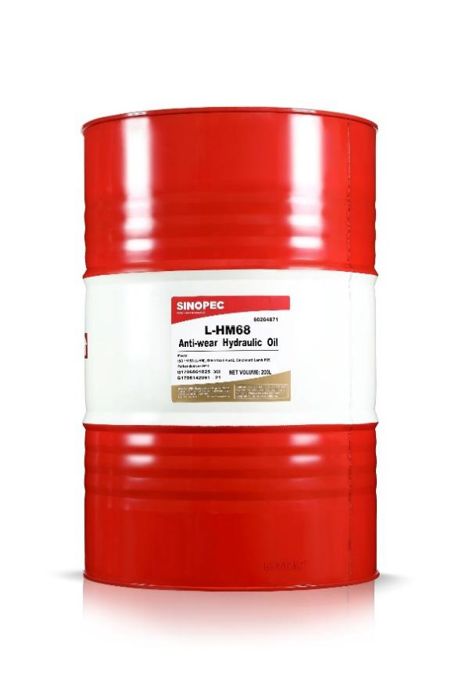
  - Requirement for Certification of Analysis (COA)

TOLL-BLENDER is responsible for the analysis of the data required for the COA of each batch of products. The provided data must be analyzed using analytical instruments within the validity period of the inspection to ensure the accuracy of the data; the analyzed data shall be recorded using the COA template provided by Sinopec (refer to below template). Sinopec will issue the COA.
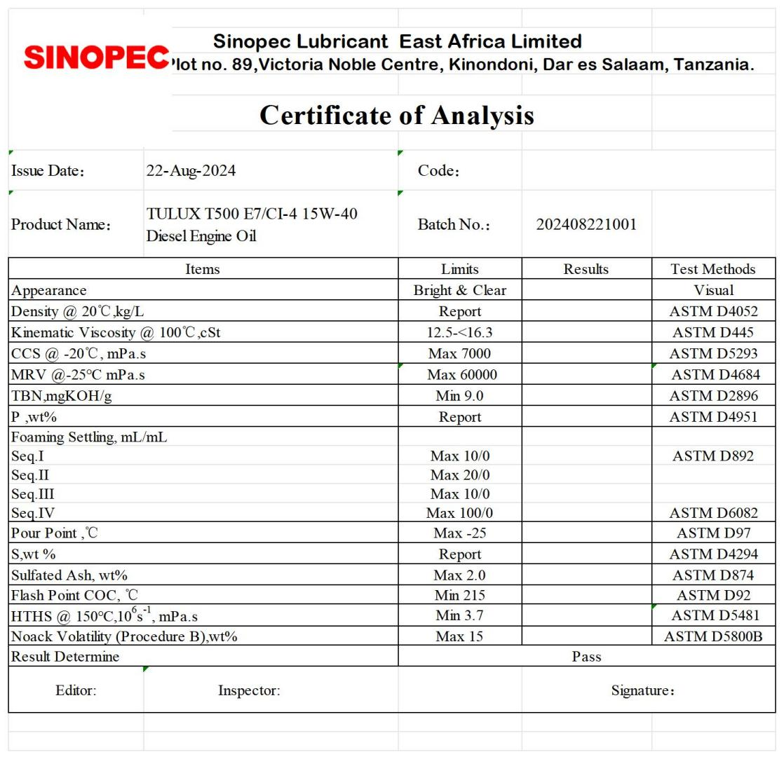
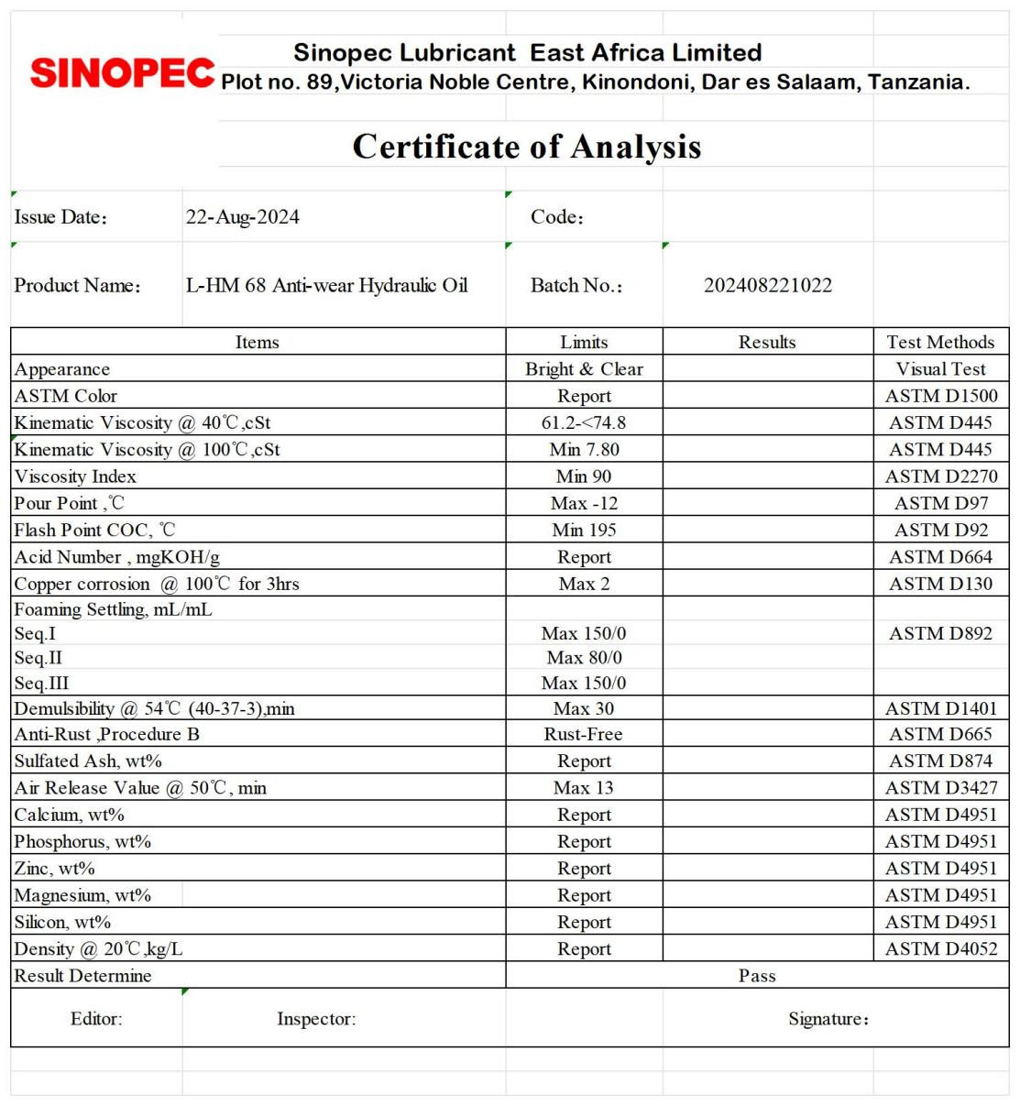

  - Requirement for Certification of Origin (COO)

TOLL-BLENDER is responsible for the provision of the COO for every batch of products.

  - Requirements for retention of oil sample

- Container

The containers for product samples must have uniform specifications and sizes. Samples with poor stability to light should be kept away from light. TOLL-BLENDER shall ensure that the sample container which is transparent does not affect the product performance.

- Amount of retention sample and period of sample retention

TOLL-BLENDER shall retain samples as follows:

Item | Amount of retention sample | Period of sample retention
Finished products | 1L | At least 2 years
Base oil | 1L | At least 1 year
Additives | 200ml | At least 2 years
First article | 250ml | At least 2 years

  - Requirements for production

Full inspection must be carried out for the first three batches for each product during trial production in accordance with the specification set out in Section 3 of this appendix below at both parties premises.
- TOLL-BLENDER
- Sinopec (Required TOLL-BLENDER to ship 2L sample each batch)

    - Product inspection will be conducted every 6 months (June & December) to ensure the consistency of testing results. TOLL-BLENDER will be required to perform full inspection for all products and prepare 2L sample for each product to Sinopec Singapore premise and bear the relevant postage fees.

    - TOLL-BLENDER should be able to provide production record and inspection record if requested.

  - Warehouse management

    - The product must not be damaged during the warehousing and logistics process, and the outer packaging must be well intact, ensuring that the product delivered to the customer is well intact and in good, clean, and dry condition, and meets specifications and requirements. Production is made on order and should be collected by no later than 5 days after collection notice from TOLL-BLENDER.

    - Products shall be shipped according to the first-in first-out principle and all the documents including tally sheet, delivery order and any other related documents must use templates provided by Sinopec, and all the documents mentioned above must be retained for at least one year.

    - Container loading should follow principle below:

- Cargo with pallet
4 drums on one pallet must be wrapped together with stretch film to avoid moving and shifting during transportation. Pallet cost will be added to the final price of products.
For 20’ container, the total load shall be 80 drums (4 drums x 20 pallets).
For 40’ container, the total load shall be 124 drums (4 drum x 31 pallets).

- Cargo without pallet (loose packaging)
For 20’ container, the total load shall be 80 drums (bottom layer 40 drums; top layer 40 drums) and a total of 5 pieces of plywood should be applied between the top and bottom layer. Four drums should be loaded in one row. After loading 2 rows (total 8 drums) at bottom layer, place plywood on top of those 8 drums. Then, continue to load another 8 drums on its top. Repeat this procedure until the container is fully loaded.

For 40’ container, it shall be loaded with a total of 130-140 drums, depending on container loading weight limit (bottom layer 80 drums; top layer 50-60 drums) and a total of 8 pieces of plywood should be strapped in place. Four drums should be loaded in one row. The remaining 2 drums should be placed at the last row of top layer. A total of 6 pieces of plywood should be placed between the top and bottom layer. Another 2 pieces of plywood are required to be placed 90 degrees at the end of top layer. Then, straps shall be used to fasten the upright plywood.

    - Pictures shall be taken during the process of loading and unloading in accordance with Section 4 and such evidence shall be retained for at least one year. The method of loading and unloading with or without pallets is set out in Section 4 (Loading and Unloading Instructions).

- PRODUCT SPECIFICATIONS AND TESTING METHODS

  - Base oil to be used for the blending of finished lubricant

- Base oil sample testing list (batch wise) - will be tested by blender for every new batch of base oil received, which will be used to blend Sinopec finished lubricant, as per agreement with Sinopec.

Base oil typical data
Supplier 1:
Item | Method | Unit | Typical Data
Item | Method | Unit | 150N GII |  | 220N GII |  | 600N GII
 |  |  | Spec. | Typical | Spec. | Typical | Spec. | Typical
ASTM Color | ASTM D1500 |  | Max 0.5 | L0.5 | Max 0.5 | L0.5 | Max 0.5 | L0.5
Viscosity @ 40℃ | ASTM D445 | ㎟/s |  | 28.81 |  | 49.38 | - | 107.05
Viscosity @ 100℃ | ASTM D445 | ㎟/s | 5.0~5.5 | 5.23 | 7.0~8.0 | 7.23 | 12.0~12.9 | 12.04
Viscosity Index | ASTM D2270 |  | Min 100 | 113 | Min 98 | 105 | Min 95 | 102
Pour Point | ASTM D6749 | ℃ | Max -12 | -17 | Max -12 | -16 | Max -12 | -14
Flash Point, COC | ASTM D92 | ℃ | Min 200 | 220 | Min 222 | 235 | Min 246 | 271
Noack Volatility | ASTM D5800 | wt% |  | 13.8 |  | 6.8
Aromatics | ASTM D3238 | wt% | Max 1.0 | 0 | Max 1.0 | 0 | Max 1.0 | 0
CCR | ASTM D189 | wt% | Max 0.01 | L0.01 | Max 0.01 | L0.01 | Max 0.01 | L0.01
TAN | ASTM D974 | mgKOH/g | Max 0.01 | 0.004 | Max 0.01 | 0.003 | Max 0.01 | 0.004

Supplier 2:
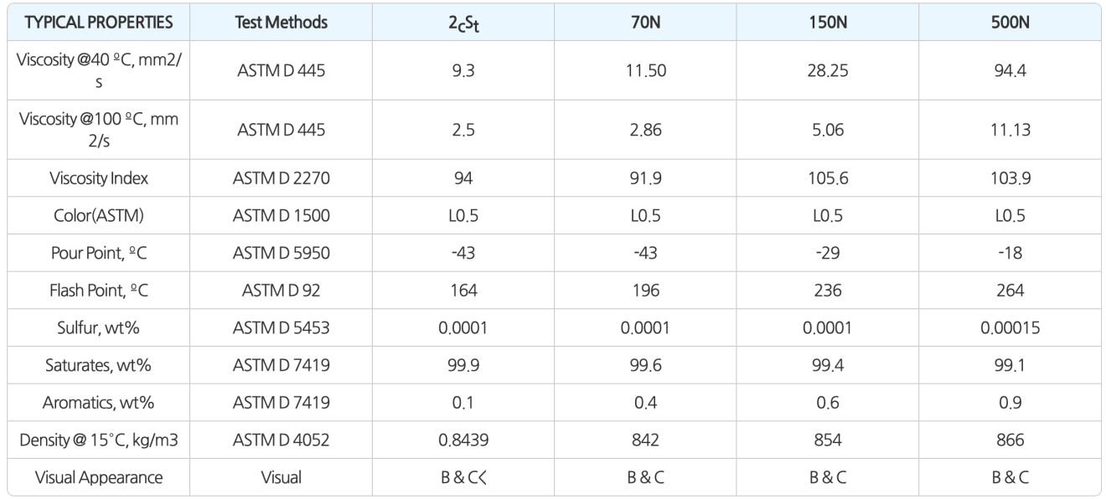

Supplier 3:
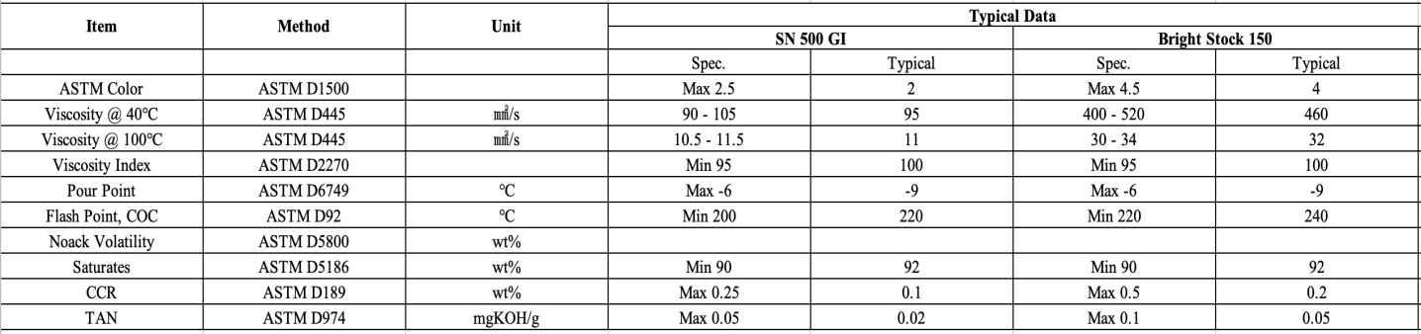

  - Specification

    - SINOPEC\TULUX T500 E7/CI-4 15W-40 Diesel Engine Oil

Formulation (From TOLL-BLENDER)
Product Description | Base Oil | Additive | VI Improver
TULUX T500\E7/CI-4 15W-40 Diesel Engine Oil

COA of finished product
Items | Limits | Test Methods | Test Frequence
Appearance | Bright & Clear | Visual Test | A
Density(20℃),kg/m³ | Report | ASTM D 4052 | A
Kinematic Viscosity(100℃), mm²/s | 12.5～<16.3 | ASTM D 445 | A
CCS(-20℃), mPa.s Max | 7000 | ASTM D5293 | A
MRV(-25℃), mPa.s Max | 60000 | ASTM D4684 | B
HTHS (150℃, 10⁶s⁻¹ ), mPa.s Min | 3.5 | ASTM D 4683 or ASTM D 4741or ASTM D 5481 | B
Pour Point, ℃ Max | -25 | ASTM D 97 | E
Flash Point(COC),℃ Min | 215 | ASTM D 92 | B
Foaming Settling, mL/mL  Sequence I Max  Sequence II Max  Sequence III Max | 10/0  20/0  10/0 | ASTM D 892 | C
Evaporative Loss (Noack,250℃,1h),%(m/m) Max | 15 | ASTM D 5800 | B
TBN, mgKOH/g | Report | ASTM D 2896 | A
Sulfated Ash, %(m/m) | Report | ASTM D 874 | B
Sulfur,%(m/m) | Report | ASTM D 2622 or ASTM D 4951 | B
Phosphorus,%(m/m) | Report | ASTM D 4951 or ASTM D 5185 | C
Kinematic Viscosity after 30 Pass Shearing(100℃), mm²/s Min | 12.5 | ASTM D6278 | B
Notes: A means Every Batch
B means Every Year
C means Every Ten batches
    - SINOPEC\L-HM 68 Anti-Wear Hydraulic Oil

Formulation (From TOLL-BLENDER)
Product Description | Base Oil | Additive | VI Improver
L-HM 68 Anti-Wear Hydraulic Oil

COA of finished product
Items | Limits | Test Methods | Frequency
Appearance | Bright & Clear | Visual Test | A
Colour , grade | Report | ASTM D1500 | B
Kinematic Viscosity(40℃), mm²/s | 61.2～74.8 | ASTM D445 | A
Kinematic Viscosity(100℃), mm²/s Min | 7.80 | ASTM D445 | A
Viscosity Index Min | 90 | ASTM D2270 | A
Pour Point, ℃ Max | -12 | ASTM D97 | C
Flash Point(COC), ℃ Min | 195 | ASTM D92 | B
Acid Number, mgKOH/g | Report | ASTM D664 | B
Copper corrosion(100℃, 3h)，grade Max | 2 | ASTM D130 | D
Foaming Settling, mL/mL  Sequence Ⅰ Max  Sequence Ⅱ Max  Sequence Ⅲ Max | 150/0  80/0  150/0 | ASTM D892 | B
Demulsibility (54℃, 40-37-3), min Max | 30 | ASTM D1401 | A
Rust Prevention, Procedure B | No Rust | ASTM D665 | B
Air Release (50℃) , min Max | 13 | ASTM D3427 | B
Sulfated Ash, % (m/m) | Report | ASTM D874 | B
Density (20℃), Kg/m³ | Report | ASTM D4052 | A
Notes: A means Every Batch
B means Every Year
C means Every Ten batches
D means Every Five batches

- LOADING AND UNLOADING INSTRUCTIONS
Before Loading
- Check the condition of the interior of the container to ensure it is in good, clean and dry condition.
- Ensure the seal number matches the tally sheet.
- Check the product name, product type, product code and quantity of drum matching the tally sheet.
- Take pictures of interior container condition, product and seal with tally sheet. Example as below:

- During Loading
- Cargo with pallets
- Take pictures (i) after loading first 2 pallets at bottom layer, (ii) after loading first 2 pallets at top layer, and (iii) after loading the second 4 pallets at second row. This photo-taking process continues for each row of pallets until end loading.

- Cargo without pallets (loose packaging)
- Take pictures (i) after loading first 8 drums at bottom layer, (ii) after loading first 8 drums at bottom layer, and (iii) the first eight rows of the products. This photo-taking process continues for each row of pallets until end loading.

- After Loading
- Take pictures after all products are loaded into a container (before closing the container’s doors).
- Take one picture with one side door closed (with container information).
- Pictures example as below:
- Cargo with pallets

- Cargo without pallets (loose packaging)

Appendix 3 Pricing

I) Monthly or Quarterly spot pricing will be followed for the initial trial run phase. Quarterly formula pricing will be activated after having forecast for full year and monthly submission of three (3) months rolling forecast in hand.

II) Non fixed cost of related components (shipping, documentation) as required by port of departure (POD) customs will be advised to Sinopec prior to placing the Purchase Order with TOLL-BLENDER to incorporate in product pricing. In this case, Sinopec shall give TOLL-BLENDER an indication of order prior to placing the official Purchase Order to TOLL-BLENDER.

Appendix 4 – Business Model

Stage | Process Node | Responsible Party | Core Performance Requirements & Timeline (KPI)
1 | New Order Receipt & Confirmation | Sinopec Operation, TOLL-BLENDER | 1. TOLL-BLENDER shall receive orders based on complete details (SINOPEC PO, Order requirements, etc.) and reply with the production schedule within 2 working days of receiving the order email.  2. No production shall be scheduled without an approved PO.
2 | Shipping Date Confirmation | TOLL-BLENDER,  Sinopec Operation | 1. TOLL-BLENDER shall provide shipping options based on INCOTERMS for Sinopec Operation to confirm with the customer.  2. The Estimated Time of Shipment (ETS) shall strictly follow the formula: "Production Lead Time + 5–7 days", to be confirmed and updated within 2 working days.
3 | Production Scheduling & Pre-shipping Check | TOLL-BLENDER,  Sinopec Operation | 1. During production, TOLL-BLENDER must proactively confirm documentation requirements to avoid shipping delays or customs fines.  2. One week prior to cargo release date/container collection, written approval must be obtained from Sinopec Operation (verifying payment and contract execution). Cargo release is strictly prohibited if there is no greenlight approval from Sinopec Operation to release cargo.
4 | Shipping Preparation & Draft Confirmation | TOLL-BLENDER,  Sinopec Operation,  Sinopec Procurement | 1. One week prior to Estimated Time of Depature (ETD)/customer pickup, TOLL-BLENDER shall arrange inspection (if applicable), and fumigation (if applicable), and provide draft documents (required documentations) for review.
5 | Final Document Transfer, Transit Tracking and Payment | TOLL-BLENDER,  Sinopec Operation | 1. Within 2 working days after vessel departure (ATD) / customer pick up, TOLL-BLENDER must provide the full set of original documents to Sinopec Operation.  2. Sinopec Operation shall forward them to the customer within 1 working day.  3. For Incoterms CIF/CFR/DAP/DDP, TOLL-BLENDER shall update the transit status every Tuesday and Thursday until port arrival.  4. The final commercial invoice and Packing List shall be issued to Sinopec, and Sinopec Procurement will submit it to the financial system for payment.

Appendix 5 Production Lead Time

The production lead time is usually 1-2 weeks after receiving the Purchase Order. The transport lead time is another week. These are approximate timelines.

