(1) vendor company name

and

(2) SINOPEC LUBRICANT (SINGAPORE) PTE LTD

__________________________________________________

FUMIGATION SERVICE AGREEMENT
(150 Tuas South Avenue 5 Singapore 637363 )

__________________________________________________

SERVICE CONTRACT

THIS CONTRACT is made on xxxxxx.

BETWEEN:

- XXXXX (Registration No. XXXX having its registered address at XXX

and

- SINOPEC LUBRICANT (SINGAPORE) PTE. LTD. (Registration No. 201010257K), a company incorporated in Singapore and having its registered office at 150 Tuas South Ave 5, Singapore 637363 (“Sinopec”).

(each a “Party” and collectively the “Parties”).

WHEREAS:

- Contractor agrees to provide certain services in favour of Sinopec, and Sinopec agrees to accept the aforementioned services in accordance with the terms and conditions set out below (“Services”). The Scope of Service and Price List are specified in Appendix 1.

- The parties have therefore agreed to enter into this Contract in relation to such Services.

NOW IT IS HEREBY AGREED as follows:

- TERM

The term (“Term”) of this Contract shall be from 1ST December 2026 to 30th November 2028. The Parties will have the option to renew this Contract in writing on terms and conditions mutually acceptable to the Parties.

- PAYMENTS AND PRICING

- Contractor shall issue an invoice for every job completed.

- Sinopec will verify the invoice before accepting the invoice for payment.

- The payment terms are as follows:

Mode of payment | Electronic Transfer
Payment timeframe | Payment will be made [60] days after acceptance of invoice.
Method of settlement | Direct payment from Sinopec to Contractor in [SGD]
Contractor’s bank details | XX

- If there is any dispute between Contractor and Sinopec, Sinopec will withhold the relevant payment until the dispute is fully resolved and Contractor’s obligation under the contract is fulfilled.

- CONTRACTOR’S OBLIGATIONS

- Contractor shall carry out its services in a safe, secure, accurate, efficient, professional and workmanlike manner that at least meets prevailing industry standards (“Services”).

- Contractor shall ensure that all its work is carried out in accordance with the industry’s code of practice and regulations, as well as applicable international standards such as ISPM 15 treatments and IPPC markings in accordance with the International Standards for Phytosanitary Measures, and the requirements of the destination country, with due attention to consumers, employees and the environment. Any rejection of cargo or packaging by authorities due to improper treatment or certification shall be deemed a material breach.

- Contractor shall comply with the requirements of all applicable rules and regulations and the laws of Singapore regarding the licensing, supply and operations of the Services.

- Contractor further agrees to furnish and/or obtain sufficient personnel to perform the Services.

- Contractor shall ensure that the fumigant used does not react with, devalue or contaminate the products or their packaging.

- SINOPEC’S OBLIGATIONS

- Sinopec shall provide access for Contractor to carry out the Services at a reasonable time as agreed by the Parties.

- Sinopec shall provide assistance to Contractor to facilitate Contractor’s proper and effective discharge of the Services.

- SINOPEC shall make payment in a timely manner in accordance with this Contract.

- LIABILITY

- The Contractor agrees, to the fullest extent permitted by applicable laws, to irrevocably and unconditionally indemnify and hold Sinopec, its officers, employees and/or agents harmless from and against any and all suits, actions, legal and/or administrative proceedings, claims, demands, damages, losses, liabilities, interest, legal fees, costs and/or expenses of whatsoever kind or nature arising directly or indirectly out of and/or in connection with any act, default and/or omission by the Contractor, their employees, agents or independent contractors, and/or any breach of the Contractor’s obligations under the terms of this Contract.

- If it appears in Sinopec’s opinion, that the Service or any part thereof does not meet the requirements of this Contract, Sinopec shall so notify the Contractor, stating the particulars of the defect, which the Contractor shall promptly rectify or otherwise make good such defect as well as any damage to the Service caused by such defects, at Contractor’s expense, if such a defect has been caused by the Contractor.

- Without limitation to the foregoing, in the event that the Contractor breaches any of its obligations under this Contract, SINOPEC will be entitled to recover from Contractor any and all damages, including, without limitation, any direct, indirect, incidental and consequential damages and all legal and other professional fees and costs incurred by SINOPEC as a result of such breach, including, without limitation, costs, expenses and losses incurred by SINOPEC: (i) in inspecting, sorting, testing, repairing or replacing any item due to the Contractor’s breach; (ii) resulting from production interruptions; (iii) in conducting other corrective actions; and (iv) resulting from personal injury (including death) or property damage, including, without limitation, any damage to the cargo or commodities caused by chemical contamination, improper ventilation, or failure to adhere to the chemical manufacturer’s safety protocols..

- TERMINATION

- This Contract may be terminated at any time upon either Party giving to the other thirty calendar (30) days’ notice in writing if:

- the other Party commits a breach of the terms of this Contract and fails to remedy such breach within seven (7) calendar days of receiving written notice specifying the breach and requiring its remedy; or

- the other Party shall go into liquidation, whether voluntary or compulsory, or is dissolved (except voluntary liquidation or dissolution for the purposes of a bona fide solvent reconstruction or amalgamation), or becomes insolvent, or if a petition shall be presented or an order made for the appointment of an administrator, or if a receiver, administrative receiver or manager shall be appointed over any part of its assets or undertaking.

- Each Party may terminate this Contract without cause by giving the other Party no less than forty-five (45) calendar days’ prior written notice.

- Any termination by any Party pursuant to this clause shall not have any effect on each Party’s rights, liabilities and obligations, to the extent accrued prior to termination.
- COSTS
Each Party shall bear its own costs, tax or duty in relation to the conclusion and execution of this Contract.

- CONFIDENTIALITY

- Prior to the execution of this Contract and during the term of this Contract, Sinopec may disclose non-public information (“Confidential Information”) to the Contractor from time to time. Once the Contractor receives the Confidential Information, the Contractor shall, in perpetuity:-

- Hold and keep secret and in confidence any and all such Confidential Information, and not release any Confidential Information to any third party without prior written approval from Sinopec;

- Not make use of the Confidential Information or any part thereof except for and solely for the purposes specified in this Contract;

- Use the same degree of care but no less than a reasonable degree of care as it would use to prevent the unauthorized use, dissemination and republication of the Confidential Information as the Contractor uses to protect its own confidential information;

- Ensure that only such of its directors, officers, advisors, employees or agents (collectively referred to as “Representatives”) whose duties require them to possess the Confidential Information shall have access to the Confidential Information provided always that such access shall strictly be to the extent and on a “need-to-know” basis only. Each of such Representatives shall be informed of the contents of this Contract by the Contractor and it shall be the responsibility of the Contractor to ensure compliance of the contents of this Contract by each employee and to restrain such Representatives from any prohibited or unauthorized disclosure or use of the Confidential Information. In any event, any default or breach by any of the Contractor’s Representatives of any term in this clause shall be deemed a default or breach by the Contractor;

- Ensure that the Confidential Information will not be copied or reproduced in any form whatsoever by the Contractor or its Representatives or any other third party without the express written permission of Sinopec, except for such copies and to such extent as may be necessary for the performance of this Contract;

- After the expiry or termination of this Contract (or upon Sinopec’s request at any time), whichever is earlier, the Contractor shall return or procure the return to Sinopec (or destroy upon Sinopec’s request) all the materials (including their copies) that contain and/or are based on the Confidential Information, whether supplied to or reproduced by the Contractor or its Representatives. Within ten (10) days of such a request, the Contractor shall provide a written assurance to Sinopec that the aforementioned materials have been returned or destroyed;

- Immediately inform Sinopec of any loss of confidentiality, unauthorized disclosure, misappropriation or misuse by any person of any Confidential Information or part thereof, upon the Contractor having knowledge of the same;

- Take, at the Contractor’s expense but under the control of Sinopec or other party designated by Sinopec, any action, including but not limited to legal proceedings, reasonably required to prevent or stop the unauthorized disclosure or use of the Confidential Information or any part thereof by any of the Contractor’s Representatives, or by any third party who has gained access to the Confidential Information or any part thereof due to the fraudulent, wilful or negligent act or omission of the Contractor or any of its Representatives or the failure by the Contractor or any of its Representatives to perform any of its obligations hereunder.

- FORCE MAJEURE

- Neither Party shall be liable to the other Party for any failure to perform its obligations hereunder to the extent that such failure is caused by an event unforeseeable and beyond the affected Party’s reasonable control, without the affected Party’s fault or negligence, including but not limited to strikes, labour disturbances or disputes affecting the Party’s employees or agents or otherwise, legislative or administrative interference, war or civil unrests (“Force Majeure Event”).

- In the event that there is a Force Majeure Event that prevents either Party from performing its obligations under this Contract, the affected Party shall immediately inform the other Party of such Force Majeure Event (including the anticipated duration of the delay) and use its best endeavours to avoid or mitigate the effect of such Force Majeure Event.

- A Party successfully invoking this clause is relieved from its duty to perform its obligations under this Contract and from any liability in damages or from any other contractual remedy for breach of contract, from the time at which the impediment causes inability to perform, provided that the notice thereof (which should include sufficient proof of the Force Majeure Event) is given without delay, and in any event no more than ten (10) calendar days after the Force Majeure Event occurs. If such notice is not given without delay, the relief is effective from the time at which notice thereof reaches the other Party. The other Party may suspend the performance of its obligations, if applicable, from the date of the notice.

- Where the effect of the impediment or event invoked is temporary, the consequences set out under paragraph 9.3 above shall apply only as long as the impediment invoked prevents performance by the affected Party of its contractual obligations. The affected Party must notify the other Party as soon as the impediment ceases to impede performance of its contractual obligations and resume its performance of this Contract thereafter.

- The affected Party is under an obligation to take all reasonable measures to limit the effect of the event invoked on the performance of this Contract. If requested by the other Party in writing, the affected Party shall, within five (5) calendar days after the other Party’s request, provide adequate assurances that the delay in the affected Party’s performance resulting from such event will not exceed thirty (30) calendar days.

- In the event that: (i) the Force Majeure Event lasts for more than thirty (30) calendar days; (ii) the delay in the affected Party’s performance resulting from such event lasts more than thirty (30) calendar days, or (iii) the affected Party does not provide such adequate assurances, the non-affected Party shall have the right (at its sole discretion) to terminate this Contract immediately.

- ASSIGNMENTS

This Contract is not assignable by either Party without prior written consent of the other Party. This Contract shall also be binding upon legal successors of the Parties, if any.

- AMENDMENTS

Any addition or amendment to this Contract shall be of no effect unless made in writing by mutual consent.

- SEVERABILITY

Should individual provisions or part thereof of this Contract be, or become, invalid and/or unenforceable, this shall not affect the validity and/or unenforceability of the remainder of this Contract. An invalid or unenforceable provision shall be replaced by one which comes closest to that particular provision in its meaning and purpose.

- WAIVER

A Party's failure to exercise any right or the waiver by a Party of any breach, shall not prevent a subsequent exercise of such right or be deemed a waiver of any subsequent breach of the same or any other term of this Contract.

- RIGHTS OF THIRD PARTIES

A person who is not a Party to this Contract has no right under the Contracts (Rights of Third Parties) Act 2001 of Singapore to enforce any term of this Contract.

- NO PARTNERSHIP, JOINT VENTURE OR AGENCY

Nothing in this Contract shall constitute or be deemed to constitute a partnership between the Parties or constitute or be deemed to constitute either Party as an agent, franchisee, joint venture partner or employee of the other Party.
- GOVERNING LAW AND DISPUTE RESOLUTION

- This Contract shall be governed by and construed in accordance with the laws of Singapore.

- Any dispute arising out of or in connection with this Contract, including any question regarding its existence, validity or termination, shall be settled through friendly negotiation. In case no settlement can be reached within thirty (30) days of such negotiation, the dispute shall be referred to and finally resolved by arbitration administered by the Singapore International Arbitration Centre (“SIAC”) in accordance with the arbitration rules of the SIAC for the time being in force, which rules are deemed to be incorporated by reference in this clause.

- The seat of the arbitration shall be Singapore. The Tribunal shall consist of one (1) arbitrator. The language of the arbitration shall be English.

- The decision made by the Tribunal shall be final and binding upon both Parties, and the fees for arbitration shall be borne by the losing Party unless otherwise awarded.

- WARRANTIES

The Contractor guarantees that the Service shall conform to and perform in accordance with the requirements of this Contract, be free from defects and be fit for Sinopec’s intended purposes.

- CONTRACTOR’S INSURANCE

- It is agreed and understood that Contractor is entering into this Contract as an independent contractor of Sinopec, and all of Contractor’s personnel and subcontractors are to be considered for all purposes as officers, employees or agents of Contractor’s. Under no circumstances shall officers, employees or agents of Contractor’s be construed or considered to be employees of Sinopec. Sinopec will not be responsible for acts or omissions of Contractor’s officers, employees or agents. The Contractor shall assume all liability for site safety and shall certify that cargo is safe for handling and free of hazardous residues before release.

- Contractor shall be responsible for maintaining the required insurance coverage at its own expense for all its officers, employees or agents including but not limited to workers’ compensation insurance. Contractor shall ensure its insurance coverage is valid for the duration of the engagement and shall provide proof of insurance coverage to Sinopec. Contractor shall also furnish a renewal certificate before the expiration of the insurance policies.

- QUALITY, HEALTH, SAFETY AND ENVIRONMENT (QHSE)

Each Party shall ensure that performance of its obligations under this Contract shall meet quality, health, safety and environment standards as required by laws and regulations in Singapore.

- SANCTIONS AND ANTI-CORRUPTION

- None of the Parties, their legal/beneficial owners, their subsidiaries (if any), nor (to the knowledge of the respective Party) any of their respective officers, directors or employees, is the subject or target of any sanctions administered by the United Nations Security Council, the European Union, the Office of Foreign Assets Control of the U.S. Department of the Treasury, Singapore or China (collectively, “Sanctions”), nor are the Parties located, organized or resident in a country or territory that is the subject or target of broad and comprehensive countrywide or territory-wide sanctions administered by the United Nations, European Union, United States, Singapore or China. Either Party shall be entitled to terminate this Contract immediately upon written notice to the other Party if, at any time, the contents of this clause or any part thereof proves to have been or becomes untrue.

- Each Party shall procure its officers, directors, employees, representatives, affiliates, consultants and/or advisors to comply with the applicable anti-corruption laws applicable to the relationship between them.

- NOTICE

- Any notice to be given under this Contract (including but not limited to all orders, order confirmations and other written documents or notices under this Contract) shall be delivered: (i) in person; (ii) by registered mail; (iii) by email; or (iv) by fax in accordance with the Parties’ respective addresses below:

Notices to Sinopec shall be sent to:

Attention: Yeu Chai Fen
Address: 150 Tuas South Ave 5, Singapore 637363
Tel.: +65 6499 64997018
Email: chaifen.lube@sinopec.com

Notices to the Contractor shall be sent to:
Address: XX
Tel.: XX
Email: XX

- The address of each Party for the purpose of notices or communications under this Contract may be amended by giving advance written notice to the other Party.

- MISCELLANEOUS

- Parties agree that a copy of the signed original of this Contract transmitted by fax or email shall be binding on the Parties and have the same force and effect as the signed original.

- This Contract may be executed in counterparts, each of which shall be deemed an original, but all of which together shall constitute one and the same instrument.

- All Appendixes annexed to the Contract shall be an integral part of the Contract.

- Entire Agreement. This Contract and its appendixes contains the whole agreement between the Parties relating to the subject matter of this Contract and supersedes all previous agreements, contracts, letters of intent, memorandum of understanding etc. between the Parties relating to the subject matter.

IN WITNESS whereof the Parties hereto or their duly authorized representatives have duly executed this Contract the day and year first above written.

Signed by )
[Name] )
[Designation] )
for and on behalf of )
XX )
Company Stamp

Signed by )
[XXXXX] )
[Director] )
for and on behalf of )
SINOPEC LUBRICANT )
(SINGAPORE) PTE. LTD. ) Company Stamp

Appendix 1 -The Scope of Service and Price List

SCOPE OF SERVICE

FOR FUMIGATION SERVICES THAT MEET YOUR OVERSEAS CUSTOMERS’ EXPECTATION FOR PEST-FREE IMPORT COMMODITIES

Normal Fumigation – Primarily involves a standard 2-step procedure of fumigating the commodities followed by adequate ventilation.
ISPM 15 Fumigation involves additional and more detailed and time-consuming fumigation procedure of gas concentration monitoring / topping-up as and when required, IPPC marking on all piece of wood packaging materials and documentation required by competent authority etc.

IPPC LOGO MARKING – On 2 opposite sides of each wood packing material

Wood packaging material for IPPC logo marking on 2 opposite sides each wood packaging material including dunnages such as chocks, spacers, fillets etc used to secure or support a commodity and each wood packaging material.

Where applicable, Contractor shall provide all certificates and records required for phytosanitary clearance.

APPENDIX 2:

PRICE LIST

FOR FUMIGATIONS (NORMAL & ISPM 15) AT YOUR PREMISES

APPENDIX 3:

SAFETY DISCIPLINARY ACTION

Any employee/contractor that violates safe work practices, safety rules and regulation, safe work
procedures, involvement in near-misses incident and workplace related accident may be subjected to disciplinary action up to and including discharge.

The appropriate disciplinary action will be determined by taking into account the gravity of the offence, the number of previous offences, type of previous offences, work history, and other pertinent factors.

UNSAFE ACT DEFINTIONS

The definition of unsafe act are provided herewith for ease of interpretation purposes.

Unsafe act is define as action which include wilfully or recklessly interfere with or misuse any appliance, protective clothing, convenience, equipment or other means or thing provided (whether for his use alone or for use by him in common with others) for securing the safety, health or welfare of persons (including himself) at work . It also encompass human behaviour of wilfully or recklessly does any act which endangers the safety or health of himself or others at work.

Near-misses incident is defined as an unplanned event that did not result in any injury, illness or damage but had the potential to do so.

Workplace-related incident is defined as any unintended event that occurs in the course of work (excluding domestic work) that leads to an injury or condition.

PROCEDURE

For the commission of any of the below unsafe acts, safety violation or involvement in near-misses incident and workplace related accident, an employee/contractor shall be subject to disciplinary action up to and including termination. Disciplinary action for the same or different offences shall progress in the following manner:

Level 1 -Minor Unsafe Acts | Commission Frequency | Punishment
Personal Protection Equipment Violation  a)tampering the personal protective equipment issued  for his personal use.  b)wearing defective / worn off personal protective  equipment knowingly.  c)failure to conform to site PPE requirement.  d)failure to change worn off personal protective  equipment.  e) failure to clean and maintain the personal  protective equipment issued to him/her.  f) wearing rings/watches/bracelet in the shop floor  whilst operating machinery.  Machinery/Equipment Violation  a)using lifting machine/appliance/accessories when it's  validity had expired.  b)using lifting work platform when it's validity had  expired.  c)failure to conduct pre-operational safety check on  forklift prior to using them.  d)failure to conduct pre-operational safety check on  ladder prior to using them.  e)failure to check the calibration expiry date of the gas  detector prior to using them.  f)failure to conduct pre-operational safety check on  scissor lift prior to using them.  g) inappropriate use of tools other than what the tool is  designed for.  h) failure to remove keys from forklift, scissor lift and  battery cart when the equipment is not in used.  I) failure to maintain speed of 5km/hr when forklift is  making turn or going up/down slope.  j) failure to adopt reverse driving for transporting  stacked items on forklift when vision was obscured.  k) failure to ensure loose empty metal 200litre container  were shrink wrapped prior to transporting them by  forklift.  l) driving battery powered forklift in the rain.  Procedure Violation  a)failure to adhere to the implemented safety  measures stipulated in the risk assessment.  b)failure to adhere to the safe work procedure.  Behavioural Violation  a)failure to perform housekeeping at deployed work  station at the end of the work day.  Work At Height Violation  a)failure to position work ladder on flat ground prior to  use.  b)failure to wear safety helmet whilst working at height  above 3m including work platform | First violation  Second violation | Written Warning: notification in writing of unsafe work behavior. This should be signed by the employee/contractor and placed in his or her personnel file.  Termination — Employee/contractor is terminated for proper cause.

Level 2 Violation | Commission Frequency | Punishment
1)Reportable case to MOM.  2)Near miss incident.  Involved in any workplace near-misses incident which is defined as an unplanned event that did not result in any  injury, illness or damage but had the potential to do so.  3)Failure to report work related incident on time to Supervisor  4)Non reportable incident requiring medical treatment other than first aid.  5)Serious At-Risk Behaviors.  a)Smoking in the shop floors.  b)Operating forklift/scissor lift/boomlift without operator license and training.  c)Performing Hot work/Work at height/Confined space/Electrical Work without license and training.  d)Conduct high risk work without Permit to Work.  e)Use of mobile phone in the workplace during operation ( except lunch hour/break time ).  f) horseplay whilst at work (pushing one another in the  shop floor).  g)carry lighter or any fire source as part of belonging  whilst working in the shop floor.  h) failure to lift up the isotanker protective guarding  during base oil unloading. | First violation | Termination — Employee/contractor is terminated for proper cause.

Notwithstanding the above, the company shall reserve its rights to amend this procedure at any time it deem fit and shall have all the exclusive rights to terminate any employee/contractor even if it is a first time unsafe act.

6.2 For Level 2 - Unsafe Acts results in workplace incident including near miss, the employees’/contractor’s immediate line leader/supervisor and its teammate who shall be reasonably expected to remind but had turned a blind eye shall be penalised and their performance appraisal will be affected. Department Management Team shall be punished accordingly to the investigation results.

6.3 For proactive reporting and immediate unsafe acts intervention by employees’/contractor’s immediate line leader/supervisor and its teammate, they will not be subjected to punishment.

Appendix 4 - Contractor Monetary Fine System

6 PROCEDURE

6.1 For the commission of any of the below unsafe act(s), or violating the plant safety rules and regulations, safe work practices and near-misses incident, contractor or service provider shall be subjected to monetary fine and demerit points and shall progress in the following manner:

6.2 Over one year period, contractor/service provider shall not accumulated more than 36 demerit
points, else they will be disqualified and barred from future bidding for any new projects from
Sinopec Lubricant Singapore Pte Ltd

Group A Safety Offences | Commission Frequency | Monetary Fine Value | Demerit Points
Personal Protection Equipment Violation  a) Failure to provide/ use personal protective equipment.  b) Failure to conform to site specific operation PPE requirement.  Machinery/Equipment Violation  a) Violate any requirement stipulated in the forklift management procedure SLS-QMS-WI-062 ,Sinopec forklift safe work procedure & Sinopec forklift risk assessment.  Procedure Violation  a) Failure to adhere to the implemented safety measures stipulated in the risk assessment.  b) Failure to adhere to the safe work procedure requirement.  Behavioural Violation  a) Failure to maintain speed of 15km/hr whilst driving inside the facility or exiting the plant applicable to both forklift and other land transport.  b) Failure to maintain speed of 5km/hr when driving forklift/battery pallet truck in the production shop floor and when making turn or going up/down slope.  c) Failure to put on seat belt when operating the forklift  d) Failure to put on safety harness whilst working on the scissor lift or boom lift.  e) Improper use of tools other than what it  is designed for.  f) Causing obstruction to fire  extinguisher/fire hose reel.  g) Carrying lighter source as part of clothing.  h) Storing flammable paint in haphazard  condition.  i)Bring hazardous chemical into Sinopec without prior approval.  j) Performing hot work in unauthorized location without prior approval.  k) Unsafe storage of gas cylinder.  l) Perform hot work without the proper  personal protection equipment.  m) Failure to remove key from forklift/scissor  lift/boom lift when the equipment is not in used.  n) Parking of vehicle in prohibited area other than the designated car park.  o) Sleeping in prohibited area other than the  designated restroom.  p) Having meals in prohibited area other than the designated area.  q) Failure to perform housekeeping and maintain the 6S and cleanliness.  r) Damaged road kerb and safety barriers.  s) Trailer, 40 footer container and container illegal reversing inside Sinopec facility. | First violation | S$50 Singapore Fifty Dollars | 3 points
 | Second Violation | S$100 Singapore One Hundred Dollars | 6 points
 | Third Violation | S$200 Singapore Two Hundred Dollars | 9 points

Group B Safety Offences | Commission Frequency | Punishment | Demerit Points
1) Smoking in the shop floors.  2) Performing Hot work/Work at height/Confined  space/Electrical Work without license and training.  3) Horseplay whilst at work (pushing one another in  the shop floor) resulting in injury in fellow  employee.  4) Physical fight in the shop floors.  5) Failure to perform Lock Out Tag Out to de-energise equipment/machinery before performing repair of equipment/machinery.  6) Involved in any hit and run accident involving vehicle without reporting to Sinopec.  8) Work at height without donning the full body safety  harness.  9) Toppled finished product storage drum of any  types.  10)Causing finished product bulk leaked out from  storage drum.  11) Using equipment/machinery that does not comply  with legal and other requirement  12) Violate any of the clauses stipulate in Sinopec  safety rules and regulation  13) Improper disposal of toxic, flammable and  hazardous wastes  14) Failure to provide secondary containment when  dismantling machinery/equipment and pipelines  which have potential oil leaked opportunity. | First violation | S$100 Singapore One Hundred Dollars | 5 points
 | Second Violation | S$200 Singapore Two Hundred Dollars | 10 points
 | Third Violation | S$300 Singapore Three Hundred Dollars | 15 points

7 HSE RECOGNITION AND REWARDS

Contractor and service providers who have outstanding HSE performance or who have
contributed to QHSE reporting will be rewarded and the rewards will be determined by the
company.

Notwithstanding the above, the company shall reserve its rights to amend this procedure at any time it deem fit and shall have all the exclusive rights to terminate any contractor even if it is a first time unsafe act.

Appendix 5 – Sinopec Lubricant Singapore Pte Ltd QHSE Policy

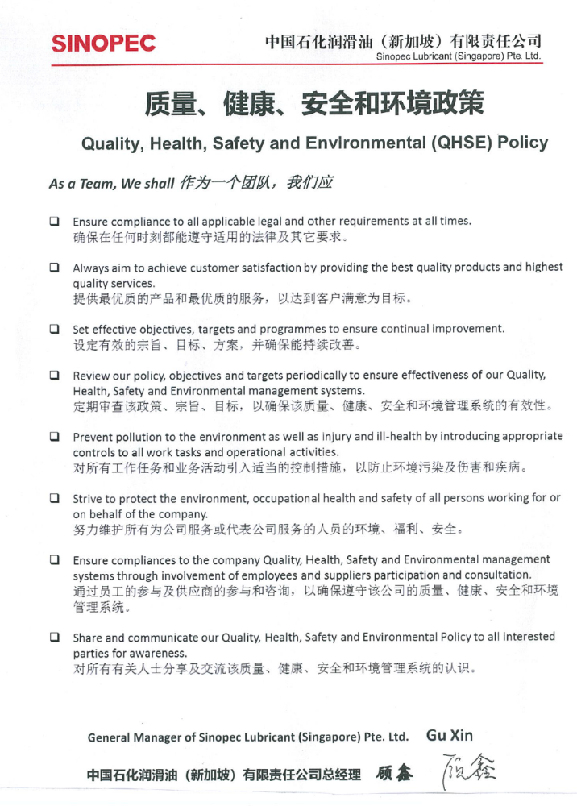
Appendix 6– Sinopec Lubricant Singapore Pte Ltd Security Policy

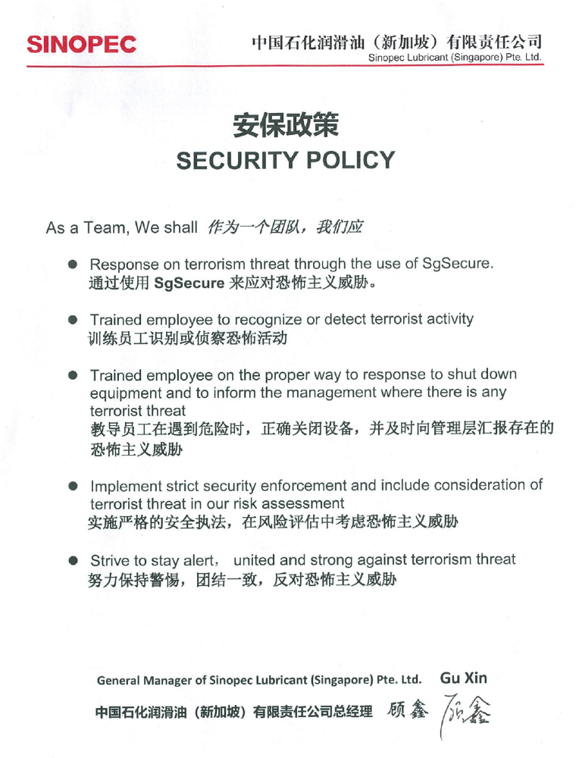

廉洁从业责任书
Agreement on Business Ethics and Principles

甲方：中国石化润滑油(新加坡)有限责任公司
Party A: Sinopec Lubricant (Singapore) Pte. Ltd.

乙方： XXXXXX
Party B: XXXXXX

为规范甲乙双方的商业行为，维护公平竞争，经双方协商，签订本责任书。
For the purpose of regulating business activities and maintaining the fair competition, after kind negotiation, Party A and Party B herein agree to sign this Agreement on Business Ethics and Principles as follows:
第一条 任何一方应严格遵守双方注册地或主要住所地所在国有关反对商业贿赂和廉洁从业的各项法律规定，严格履行双方签订的合同或协议，恪守商业道德和正当竞争的市场行为准则，共同营造公平公正的商业交易环境。
Article 1. Either party shall strictly comply with relevant laws and regulations of anti-commercial bribery and business of ethics and principles of both parties’register locations or their main domiciles of their own country. Party A and Party B shall strictly execute any contracts or agreements signed by and between them, adhere to commercial morality and code of market conduct, to jointly build a fair and impartial business environment.
第二条 甲方应禁止本公司员工、代理人利用职务之便，向乙方及其相关单位和人员索要或接受折扣费、中介费、佣金、礼金、有价证券、支付凭证、贵重物品等任何好处；不得参加乙方及其相关单位安排的可能影响公平交易的宴请及健身、娱乐等活动；不得向乙方及其相关单位和人员提出超出工作范围之外的，可能影响公平交易的事项或要求。乙方发现甲方及其员工、代理人有违反本责任书规定的，应当予以拒绝，并及时向甲方监察部门通报。
Article 2. Party A shall prohibit any of its employees and agencies from taking advantages of their positions to request or accept discount fees, agency fees, commissions, gift-money, marketable securities, disbursement voucher, costly presents or any other valuable goods and services from Party B or any other relevant companies and personnel; and shall prohibit them from attending any banquets, gymnastic activities, entertainment or any other activities arranged by Party B or relevant companies which may affect the fair execution of business between Party A and Party B. Party A shall not make any requirements or demands on Party B or any other relevant companies or personnel that are beyond the working scope and may affect the fair execution of business between both parties. If Party A, its personnel and agencies are found to break rules of this Agreement, Party B shall reject those requirements or demands and report timely to Party A’s inspection and supervision department.
第三条 乙方应禁止本公司员工、代理人及其相关单位和人员，给予或允诺、暗示给予甲方员工、代理以折扣费、中介费、佣金、礼金、有价证券、支付凭证、贵重物品等任何好处；不得安排有可能影响公平交易的宴请、健身、娱乐等活动；不得为甲方员工、代理及其特定关系人提出的超出工作范围之外的，可能影响公平交易的任何事项提供便利。
甲方发现乙方及其相关单位和人员有违反本责任书规定的，有权选择索赔或在本公司、本公司控股企业及其关联企业内给予通报、限制或禁止与其交易的处理。
Article 3. Party B shall take all necessary measures to prevent its employees, agencies, relevant companies and personnel from offering, promising, or implying presenting discount fees, agency fees, commissions, gift-money, marketable securities, disbursement voucher, costly presents or any other valuable goods and services to Party A’s employees and agencies; and shall not arrange any banquets, gymnastic activities, entertainment or any other activities which may influence the fair and impartial execution of business between Party A and Party B; and shall not offer any improper convenience which is beyond the working scope and may affect the fair execution of business between both parties to Party A’s employees, agencies and special related person.
If Party B, or its relevant companies and personnel are found to violate the rules of this Agreement, Party A will be entitled to request the compensation, or to give notification among Party A, its holding companies and relevant enterprises, and to restrict or prohibit Party B to do business with Party A.
第四条 本责任书经双方签署后生效。甲乙双方签订交易合同的，本责任书作为交易合同附件，与交易合同具有同等法律效力；未签订交易合同的，本责任书独立有效。
Article 4. This agreement will come into effect as soon as it is signed by Party A and Party B. If contracts are signed by both parties, this agreement shall be deemed as the appendix of the contracts and have the same legal effect as that of the contracts; if no contracts have been signed by and between both parties, this Agreement shall be valid independently.
第五条 甲乙双方及其人员在商业活动完成后，发生或发现违反本责任书规定的行为，按本责任书规定处理。
Article 5. Party A, Party B and their personnel should conform to this Agreement strictly, and should be governed by this Agreement after the business activities are fulfilled.
第六条 本责任书以中文和英文书就，中文内容与英文内容之间的任何不一致，以英文内容为准。
Article 6. This agreement has been made out in both Chinese and English versions. In case of any divergence of interpretation, the English version shall prevail.
第七条本责任书一式两份，甲乙双方各执一份，具有同等法律效力。
Article 7. This Agreement is made in two copies, one copy to be held by each party, and each copy is legally of equal effect.

甲方单位：中国石化润滑油(新加坡)有限责任公司
Party A: Sinopec Lubricant (Singapore) Pte. Ltd.
姓名/Name:
职称/Designation:
电话/Telephone Number:
日期/Date:
签名和公章/Signature and company stamp:

乙方单位：
Party B:
姓名/Name:
职称/Designation:
电话/Telephone Number:
日期/Date:
签名和公章/Signature and company stamp:

